Unit 5 Lesson 15: Lots of Fruit

WU Notice and Wonder: Fruit Stand (Warm up)

Student Task Statement
What do you notice?
What do you wonder?


1 Fruit Story Problems

Student Task Statement

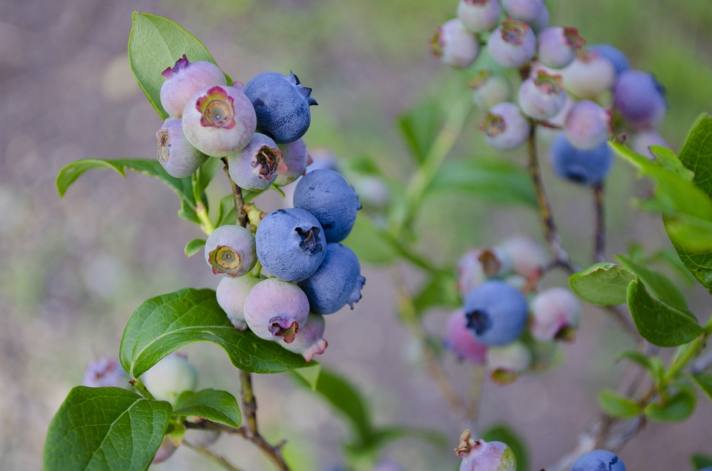



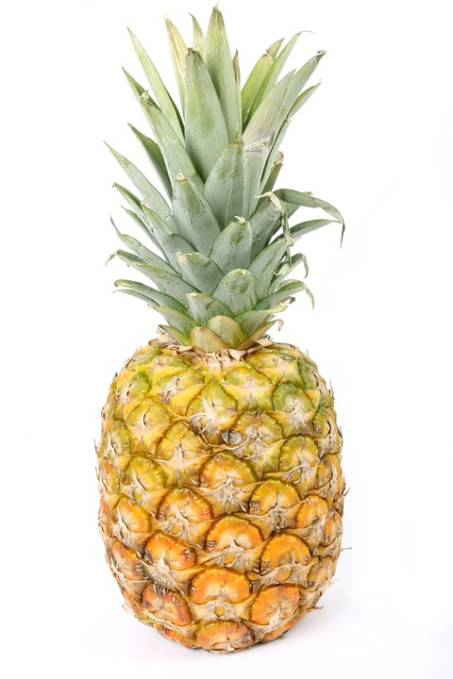

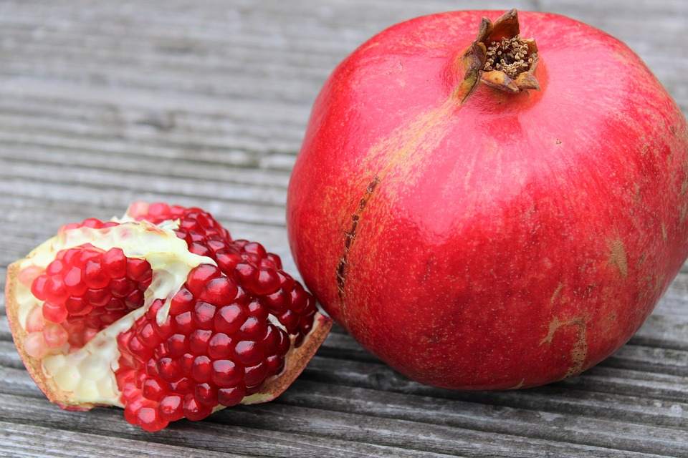

Solve the story problem.
Show your thinking using objects, drawings, numbers, or words.

2 All the Solutions

Student Task Statement
Show your thinking using drawings, numbers, words, or objects.
© CC BY 2021 Illustrative Mathematics®

