Lesson 6: Multipliquemos números de dos dígitos por números de un dígito

Standards Alignments
Addressing | 4.NBT.B.5

Teacher-facing Learning Goals
- Multiply two-digit and one-digit whole numbers using place value understanding and properties of operations.

Student-facing Learning Goals
- Multipliquemos números de dos dígitos por números de un dígito.

Lesson Purpose
The purpose of this lesson is for students to multiply a two-digit number and a one-digit number using place value understanding.
In the previous lesson, students solved two-digit multiplication problems in a way that made sense to them. They discussed decomposing factors and considered different representations of their strategy. In this lesson, students extend these ideas to find the value of products beyond 100, focusing on representations and strategies based on place value and the properties of operations, which are familiar from grade 3.
Students analyze base-ten diagrams and diagrams that involve rectangles, some of which are partitioned by place value. They explain how the diagrams represent multiplication and make connections between them, deepening their understanding of place value and properties of operations. At the end of the lesson, students consider a rectangular diagram that will be used through the rest of the section.

Access for:

Students with Disabilities
- Engagement (Activity 2)

English Learners
- MLR1 (Activity 2)

Instructional Routines
Notice and Wonder (Warm-up)

Lesson Timeline
Warm-up | 10 min
Activity 1 | 20 min
Activity 2 | 15 min
Lesson Synthesis | 10 min
Cool-down | 5 min

Teacher Reflection Question
What strategy did most students use in their work today? What strategy did you anticipate today? Which did you not anticipate?

Cool-down
(to be completed at the end of the lesson) 5min
Representa el producto

Standards Alignments
Addressing | 4.NBT.B.5

Student-facing Task Statement
Encuentra el valor de $6×83$. Si te ayuda, usa un diagrama.

Student Responses
Sample response:
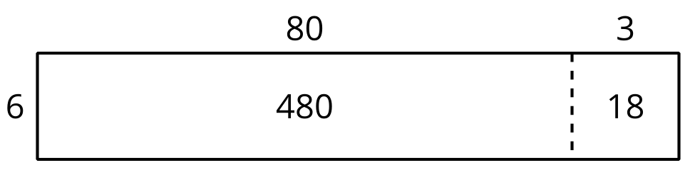
$6×80=480$
$6×3=18$
$480+18=498$

