Grade 2
Unit 1Lesson 8CC BY NC 2024 Illustrative Mathematics®
Unit 1, Lesson 8

Interpret Picture Graphs
- Let’s answer questions about picture graphs.
Grade 2
Unit 1Lesson 8CC BY NC 2024 Illustrative Mathematics®

Warm-upHow Many Do You See: Dots within 10
How many do you see? How do you see them?
Unable to process <img src="/tikz_files/237771.svg">Failed: rsvg-convert --format png --dpi-x 300 --dpi-y 300 /app/tmp/svgtopng-1786380663.3788912.svg --output /app/tmp/svgtopng-1786380663.3788912.png Backtrace: /app/app/services/script/runner.rb:34:in `block in run_cmd' <internal:kernel>:90:in `tap' /app/app/services/script/runner.rb:32:in `run_cmd' /app/app/services/script/svg_to_png.rb:27:in `convert_svg_to_png' /app/app/services/script/svg_to_png.rb:17:in `to_png' /app/vendor/bundle/ruby/3.3.0/gems/embeddable_content-1.1.0/app/services/embeddable_content/images/image_downloader.rb:37:in `png_rendered_from_svg' /app/vendor/bundle/ruby/3.3.0/gems/embeddable_content-1.1.0/app/services/embeddable_content/images/image_downloader.rb:33:in `raw_image_data' /app/vendor/bundle/ruby/3.3.0/gems/embeddable_content-1.1.0/app/services/embeddable_content/images/image_downloader.rb:13:in `block in save' <internal:kernel>:90:in `tap' /app/vendor/bundle/ruby/3.3.0/gems/embeddable_content-1.1.0/app/services/embeddable_content/images/image_downloader.rb:13:in `save'
Unable to process <img src="/tikz_files/237772.svg">Failed: rsvg-convert --format png --dpi-x 300 --dpi-y 300 /app/tmp/svgtopng-1786380663.4432025.svg --output /app/tmp/svgtopng-1786380663.4432025.png Backtrace: /app/app/services/script/runner.rb:34:in `block in run_cmd' <internal:kernel>:90:in `tap' /app/app/services/script/runner.rb:32:in `run_cmd' /app/app/services/script/svg_to_png.rb:27:in `convert_svg_to_png' /app/app/services/script/svg_to_png.rb:17:in `to_png' /app/vendor/bundle/ruby/3.3.0/gems/embeddable_content-1.1.0/app/services/embeddable_content/images/image_downloader.rb:37:in `png_rendered_from_svg' /app/vendor/bundle/ruby/3.3.0/gems/embeddable_content-1.1.0/app/services/embeddable_content/images/image_downloader.rb:33:in `raw_image_data' /app/vendor/bundle/ruby/3.3.0/gems/embeddable_content-1.1.0/app/services/embeddable_content/images/image_downloader.rb:13:in `block in save' <internal:kernel>:90:in `tap' /app/vendor/bundle/ruby/3.3.0/gems/embeddable_content-1.1.0/app/services/embeddable_content/images/image_downloader.rb:13:in `save'
Unable to process <img src="/tikz_files/237773.svg">Failed: rsvg-convert --format png --dpi-x 300 --dpi-y 300 /app/tmp/svgtopng-1786380663.4868112.svg --output /app/tmp/svgtopng-1786380663.4868112.png Backtrace: /app/app/services/script/runner.rb:34:in `block in run_cmd' <internal:kernel>:90:in `tap' /app/app/services/script/runner.rb:32:in `run_cmd' /app/app/services/script/svg_to_png.rb:27:in `convert_svg_to_png' /app/app/services/script/svg_to_png.rb:17:in `to_png' /app/vendor/bundle/ruby/3.3.0/gems/embeddable_content-1.1.0/app/services/embeddable_content/images/image_downloader.rb:37:in `png_rendered_from_svg' /app/vendor/bundle/ruby/3.3.0/gems/embeddable_content-1.1.0/app/services/embeddable_content/images/image_downloader.rb:33:in `raw_image_data' /app/vendor/bundle/ruby/3.3.0/gems/embeddable_content-1.1.0/app/services/embeddable_content/images/image_downloader.rb:13:in `block in save' <internal:kernel>:90:in `tap' /app/vendor/bundle/ruby/3.3.0/gems/embeddable_content-1.1.0/app/services/embeddable_content/images/image_downloader.rb:13:in `save'
Grade 2
Unit 1Lesson 8CC BY NC 2024 Illustrative Mathematics®

Activity 1Sports People Love
Clare asked a group of children, “Which sport do you love?” Their responses are shown in this picture graph.
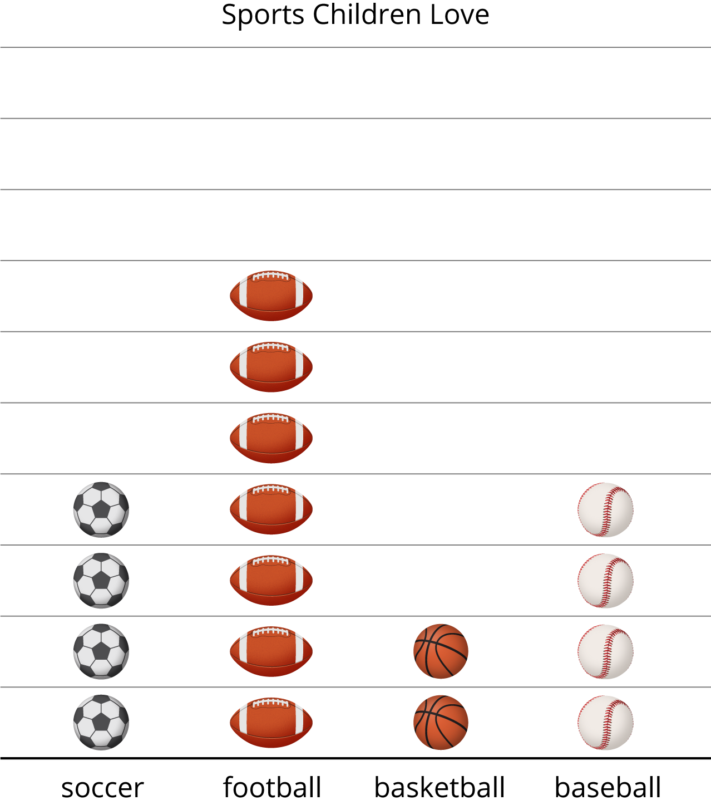
What can you learn about the sports children love from Clare’s picture graph?
A group of adults were asked, “Which sport do you love?” Their responses are shown in this picture graph.
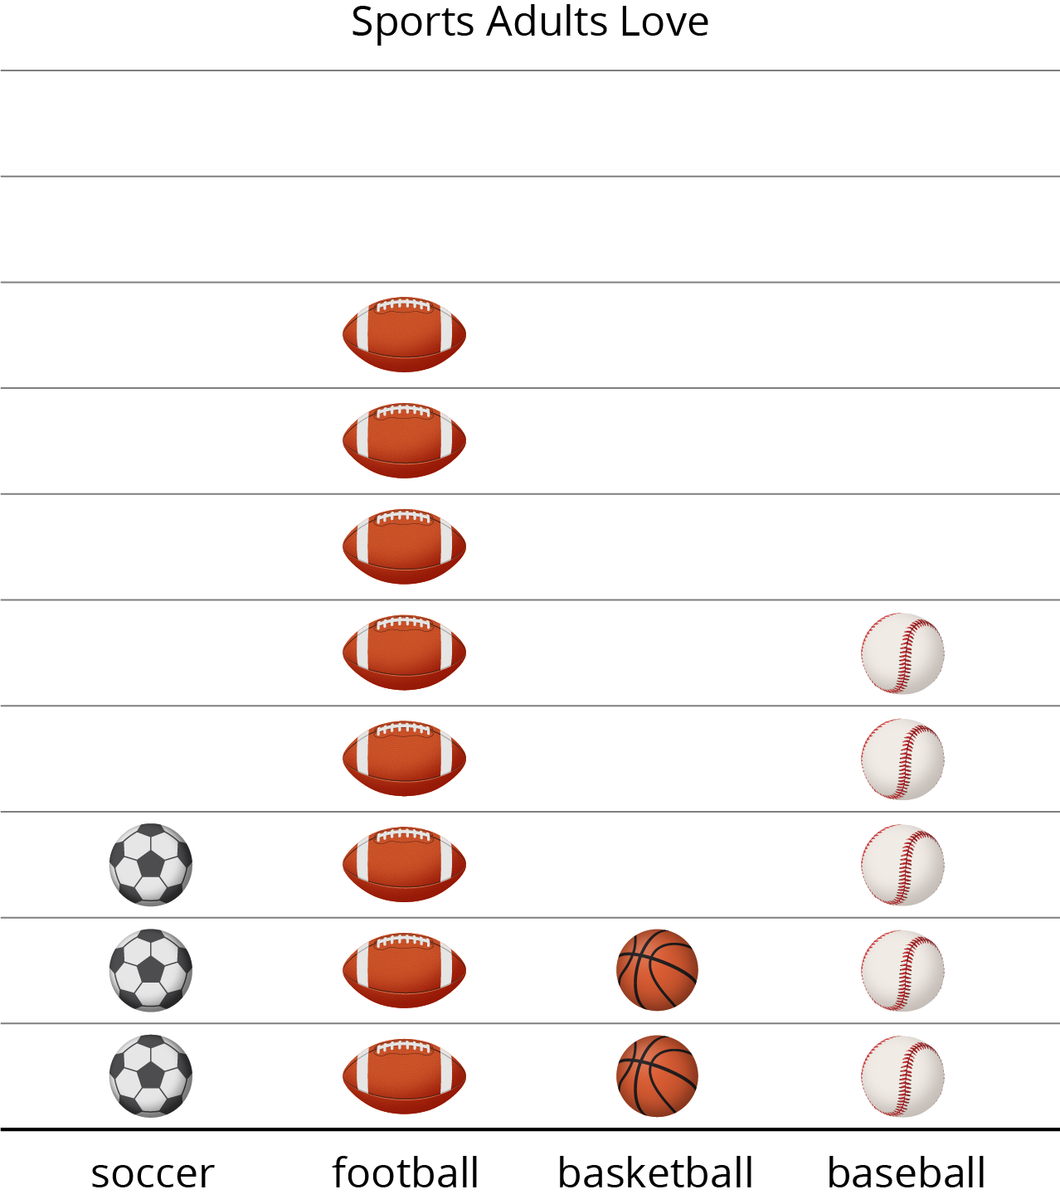
- How many adults like basketball?
- How many like football or baseball? Show your thinking using drawings, numbers, or words.
- Write 1 fact you learned about the data in the picture graph.
Grade 2
Unit 1Lesson 8CC BY NC 2024 Illustrative Mathematics®

Activity 2Answer Questions
A group of children were asked, “Which is your favorite art supply?” Their responses are shown in this picture graph.
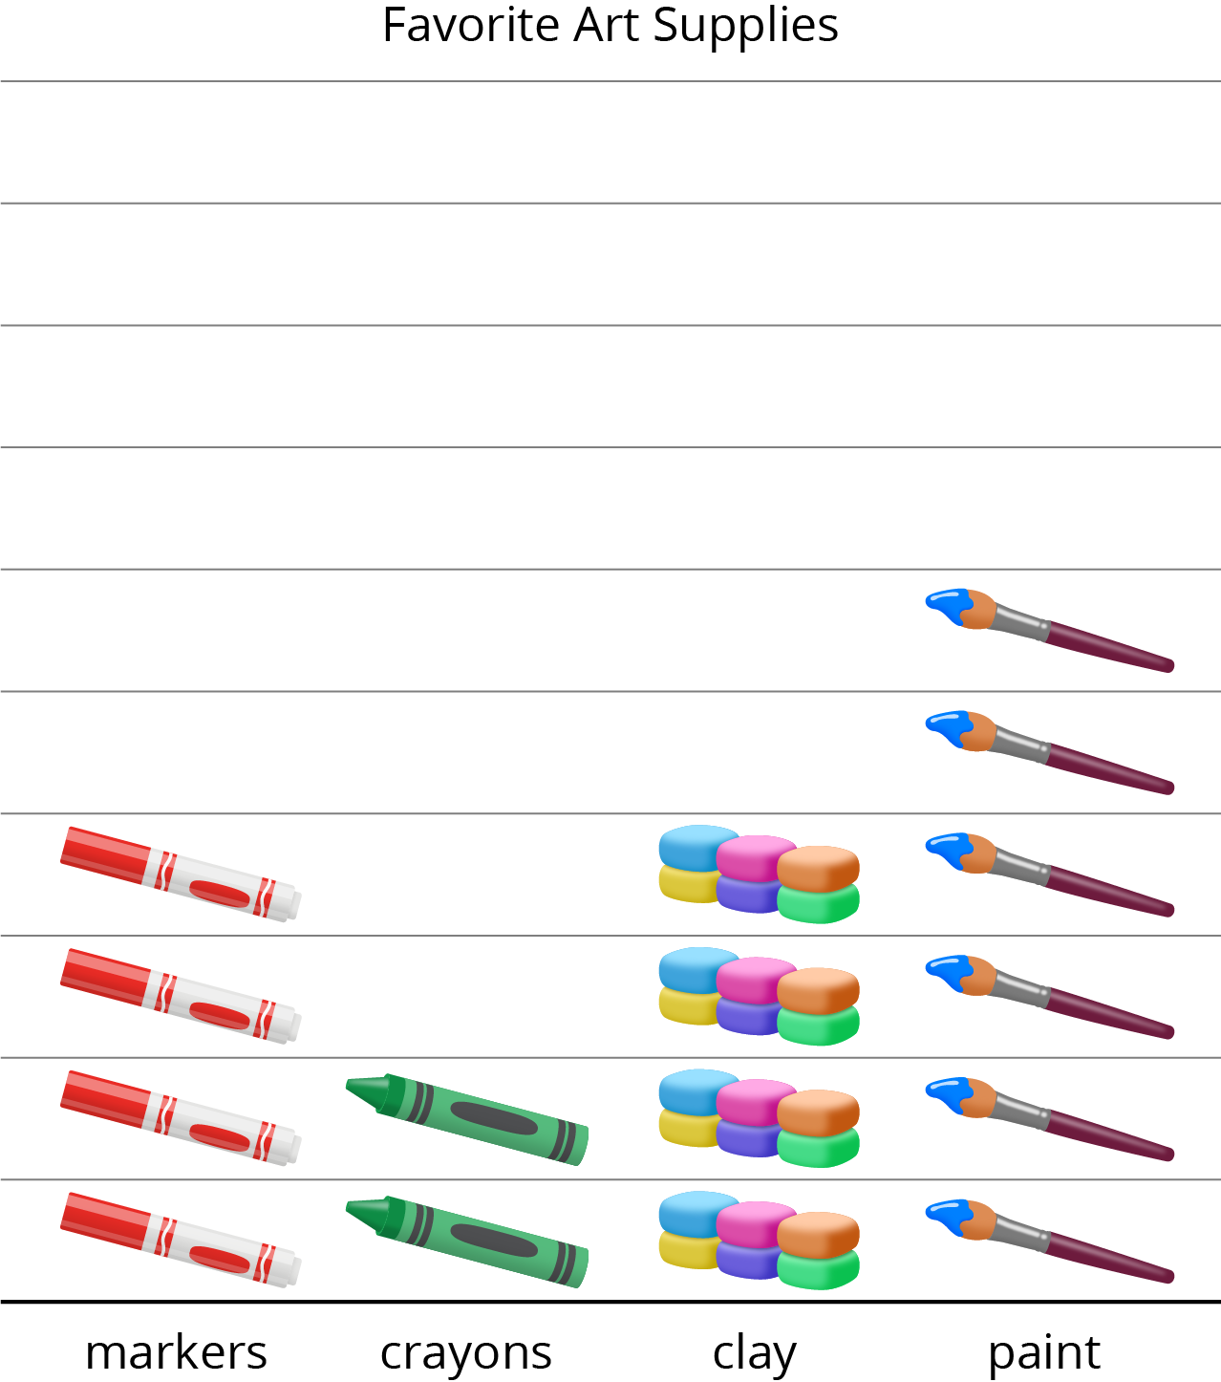
- Circle the 4 questions the graph can answer.
  - How many children chose markers?
  - How many chose crayons or clay?
  - Why did so many children choose paint?
  - How many more children chose markers than crayons?
  - What is the total number of children who chose paint or markers?
- Answer each question you circled.

