Grade 2
Unit 2Lesson 6CC BY NC 2024 Illustrative Mathematics®
Unit 2, Lesson 6

Compare Methods for Subtraction
- Let’s compare ways to subtract.
Grade 2
Unit 2Lesson 6CC BY NC 2024 Illustrative Mathematics®

Warm-up True or False: How Many Tens? How Many Ones?
Decide if each statement is true or false. Be prepared to explain your reasoning.
- $64=60+4$
- $64=50+14$
- $64=30+24$
Grade 2
Unit 2Lesson 6CC BY NC 2024 Illustrative Mathematics®

Activity 1Different Ways to Decompose
Diego and Elena draw base-ten diagrams to decompose a ten.
Diego’s diagram:
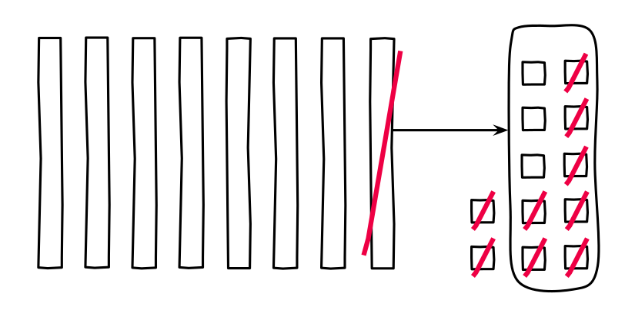
Elena's diagram:
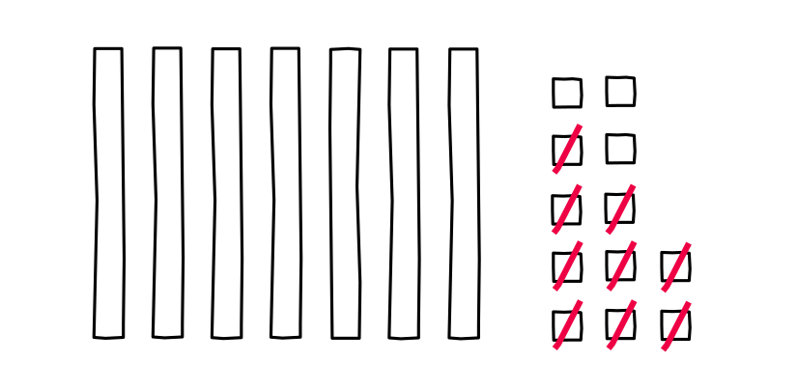
- Compare the base-ten diagrams.
  - How are the diagrams alike?
  - How are they different?
- Tyler used equations to show his thinking.
- $82−9$
$82=70+12$
$12−9=3$
$70+3=73$
- Diego says Tyler’s work matches his diagram.
Elena says it matches her diagram.
- Diego’s diagram:
- Elena's diagram:
- Do you agree with Diego or Elena? Explain your reasoning.

