Grade 6
Unit 1Lesson 5CC BY NC Illustrative Mathematics, based on IM 6–8 Math, CC BY Open Up Resources.
Unit 1, Lesson 5

Bases and Heights of Parallelograms
Let’s investigate the area of parallelograms some more.
Grade 6
Unit 1Lesson 5CC BY NC Illustrative Mathematics, based on IM 6–8 Math, CC BY Open Up Resources.

5.1A Parallelogram and Its Rectangles
Elena and Tyler were finding the area of this parallelogram:
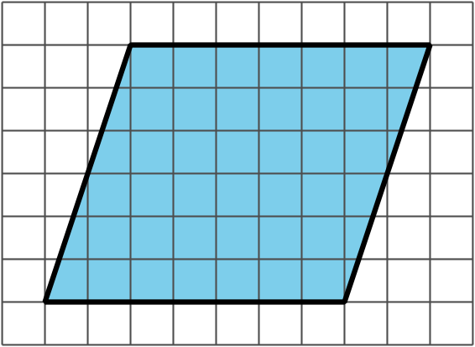
Here is how Elena did it:
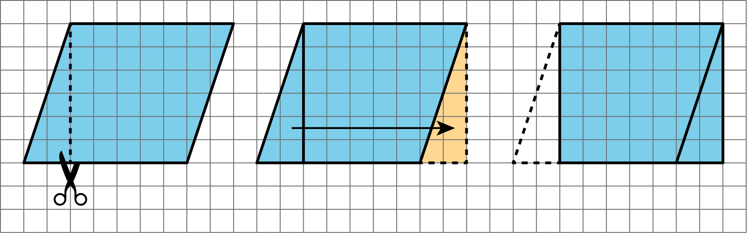
Here is how Tyler did it:
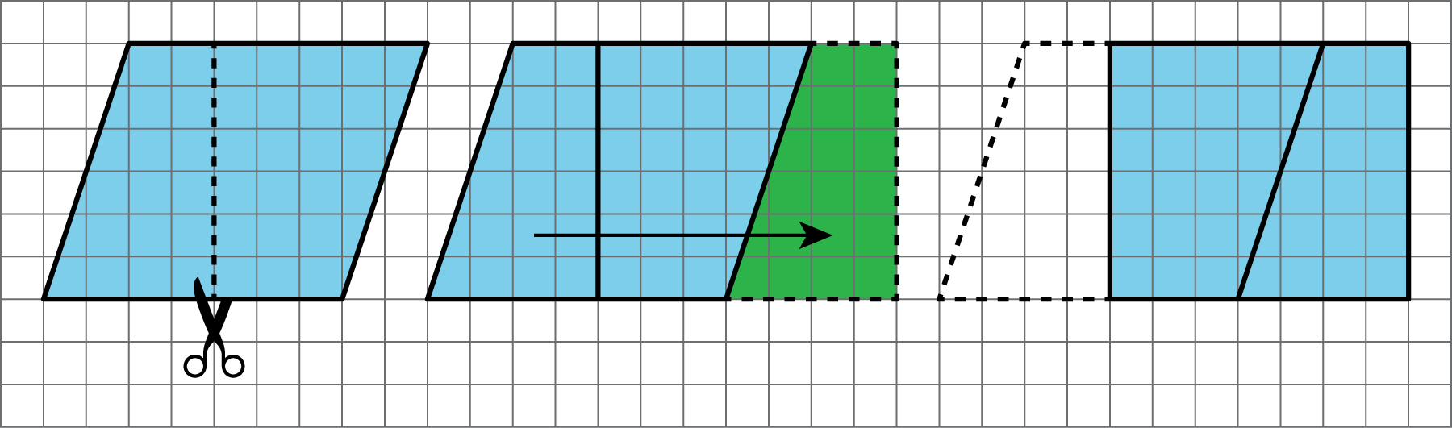
How are the two strategies for finding the area of a parallelogram the same? How they are different?
Grade 6
Unit 1Lesson 5CC BY NC Illustrative Mathematics, based on IM 6–8 Math, CC BY Open Up Resources.

5.2The Right Height?
Here are some drawings of parallelograms. In each drawing, one side is labeled “base.”
In the first four drawings, each dashed segment represents a height that corresponds to the given base.
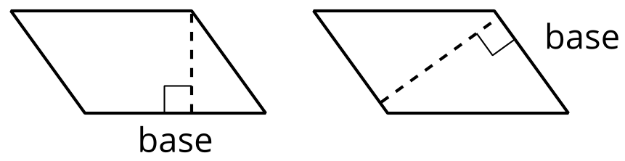
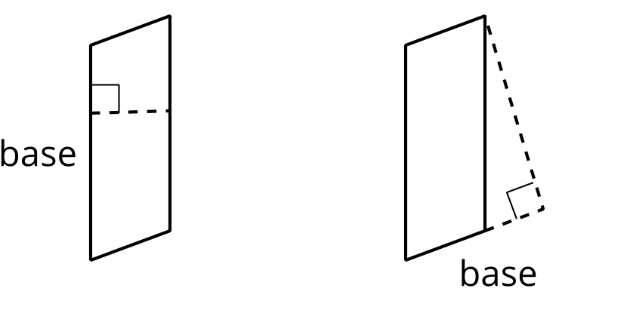
In the next four drawings, each dashed segment does not represent a height that corresponds to the given base.
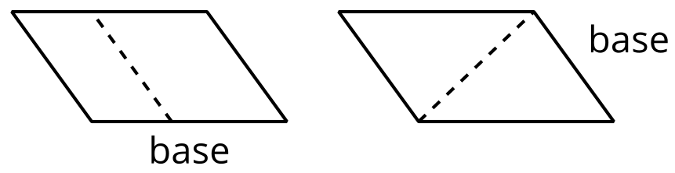
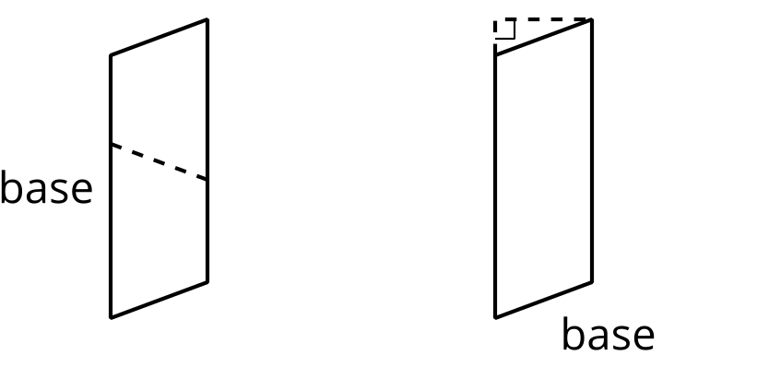
- Select all the statements that are true about bases and heights in a parallelogram.
  - Only a horizontal side of a parallelogram can be a base.
  - Any side of a parallelogram can be a base.
  - A height can be drawn at any angle to the side chosen as the base.
  - A base and its corresponding height must be perpendicular to each other.
  - A height can only be drawn inside a parallelogram.
  - A height can be drawn outside of the parallelogram, as long as it is drawn at a 90-degree angle to the base.
  - A base cannot be extended to meet a height.
- Five students labeled a base $b$ and a corresponding height $h$ for each of these parallelograms. Are all drawings correctly labeled? Explain how you know.
- A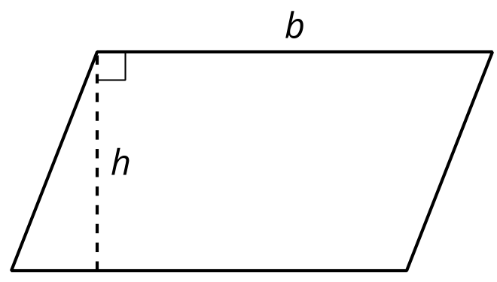
- B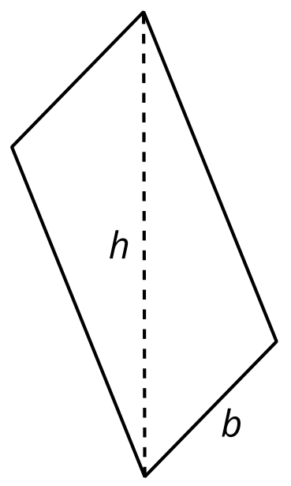
- C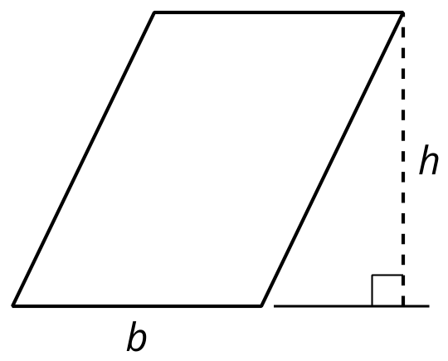
- D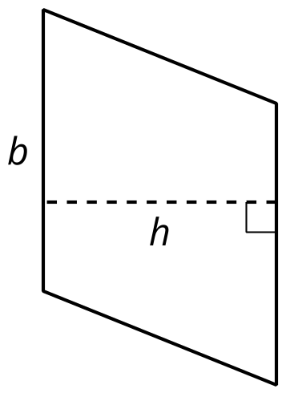
- E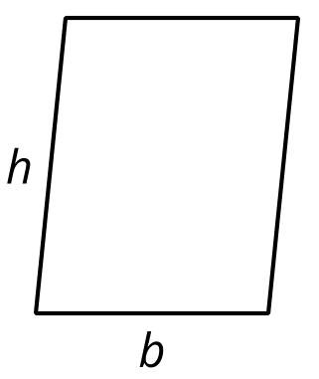
Grade 6
Unit 1Lesson 5CC BY NC Illustrative Mathematics, based on IM 6–8 Math, CC BY Open Up Resources.

5.3Finding the Formula for Area of Parallelograms
For each parallelogram:
- Identify a base and a corresponding height, and record their lengths in the table.
- Find the area of the parallelogram and record it in the last column of the table.
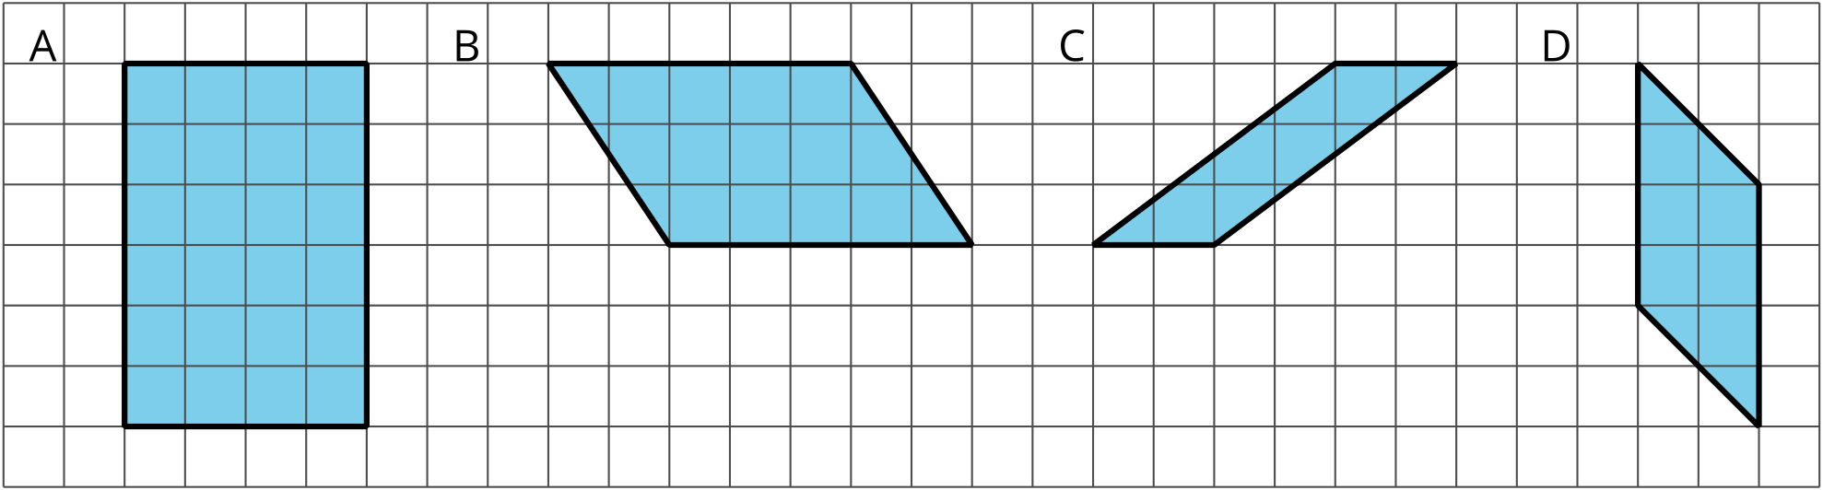
parallelogram | base (units) | height (units) | area (sq units)
A
B
C
D
any parallelogram | $b$ | $h$
In the last row of the table, write an expression for the area of any parallelogram, using $b$ and $h$ .

Are you ready for more?
- What happens to the area of a parallelogram if the height doubles but the base is unchanged? If the height triples? If the height is 100 times the original?
- What happens to the area if both the base and the height double? Both triple? Both are 100 times their original lengths?

Lesson 5 Summary
- We can choose any side of a parallelogram as the base. Both the side selected (the segment) and its length (the measurement) are called the base.
- If we draw any perpendicular segment from a point on the base to the opposite side of the parallelogram, that segment will always have the same length. We call that value the height. There are infinitely many segments that can represent the height!
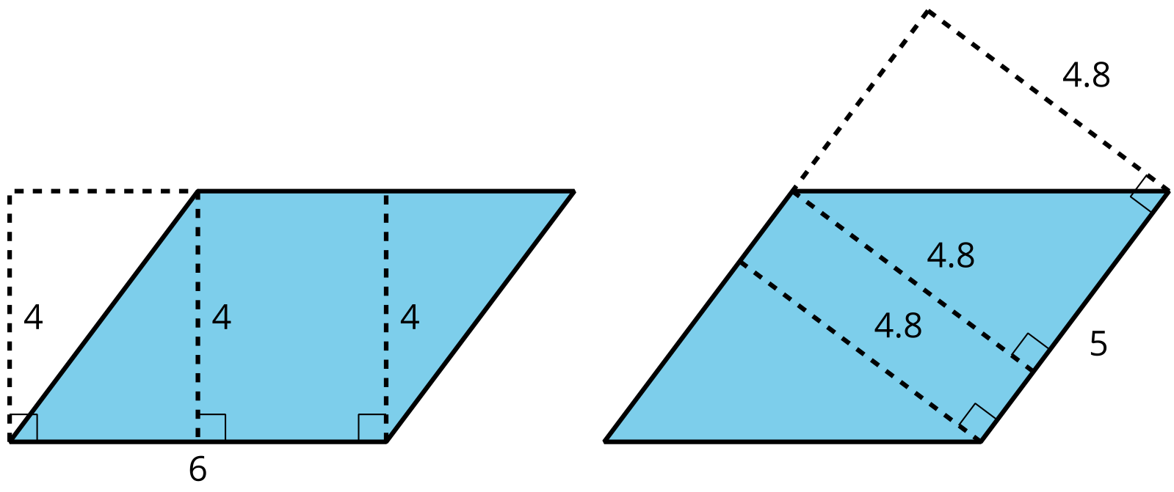
Here are two copies of the same parallelogram. On the left, the side that is the base is 6 units long. Its corresponding height is 4 units. On the right, the side that is the base is 5 units long. Its corresponding height is 4.8 units. For both, three different segments are shown to represent the height. We could draw in many more!
No matter which side is chosen as the base, the area of the parallelogram is the product of that base and its corresponding height. We can check this:
$4×6=24$
and
$4.8×5=24$
We can see why this is true by decomposing and rearranging the parallelograms into rectangles.
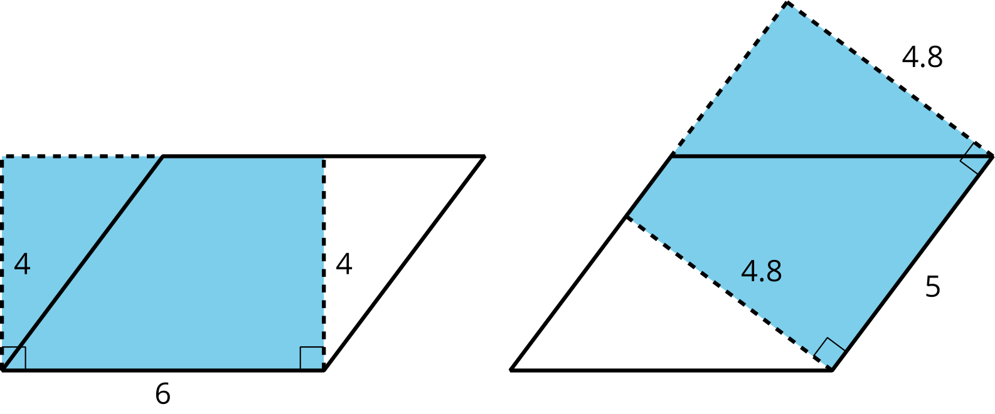
Notice that the side lengths of each rectangle are the base and height of the parallelogram. Even though the two rectangles have different side lengths, the products of the side lengths are equal, so they have the same area! And both rectangles have the same area as does the parallelogram.
We often use letters to stand for numbers. If $b$ is a base of a parallelogram (in units), and $h$ is the corresponding height (in units), then the area of the parallelogram (in square units) is the product of these two numbers:
$b⋅h$
Notice that we write the multiplication symbol with a small dot instead of a $×$ symbol. This is so that we don’t get confused about whether $×$ means multiply, or whether the letter $x$ is standing in for a number.

