Grade 6
Unit 3Lesson 13CC BY NC Illustrative Mathematics, based on IM 6–8 Math, CC BY Open Up Resources.
Unit 3, Lesson 13

Benchmark Percentages
Let’s contrast percentages and fractions.
Grade 6
Unit 3Lesson 13CC BY NC Illustrative Mathematics, based on IM 6–8 Math, CC BY Open Up Resources.

13.1Which Three Go Together: Shaded Diagram
Which three go together? Why do they go together?
A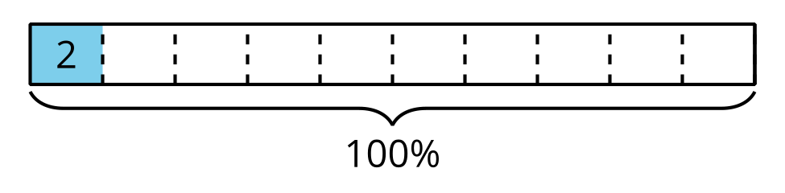
B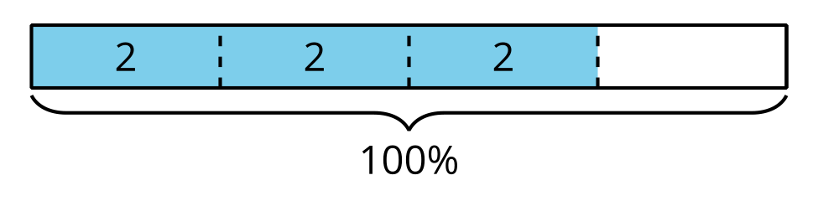
C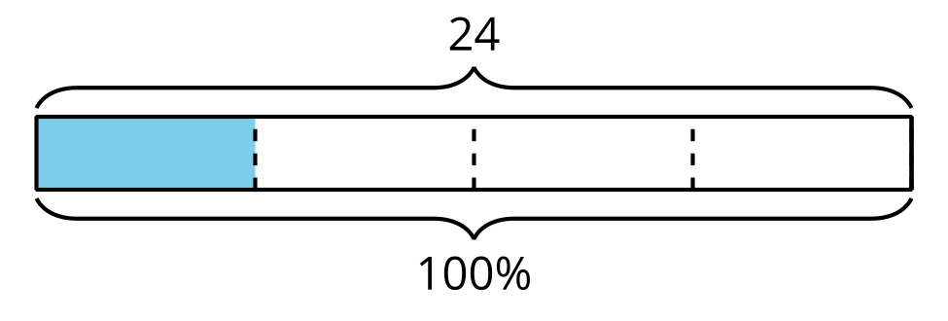
D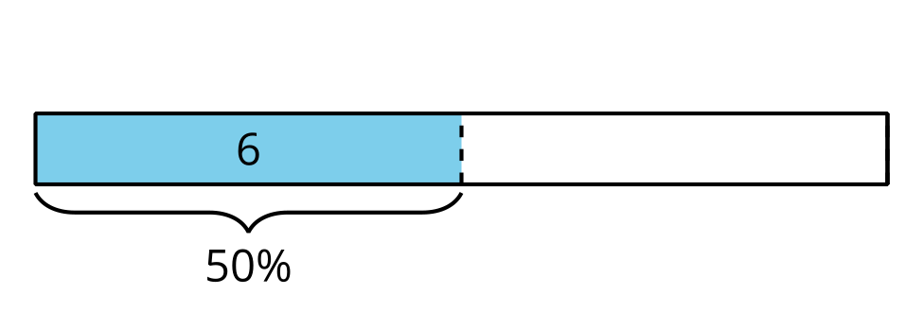
Grade 6
Unit 3Lesson 13CC BY NC Illustrative Mathematics, based on IM 6–8 Math, CC BY Open Up Resources.

13.2Liters, Meters, and Hours

  - How much is 50% of 10 liters of milk?
  - 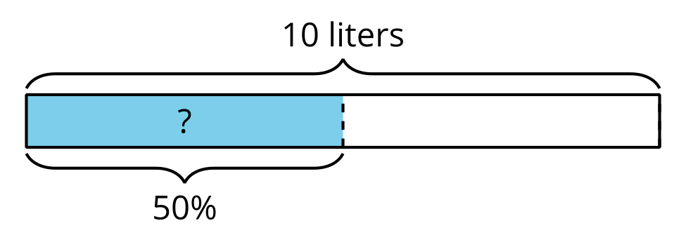
  - How far is 50% of a 2,000-kilometer trip?
  - 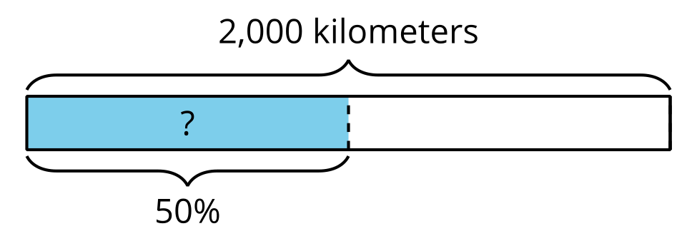
  - How long is 50% of a 24-hour day?
  - 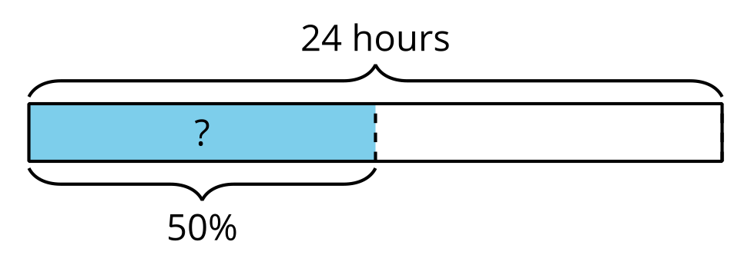
  - How can you find 50% of any number?

  - How far is 10% of a 2,000-kilometer trip?
  - How much is 10% of 10 liters of milk?
  - How long is 10% of a 24-hour day?
  - How can you find 10% of any number?

  - How long is 75% of a 24-hour day?
  - How far is 75% of a 2,000-kilometer trip?
  - How much is 75% of 10 liters of milk?
  - How can you find 75% of any number?
Grade 6
Unit 3Lesson 13CC BY NC Illustrative Mathematics, based on IM 6–8 Math, CC BY Open Up Resources.

13.3Nine Is . . .
Calculate each value mentally. Be prepared to explain your reasoning.
- 9 is 50% of what number?
- 9 is 25% of what number?
- 9 is 10% of what number?
- 9 is 75% of what number?
- 9 is 150% of what number?
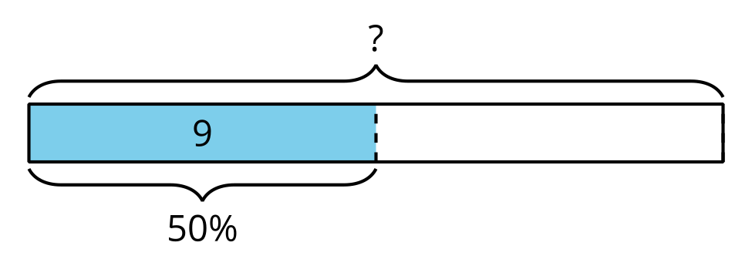
Grade 6
Unit 3Lesson 13CC BY NC Illustrative Mathematics, based on IM 6–8 Math, CC BY Open Up Resources.

13.4Shopping with Coupons
Han and Clare go shopping, and they each have a coupon.
- Han buys an item with a normal price of $15, and uses a 10% off coupon. How much does he save by using the coupon? Show your reasoning.
- 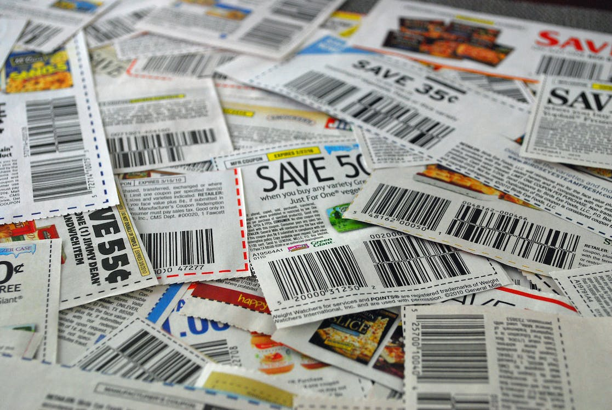
- Clare buys an item with a normal price of $24, but saves $6 by using a coupon. For what percentage off is this coupon? Show your reasoning.

Are you ready for more?
​​Clare paid full price for an item. Han bought the same item for 80% of the full price. Clare said, “I can’t believe I paid 125% of what you paid, Han!” Is what she said true? Explain your reasoning.

Lesson 13 Summary
Certain percentages are easy to think about in terms of fractions.
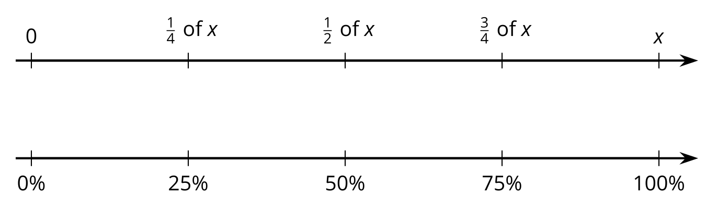
- 25% of a number is always $\frac{1}{4}$ of that number. For example, 25% of 40 liters is $\frac{1}{4}⋅40$, or 10 liters.
- 50% of a number is always $\frac{1}{2}$ of that number. For example, 50% of 82 kilometers is $\frac{1}{2}⋅82$, or 41 kilometers.
- 75% of a number is always $\frac{3}{4}$ of that number. For example, 75% of 1 pound is $\frac{3}{4}$ pound.
- 10% of a number is always $\frac{1}{10}$ of that number. For example, 10% of 95 meters is 9.5 meters.
We can also find multiples of 10% using tenths. For example, 70% of a number is always $\frac{7}{10}$ of that number, so 70% of 30 days is $\frac{7}{10}⋅30$, or 21 days.
