Unit 9 Lesson 2: Regular Tessellations

1 Regular Tessellations (Optional)

Images for Launch
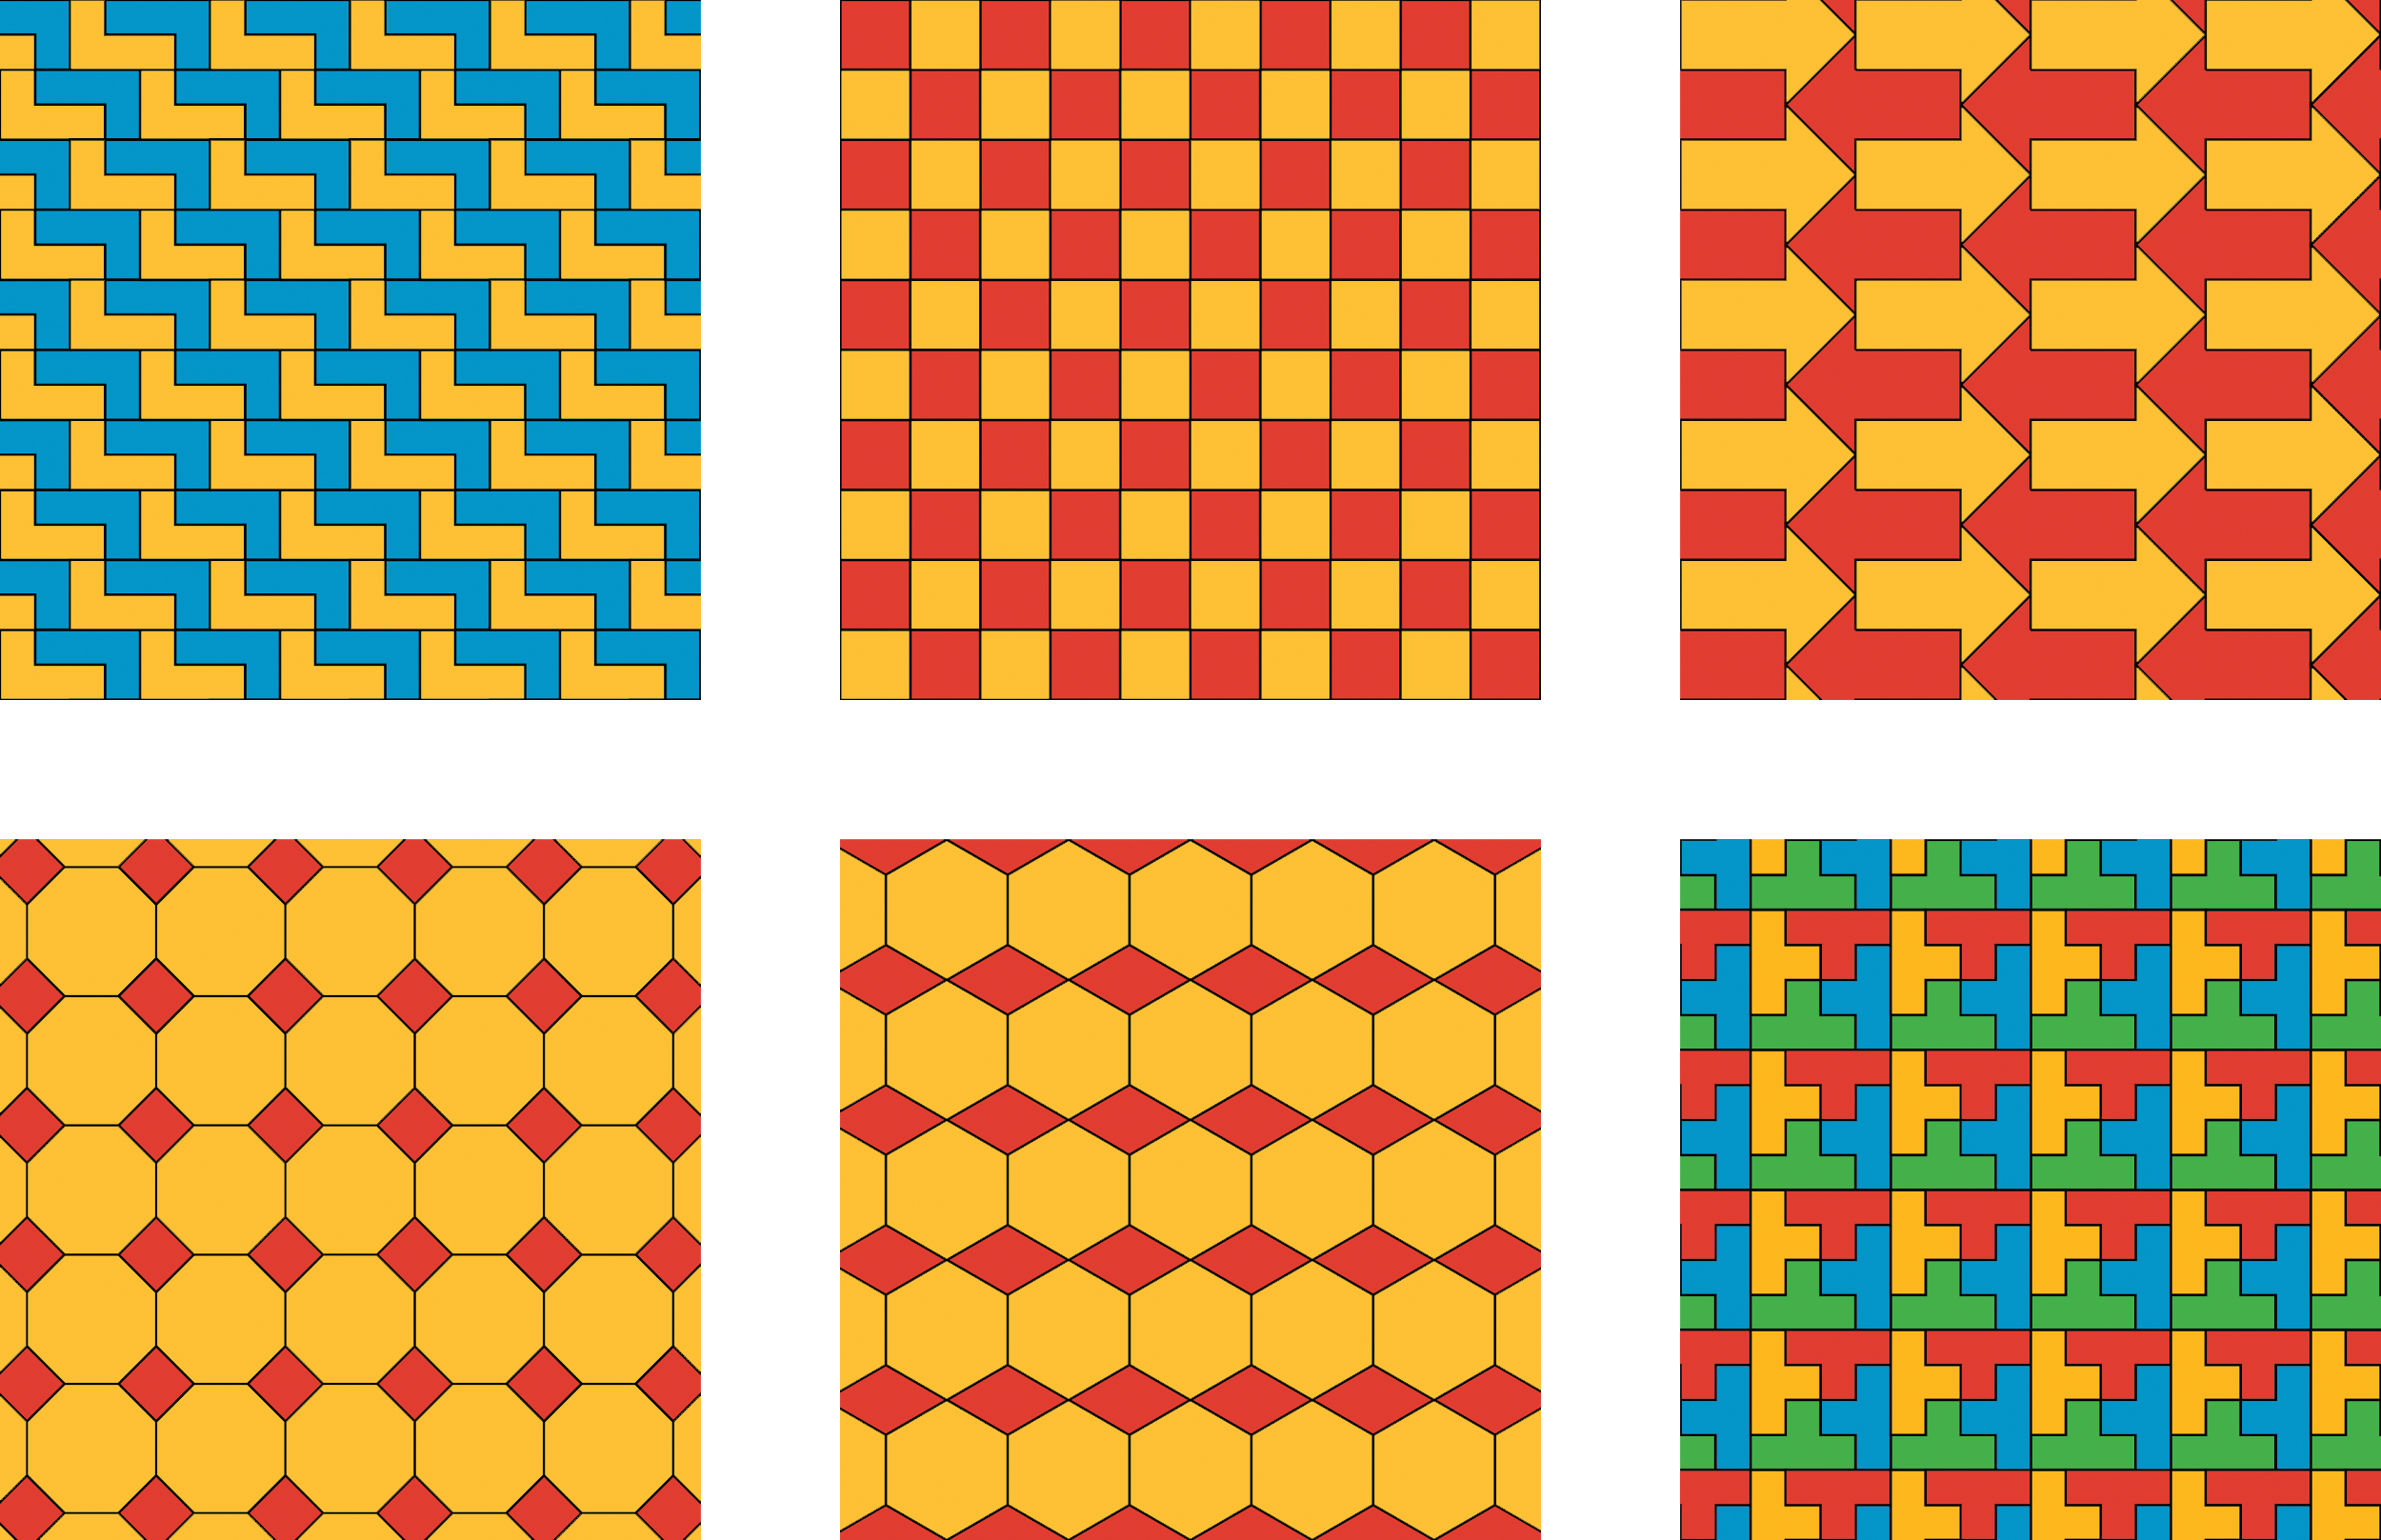

Student Task Statement
- For each shape (triangle, square, pentagon, hexagon, and octagon), decide if you can use that shape to make a regular tessellation of the plane. Explain your reasoning.
- 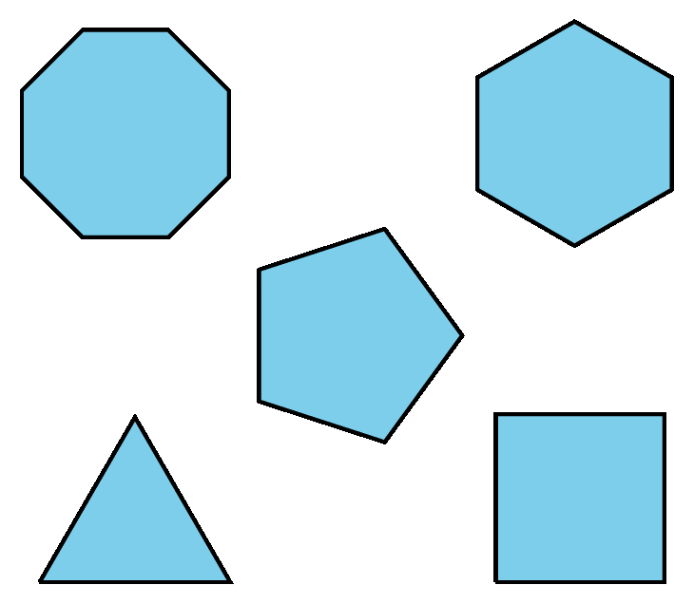
- For the polygons that do not work, what goes wrong? Explain your reasoning.

Activity Synthesis
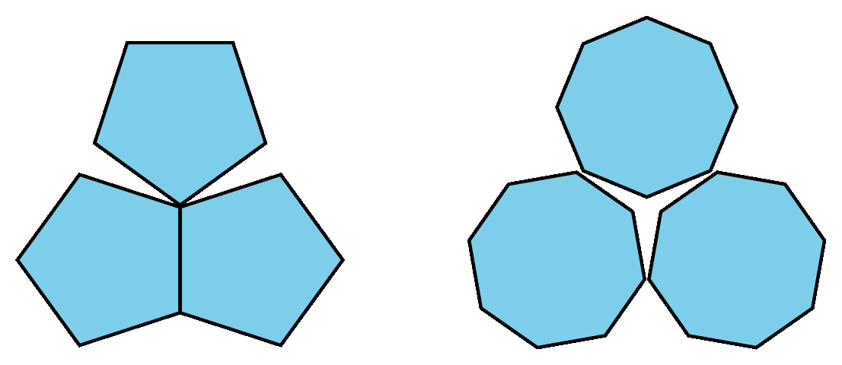

2 Equilateral Triangle Tessellation (Optional)

Student Task Statement
- What is the measure of each angle in an equilateral triangle? How do you know?
- How many triangles can you fit together at one vertex? Explain why there is no space between the triangles.

- Explain why you can continue the pattern of triangles to tessellate the plane.
- How can you use your triangular tessellation of the plane to show that regular hexagons can be used to give a regular tessellation of the plane?

3 Regular Tessellation for Other Polygons (Optional)

Student Task Statement
- Can you make a regular tessellation of the plane using regular polygons with 7 sides? What about 9 sides? 10 sides? 11 sides? 12 sides? Explain.
- 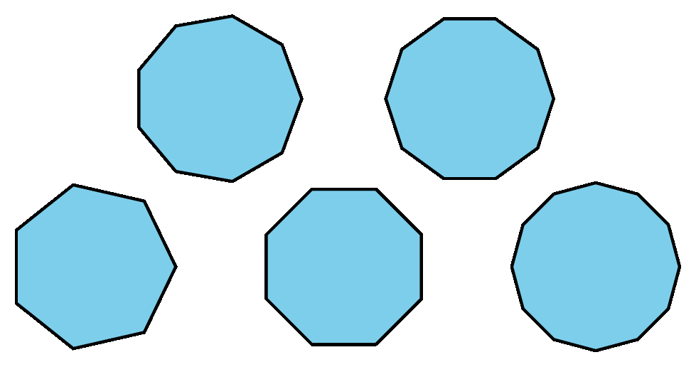
- How does the measure of each angle in a square compare to the measure of each angle in an equilateral triangle? How does the measure of each angle in a regular 8-sided polygon compare to the measure of each angle in a regular 7-sided polygon?
- What happens to the angles in a regular polygon as you add more sides?
- Which polygons can be used to make regular tessellations of the plane?
© CC BY Open Up Resources. Adaptations CC BY IM.

