Grade 2
Unit 6Lesson 9CC BY NC 2024 Illustrative Mathematics®
Unit 6, Lesson 9

You Took the Whole Thing!
- Let’s talk about the whole.
Grade 2
Unit 6Lesson 9CC BY NC 2024 Illustrative Mathematics®

Warm-upNotice and Wonder: Crafts with Circles
What do you notice? What do you wonder?
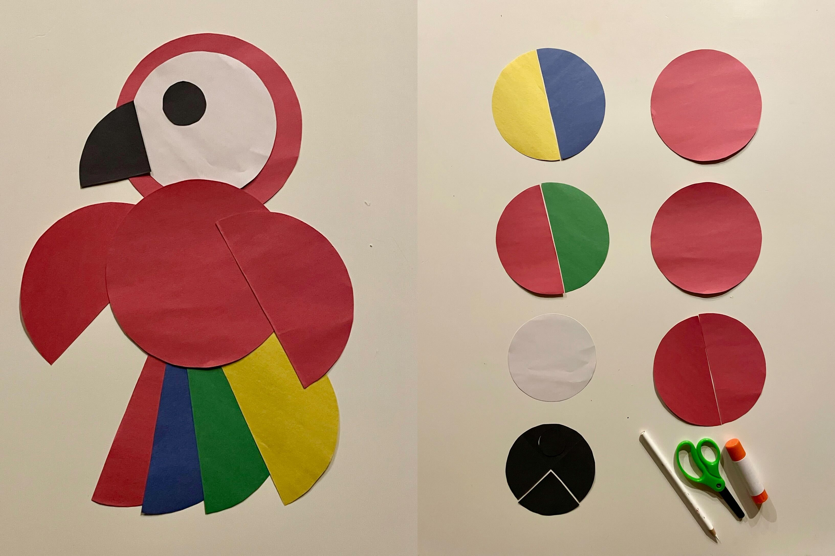
Grade 2
Unit 6Lesson 9CC BY NC 2024 Illustrative Mathematics®

Activity 1A Circle to Share
Clare’s friends share a paper circle to make a craft. The image shows how they cut it.
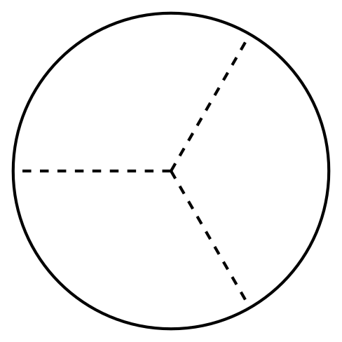
- Clare takes 3 pieces of the circle to make her craft. Her friends get upset with her.
  - Why are her friends upset?
  - How many thirds does Clare take?
  - How much of the circle is left?
- Craft Pieces
- Group
- Priya
- Han
- Diego
  - Priya gets ___________________________ of the circle.
  - Together, Priya, Han, and Diego have ___________________________ of the circle.
- Craft Pieces
- 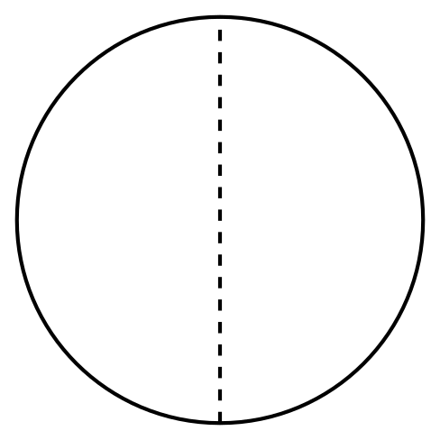
- Group
- Jada
- Mai
  - Each person gets ___________________________ of the circle.
  - Together, Jada, and Mai have ___________________________ of the circle.
- Craft Pieces
- 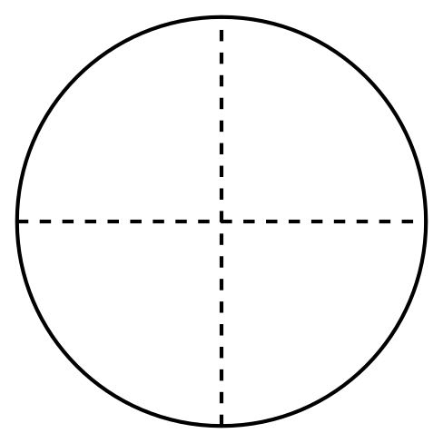
- Group
- Elena
- Tyler
- Lin
- Kiran
  - How many pieces does each person get? ___________________________
  - How many pieces does the group have in all? _______________________
Grade 2
Unit 6Lesson 9CC BY NC 2024 Illustrative Mathematics®

Activity 2Equal-Size Shares of the Circle
Students painted these circles in art class.
A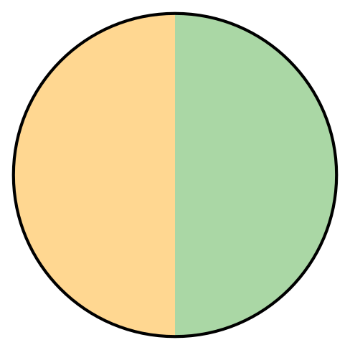
B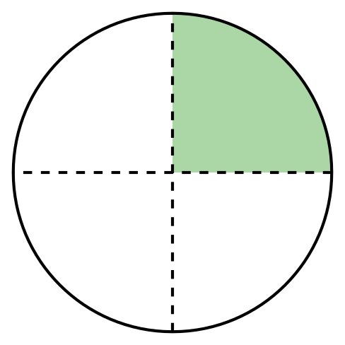
C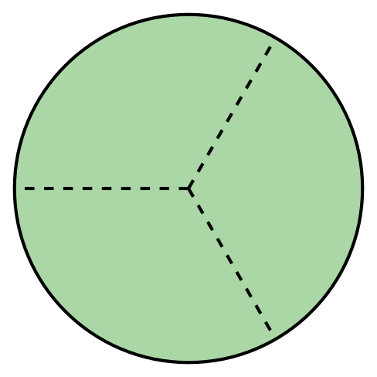
D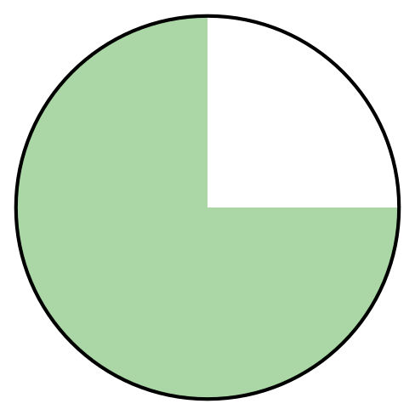
Write the letter of each image next to the matching story.
- Noah painted most of his circle green. He left a quarter of the circle for Diego to paint.
- __________
- Lin painted half of her circle green. Elena finished painting the circle.
- __________
- Tyler split his circle into 4 equal-size pieces. He painted a quarter of the circle.
- __________
- Mai, Clare, and Priya split a circle. They each painted an equal-size piece.
- __________
  - How much of the circle did each person paint?
  - _____________________________
  - How much of the circle did they paint in all?
  - _____________________________
- Now you try.
  - Partition the circle into 4 equal-size pieces.
  - Shade a quarter of the circle red.
  - Shade the rest of the circle blue.
- 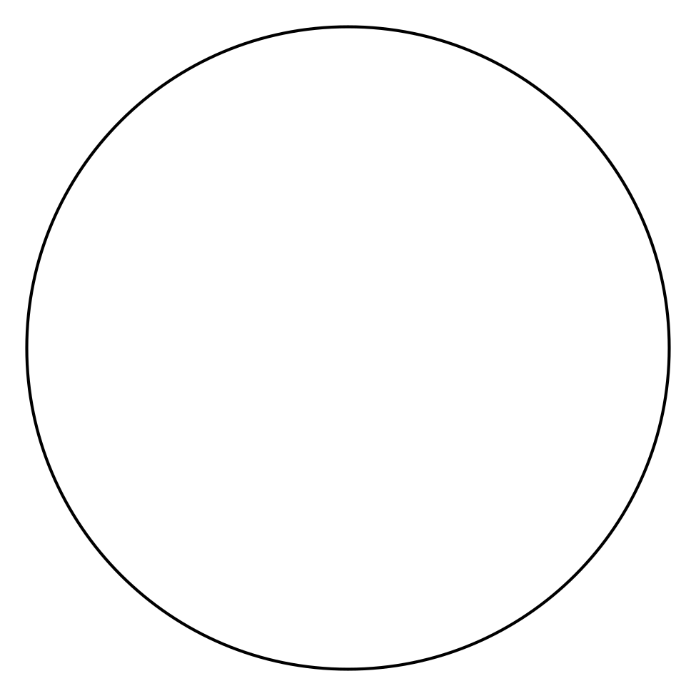
- How much of the circle is shaded? _____________________________

  - Partition the circle into 2 equal-size pieces.
  - Shade one half of the circle blue.
  - Shade the other piece yellow.
- How much of the circle is yellow? ________________________
- How much of the circle is shaded? ________________________

Section B Summary
We composed and decomposed shapes. Sometimes the pieces make up a whole shape, but all the pieces are not the same size. Sometimes the whole is partitioned into equal-size pieces with special names. We partitioned shapes into halves, thirds, and fourths. We learned that halves, thirds, and fourths of the same shape can look different. We learned that we can say a whole shape is 2 halves, 3 thirds, 4 fourths, or 4 quarters.
- When a whole shape is split into 2 pieces that are the same size, one piece is called a half.
- When a whole shape is split into 3 pieces that are the same size, one piece is called a third.
- When a whole shape is split into 4 pieces that are the same size, one piece is called a fourth.
How can you use halves, thirds, fourths, or quarters to describe the pieces of these shapes? How can you use halves, thirds, fourths, or quarters to describe the whole shape?
