Lesson 6: Rectangles and Squares
- Let’s learn the names of some more shapes.

Warm-up: What Do You Know About Triangles?
What do you know about triangles?

6.1: Sort Rectangles
Let’s put the shapes into 2 groups.
Rectangle
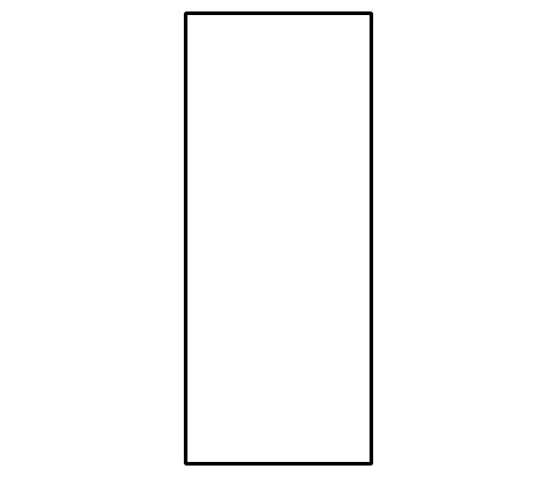
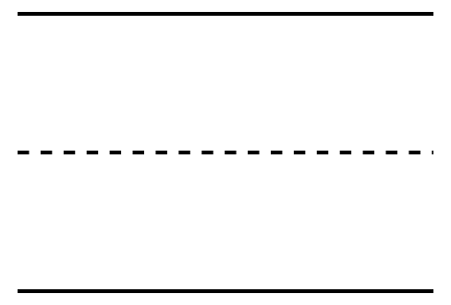
Not a Rectangle
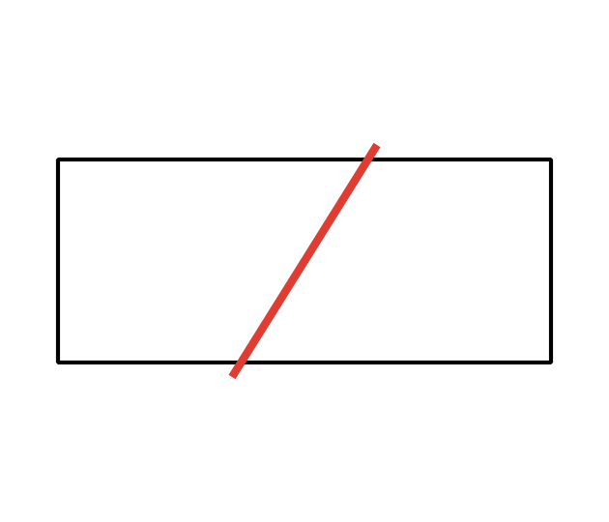

6.2: Compare Length of Rectangles
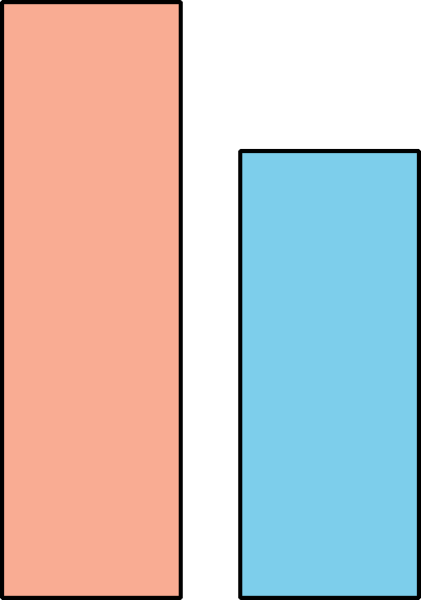

- 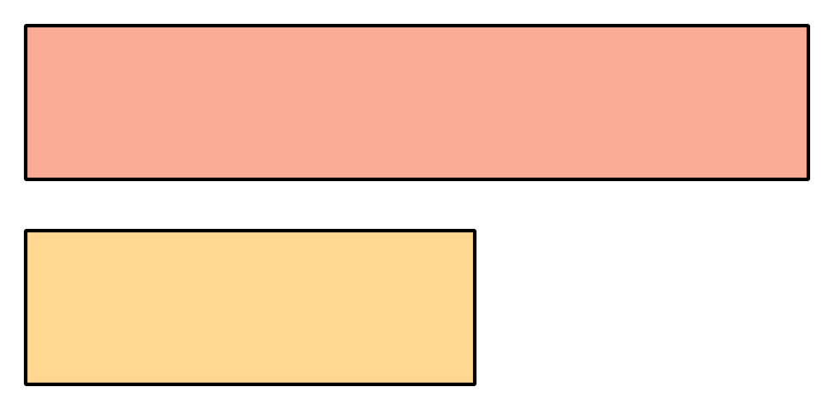

- 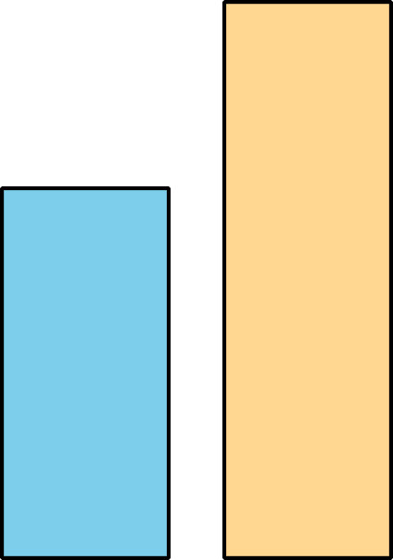

- 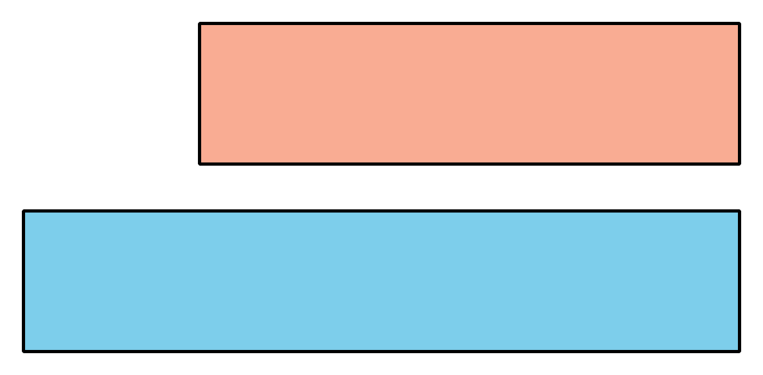

- 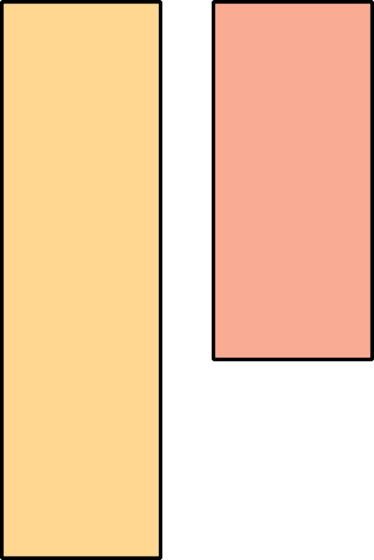

6.3: Centers: Choice Time
Choose a center.
Counting Collections
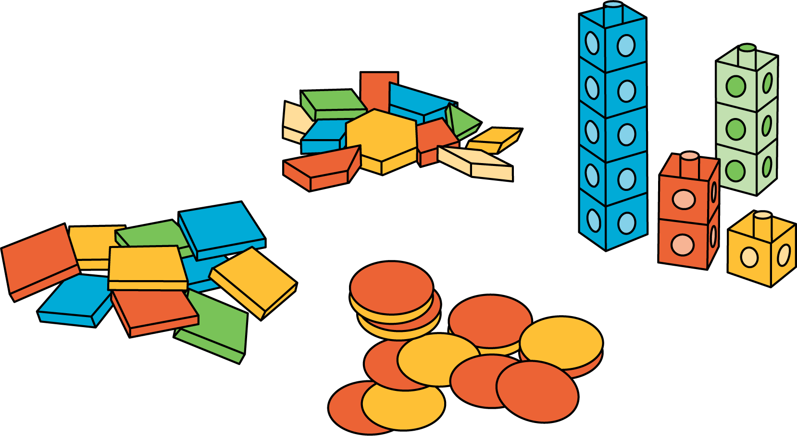
Which One
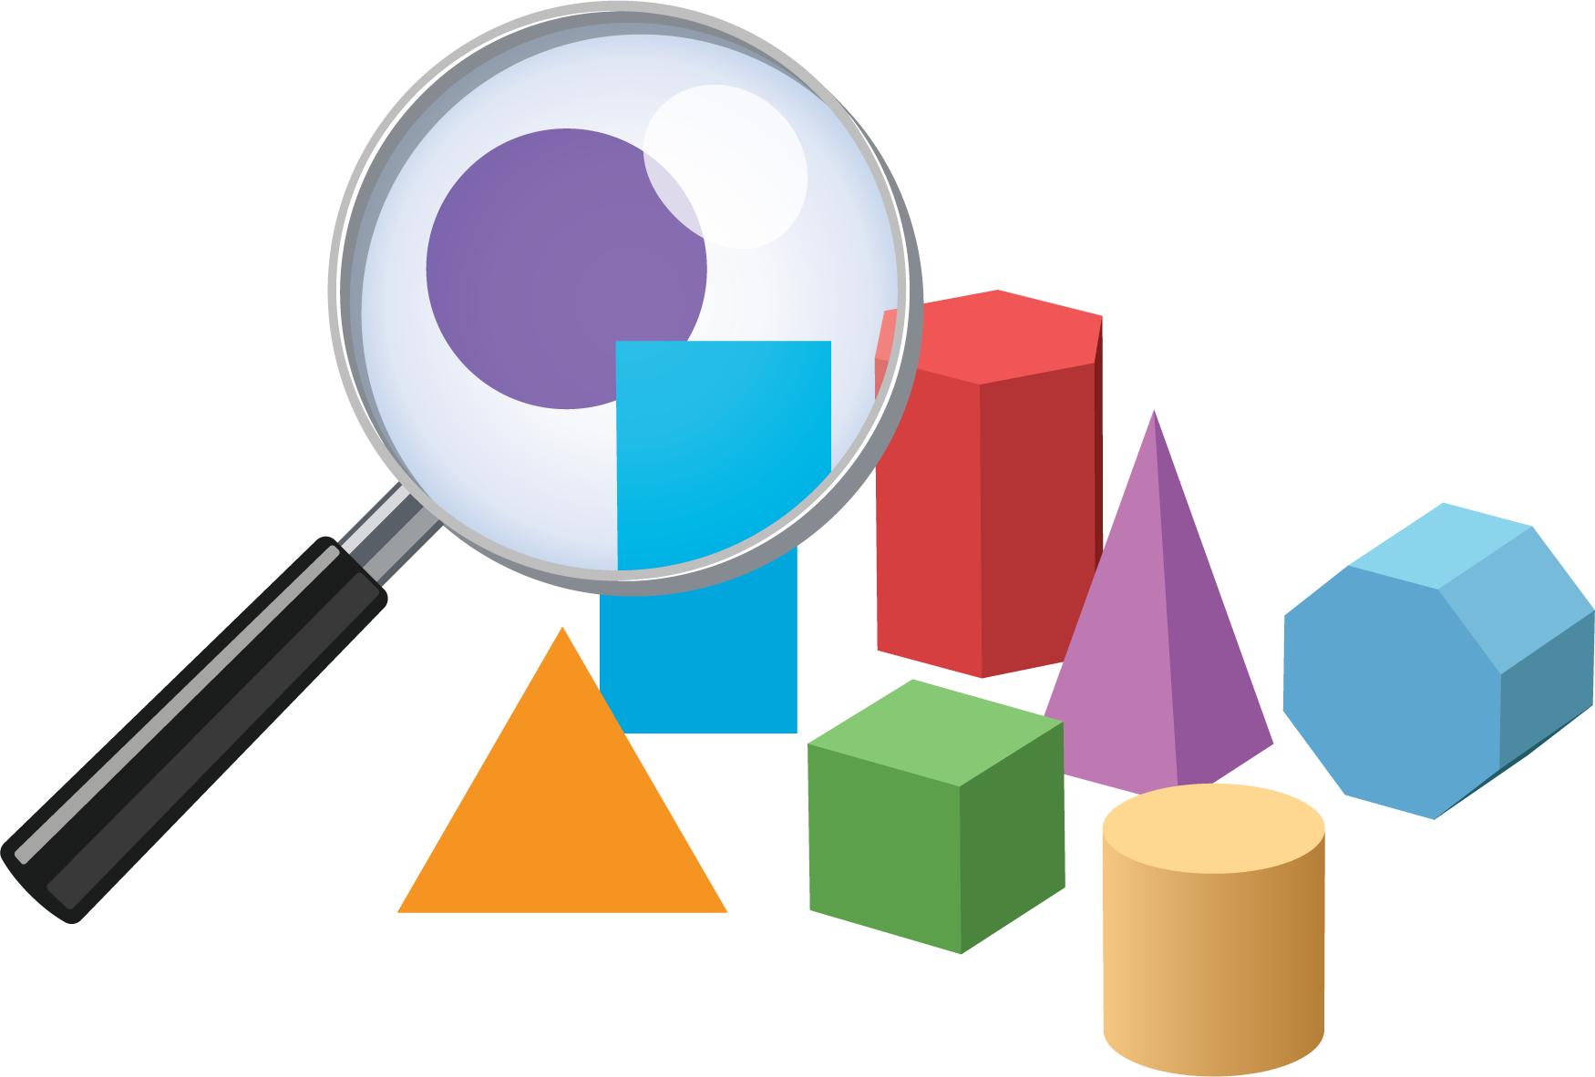
Picture Books
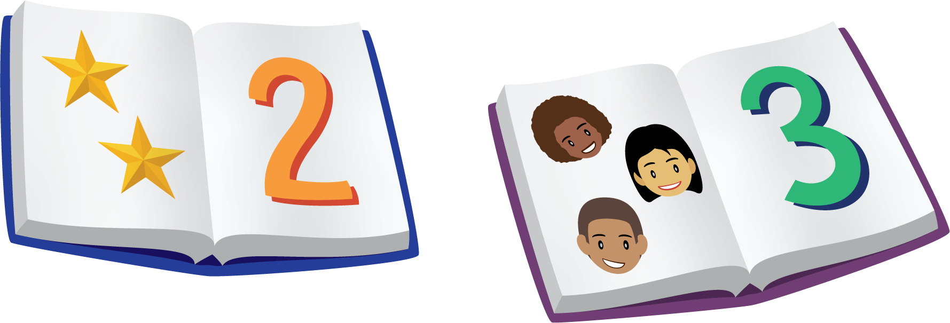
Bingo
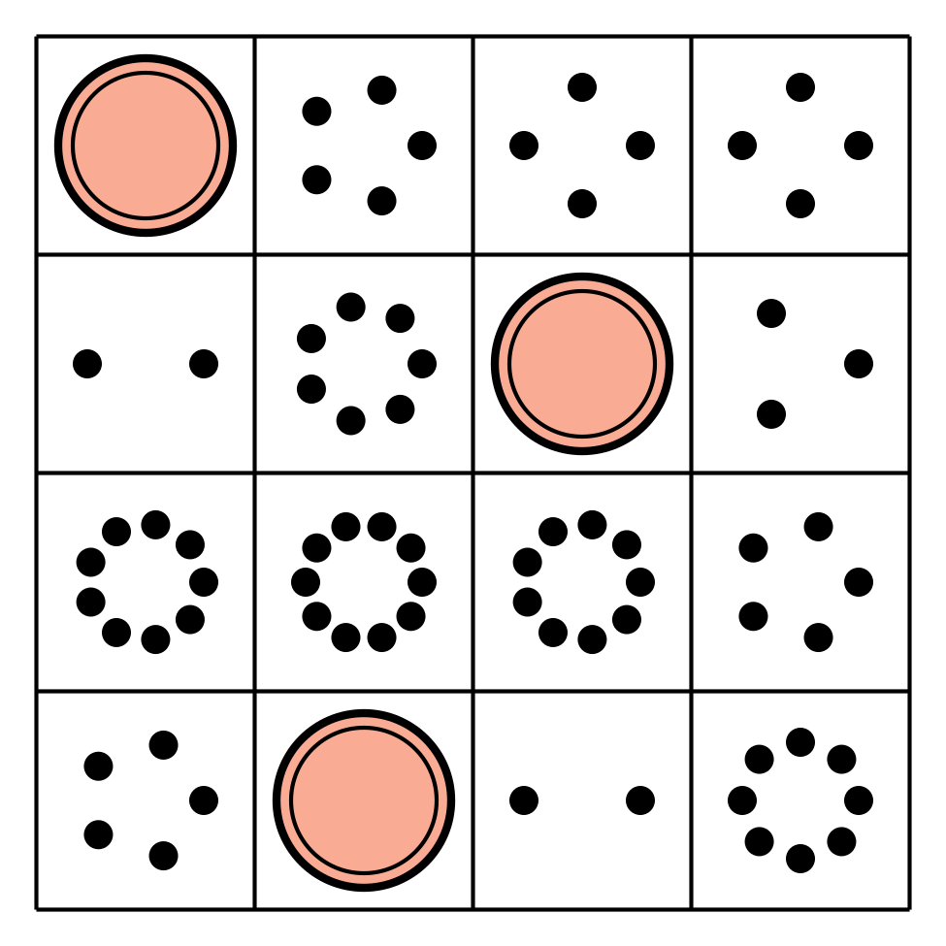
Shake and Spill

© CC BY 2021 Illustrative Mathematics®

