Unit 5 Lesson 5: Representing Exponential Decay

1 Two Other Tables (Warm up)

Student Task Statement
Use the patterns you notice to complete the tables. Show your reasoning.
Table A
$x$ | 0 | 1 | 2 | 3 | 4 | 25
$y$ | 2.5 | 10 | 17.5 | 25

Table B
$x$ | 0 | 1 | 2 | 3 | 4 | 25
$y$ | 2.5 | 10 | 40 | 160

2 The Algae Bloom

Student Task Statement
In order to control an algae bloom in a lake, scientists introduce some treatment products.
Once the treatment begins, the area covered by algae $A$, in square yards, is given by the equation $A=240⋅{\left(\frac{1}{3}\right)}^{t}$. Time, $t$, is measured in weeks.
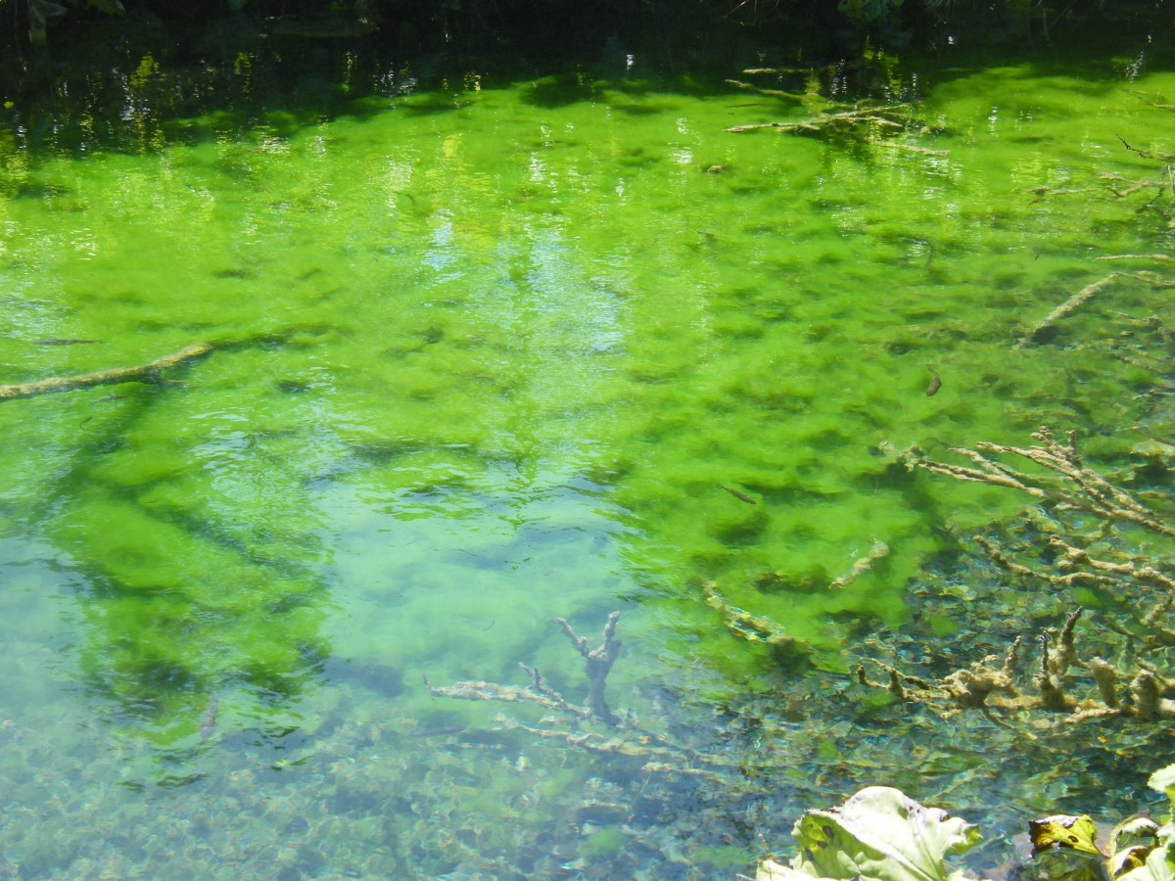
- In the equation, what does the 240 tell us about the algae? What does the $\frac{1}{3}$ tell us?
- Create a graph to represent $A=240⋅{\left(\frac{1}{3}\right)}^{t}$ when $t$ is 0, 1, 2, 3, and 4. Think carefully about how you choose the scale for the axes. If you get stuck, consider creating a table of values.
- 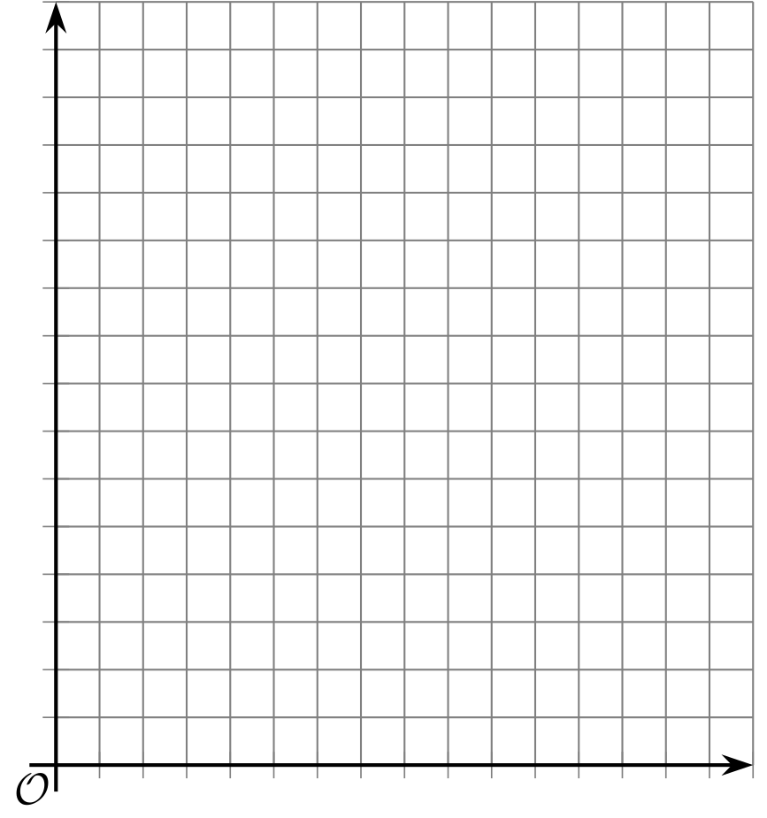
- About how many square yards will the algae cover after 2.5 weeks? Explain your reasoning.

3 Insulin in the Body

Student Task Statement
A patient who is diabetic receives 100 micrograms of insulin. The graph shows the amount of insulin, in micrograms, remaining in his bloodstream over time, in minutes.
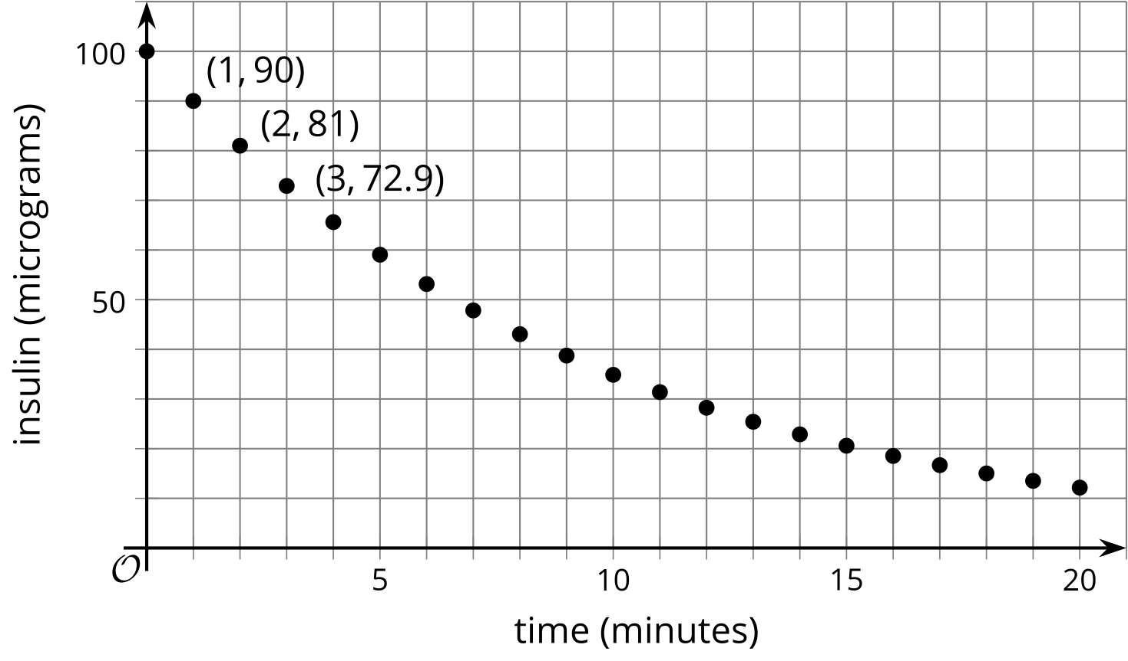
- Scientists have found that the amount of insulin in a patient’s body changes exponentially. How can you check if the graph supports the scientists’ claim?
- How much insulin broke down in the first minute? What fraction of the original insulin is that?
- How much insulin broke down in the second minute? What fraction is that of the amount one minute earlier?
- What fraction of insulin remains in the bloodstream for each minute that passes? Explain your reasoning.
- Complete the table to show the predicted amount of insulin 4 and 5 minutes after injection.
- time after injection (minutes) | - 0 | - 1 | - 2 | - 3 | - 4 | - 5
- insulin in the bloodstream (micrograms) | - 100 | - 90 | - 81 | - 72.9
- Describe how you would find how many micrograms of insulin remain in his bloodstream after 10 minutes. After $m$ minutes?

Images for Activity Synthesis
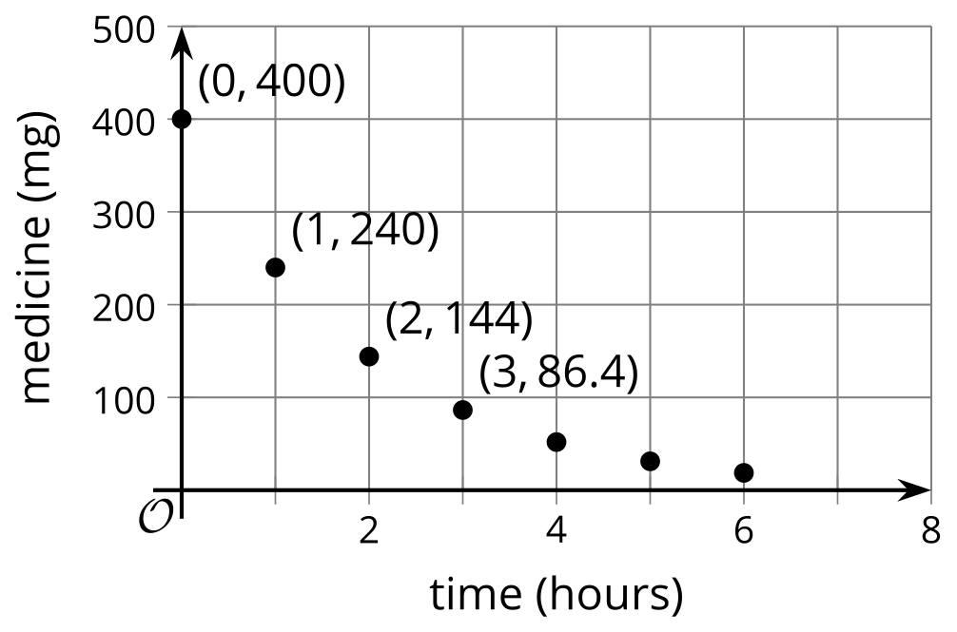
© CC BY 2019 by Illustrative Mathematics®

