Lesson 8: What is an Inch?

Standards Alignments
Addressing | 2.MD.A.1, 2.MD.A.3

Teacher-facing Learning Goals
- Define an inch as a unit of measure.
- Use a ruler to measure length in inches.

Student-facing Learning Goals
- Let’s measure in inches.

Lesson Purpose
The purpose of this lesson is for students to learn that an inch is a standard length unit in the U.S. customary system and use it to measure length.
In previous lessons, students learned the importance of using standard length units to measure and compare lengths. They learned about length units from the metric system and measured the length of objects in centimeters and meters with different tools, including rulers and meter sticks.
In this lesson, students learn that an inch is a standard unit of measure in the U.S. customary system. They use inch tiles or rulers to measure the length of classroom objects and the sides of geometric shapes in inches (MP2, MP5). Students use their tools and their measurements of classroom objects to develop a benchmark for the length of an inch, which will support them with estimating in later lessons.
Students need access to inch tiles and rulers throughout the lesson, including the cool-down.

Access for:

Students with Disabilities
- Representation (Activity 1)

English Learners
- MLR8 (Activity 2)

Instructional Routines
Notice and Wonder (Warm-up)

Materials to Gather
- Inch tiles: Activity 1, Activity 2
- Objects of various lengths: Activity 1
- Rulers (inches): Activity 1, Activity 2

Lesson Timeline
Warm-up | 10 min
Activity 1 | 25 min
Activity 2 | 10 min
Lesson Synthesis | 10 min
Cool-down | 5 min

Teacher Reflection Question
In Activity 2, students estimated the length of objects in inches. Did their previous work measuring and estimating with centimeters make working with a new length unit easier? How have you seen students making progress toward making more accurate estimates?

Cool-down
(to be completed at the end of the lesson) 5min
Measure a Rectangle

Standards Alignments
Addressing | 2.MD.A.1

Student-facing Task Statement
Measure the long and short sides of the rectangle in inches.
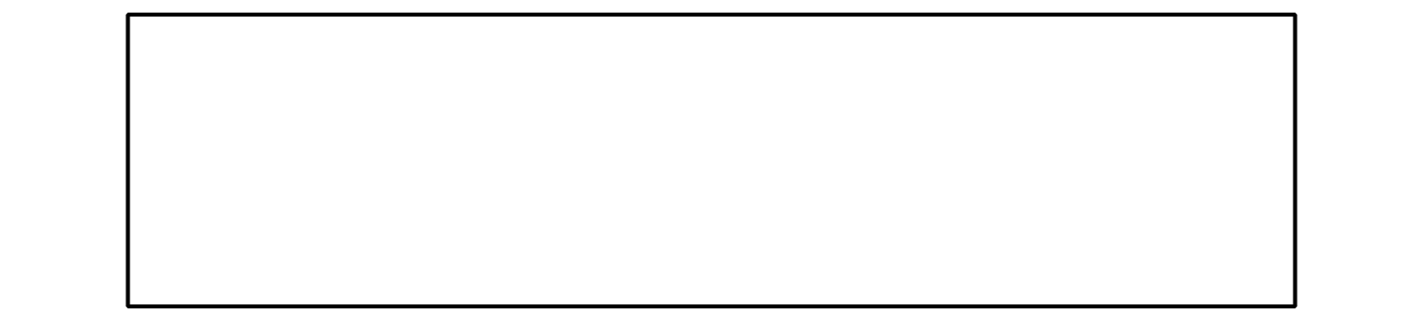
- Long side: ____________ in
- Short side: ____________ in

Student Responses
- 4
- 1

