Grade 2
Unit 4Lesson 12CC BY NC 2024 Illustrative Mathematics®
Unit 4, Lesson 12

Equations with Unknowns
- Let’s represent addition and subtraction with number lines and with equations using a ? for the unknown.
Grade 2
Unit 4Lesson 12CC BY NC 2024 Illustrative Mathematics®

Warm-upTrue or False: Making Tens
Decide if each statement is true or false. Be prepared to explain your reasoning.
- $40=10+27+3$
- $47=20+7+3+10$
- $60=3+47+10$
Grade 2
Unit 4Lesson 12CC BY NC 2024 Illustrative Mathematics®

Activity 1 Number Line Riddles
Solve each riddle to find the mystery number.
For each riddle:
- Write an equation that represents the riddle. Write a ? for the unknown.
- Represent the equation on the number line. Write the mystery number.
- I started at 15 and jumped 17 to the right. Where did I end?
- Equation: _______________________________
- Mystery number: _______________________
- I started at a number and jumped 20 to the left. I ended at 33. Where did I start?
- Equation: _______________________________
- Mystery number: _______________________
- I started at 42 and ended at 80. How far did I jump?
- Equation: _______________________________
- Mystery number: _______________________
- I started at 76 and jumped 27 to the left. Where did I end?
- Equation: _______________________________
- Mystery number: _______________________
- I started at a number and jumped 19 to the right. I ended at 67. Where did I start?
- Equation: _______________________________
- Mystery number: _______________________
- I started at 92 and ended at 33. How far did I jump?
- Equation: _______________________________
- Mystery number: _______________________
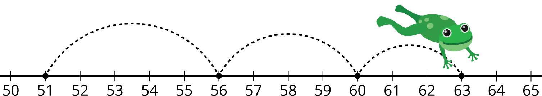
Grade 2
Unit 4Lesson 12CC BY NC 2024 Illustrative Mathematics®

Activity 2Make the Equations True
Find the number that makes each equation true.
Show your thinking using a number line.
- $?−48=19$
- $86−?=39$
- $?+57=72$
- $73+?=91$

