Algebra 1
Unit 2Lesson 11CC BY NC 2024 Illustrative Mathematics®
Unit 2, Lesson 11

Connecting Equations to Graphs (Part 2)
- Let's analyze different forms of linear equations and how the forms relate to their graphs.
Algebra 1
Unit 2Lesson 11CC BY NC 2024 Illustrative Mathematics®

11.1Rewrite These!
Rewrite each quotient as a sum or a difference.
- $\frac{4x−10}{2}$
- $\frac{1−50x}{\text{-}2}$
- $\frac{5\left(x+10\right)}{25}$
- $\frac{\text{-}\frac{1}{5}x+5}{2}$
Algebra 1
Unit 2Lesson 11CC BY NC 2024 Illustrative Mathematics®

11.2Graphs of Two Equations
Here are two graphs that represent situations you have seen in earlier activities.
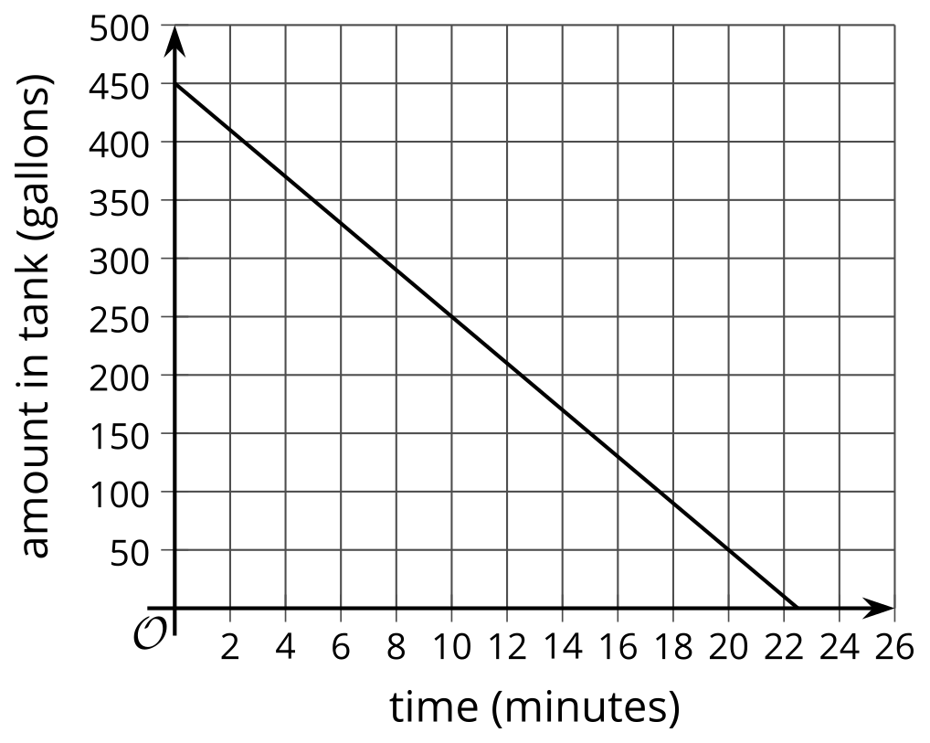
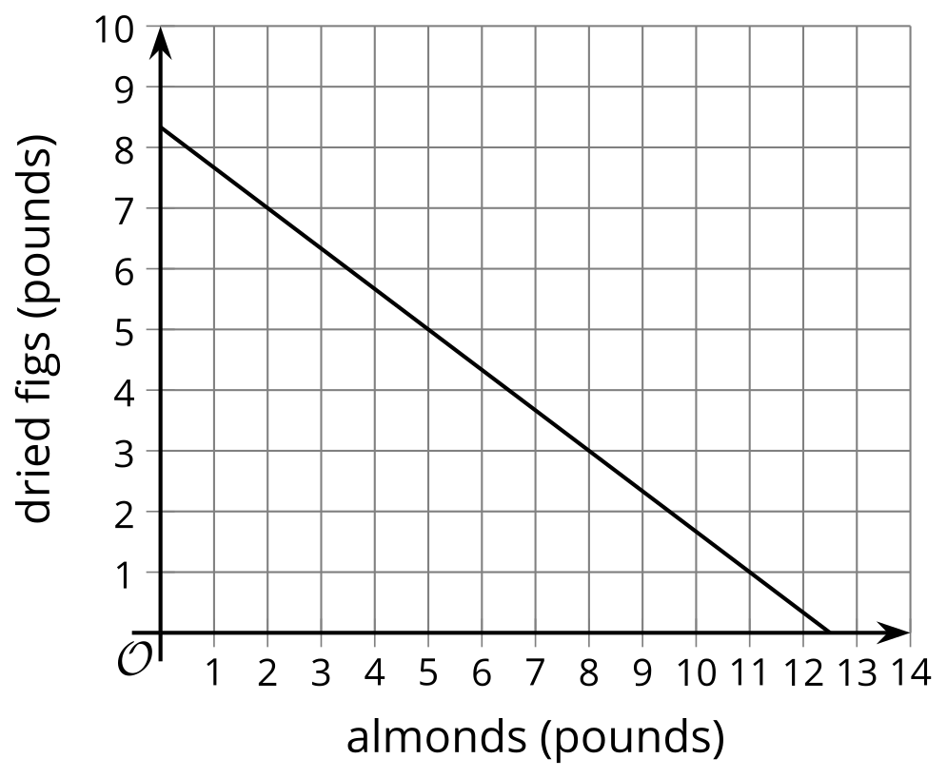
- The first graph represents $a=450−20t$, which describes the relationship between gallons of water in a tank and time in minutes.
  - Where on the graph can we see the 450? Where can we see the -20?
  - What do these numbers mean in this situation?
- The second graph represents $6x+9y=75$. It describes the relationship between pounds of almonds and figs and the dollar amount Clare spent on them.
- Suppose a classmate says, “I am not sure that the graph represents $6x+9y=75$ because I don’t see the 6, 9, or 75 on the graph.” How would you show your classmate that the graph indeed represents this equation?
Algebra 1
Unit 2Lesson 11CC BY NC 2024 Illustrative Mathematics®

11.3Slope Match
Match each of the equations with the slope $m$ and $y$-intercept of its graph.
- $\text{-}4x+3y=3$
- $12x−4y=8$
- $8x+2y=16$
- $\text{-}x+\frac{1}{3}y=\frac{1}{3}$
- $\text{-}4x+3y=\text{-}6$
A: $m=3$, $y\text{-int}=\left(0,1\right)$
B: $m=\frac{4}{3}$, $y\text{-int}=\left(0,1\right)$
C: $m=\frac{4}{3}$, $y\text{-int}=\left(0,\text{-}2\right)$
D: $m=\text{-}4$, $y\text{-int}=\left(0,8\right)$
E: $m=3$, $y\text{-int}=\left(0,\text{-}2\right)$

Are you ready for more?
Each equation in this activity is in the form $Ax+By=C$.
- For each equation, graph the equation and, on the same coordinate plane, graph the line passing through $\left(0,0\right)$ and $\left(A,B\right)$. What is true about each pair of lines?
- What are the coordinates of the $x$-intercept and $y$-intercept in terms of $A$, $B$, and $C$?

Lesson 11 Summary
Here are two situations and two equations that represent them.
Situation 1: Mai receives a $40 bus pass. Each school day, she spends $2.50 to travel to and from school.
Let $d$ be the number of school days since Mai receives a pass and $b$ be the balance or dollar amount remaining on the pass.
Situation 2: A student club is raising money by selling popcorn and iced tea. The club is charging $3 per bag of popcorn and $1.50 per cup of iced tea, and plans to make $60.
Let $p$ be the bags of popcorn sold and $t$ the cups of iced tea sold.
$b=40−2.50d$
$3p+1.50t=60$
Here are graphs of the equations. On each graph, the coordinates of some points are shown.
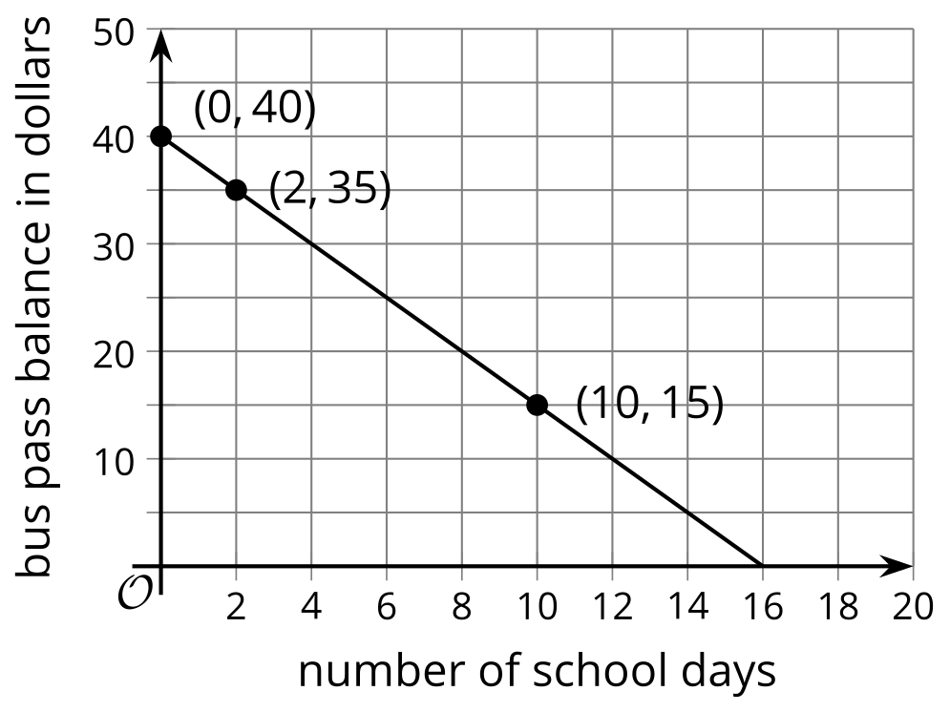
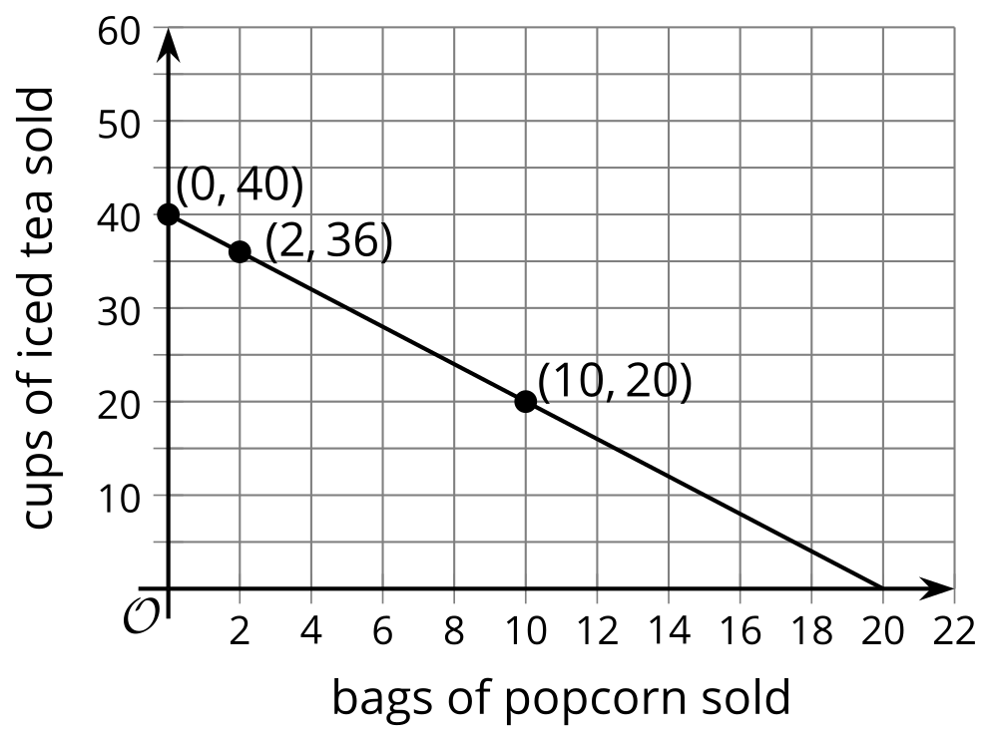
The 40 in the first equation can be observed on the graph and the -2.50 can be found with a quick calculation. The graph intersects the vertical axis at 40 and the -2.50 is the slope of the line. Every time $d$ increases by 1, $b$ decreases by 2.50. In other words, with each passing school day, the dollar amount in Mai's bus pass drops by 2.50.
The numbers in the second equation are not as apparent on the graph. The values where the line intersects the vertical and horizontal axes, 40 and 20, are not in the equation. We can, however, reason about where they come from.
- If $p$ is 0 (no popcorn is sold), the club would need to sell 40 cups of iced tea to make $60 because $40\left(1.50\right)=60$.
- If $t$ is 0 (no iced tea is sold), the club would need to sell 20 bags of popcorn to make $60 because $20\left(3\right)=60$.
What about the slope of the second graph? We can compute it from the graph, but it is not shown in the equation $3p+1.50t=60$.
Notice that in the first equation, the variable $b$ was isolated. Let’s rewrite the second equation and isolate $t$:
$\begin{matrix}3p+1.50t & =60 \\ 1.50t & =60−3p \\ t & =\frac{60−3p}{1.50} \\ t & =40−2p\end{matrix}$
Now the numbers in the equation can be more easily related to the graph: The 40 is where the graph intersects the vertical axis and the -2 is the slope. The slope tells us that as $p$ increases by 1, $t$ falls by 2. In other words, for every additional bag of popcorn sold, the club can sell 2 fewer cups of iced tea.

