Grade 6
Unit 1Lesson 2CC BY NC Illustrative Mathematics, based on IM 6–8 Math, CC BY Open Up Resources.
Unit 1, Lesson 2

Finding Area by Decomposing and Rearranging
Let’s create shapes and find their areas.
Grade 6
Unit 1Lesson 2CC BY NC Illustrative Mathematics, based on IM 6–8 Math, CC BY Open Up Resources.

2.1Notice and Wonder: Squares in Shapes
What do you notice? What do you wonder?
A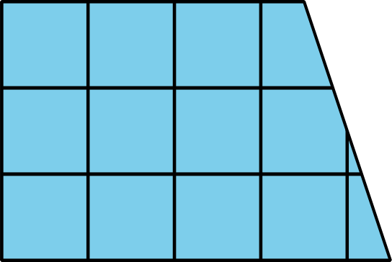
B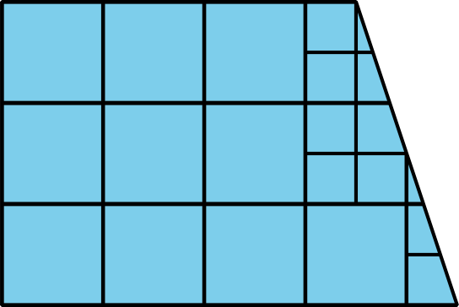
C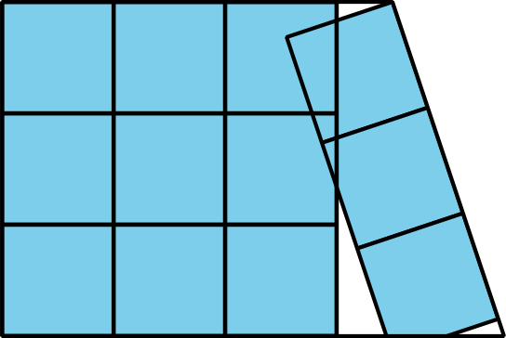
D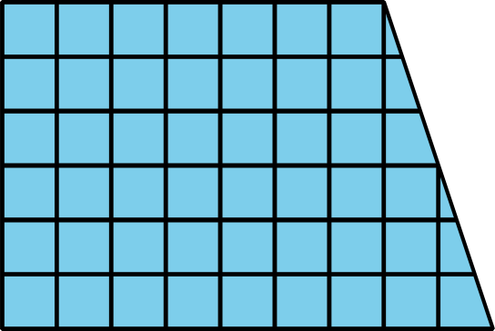
Grade 6
Unit 1Lesson 2CC BY NC Illustrative Mathematics, based on IM 6–8 Math, CC BY Open Up Resources.

2.2What Is Area?
You may recall that the term area tells us something about the number of squares inside a two-dimensional shape.
- Here are four drawings that each show squares inside a shape. Select all drawings whose squares could be used to find the area of the shape. Be prepared to explain your reasoning.
- A
- B
- C
- D
- Write a definition of “area” that includes all the information that you think is important.
Grade 6
Unit 1Lesson 2CC BY NC Illustrative Mathematics, based on IM 6–8 Math, CC BY Open Up Resources.

2.3Composing Shapes
Your teacher will give you 1 square and some small, medium, and large right triangles. The area of the square is 1 square unit.
- Notice that you can put together 2 small triangles to make a square. What is the area of the square composed of 2 small triangles? Be prepared to explain your reasoning.
- Use your shapes to create a new shape with an area of 1 square unit that is not a square. Trace your shape.
- Use your shapes to create a new shape with an area of 2 square units. Trace your shape.
- Use your shapes to create a different shape with an area of 2 square units. Trace your shape.
- Use your shapes to create a new shape with an area of 4 square units. Trace your shape.

Are you ready for more?
Find a way to use all of your pieces to compose a single large square. What is the area of this large square?
Grade 6
Unit 1Lesson 2CC BY NC Illustrative Mathematics, based on IM 6–8 Math, CC BY Open Up Resources.

2.4Tangram Triangles
Recall that the area of the square you saw earlier is 1 square unit. Complete each statement and explain your reasoning.
- The area of the small triangle is _________ square units. I know this because . . .
- The area of the medium triangle is _________ square units. I know this because . . .
- The area of the large triangle is _________ square units. I know this because . . .

Lesson 2 Summary
Here are two important principles for finding area:
- If two figures can be placed one on top of the other so that they match up exactly, then they have the same area.
- We can decompose a figure (break a figure into pieces) and rearrange the pieces (move the pieces around) to find its area.
Here are illustrations of the two principles.
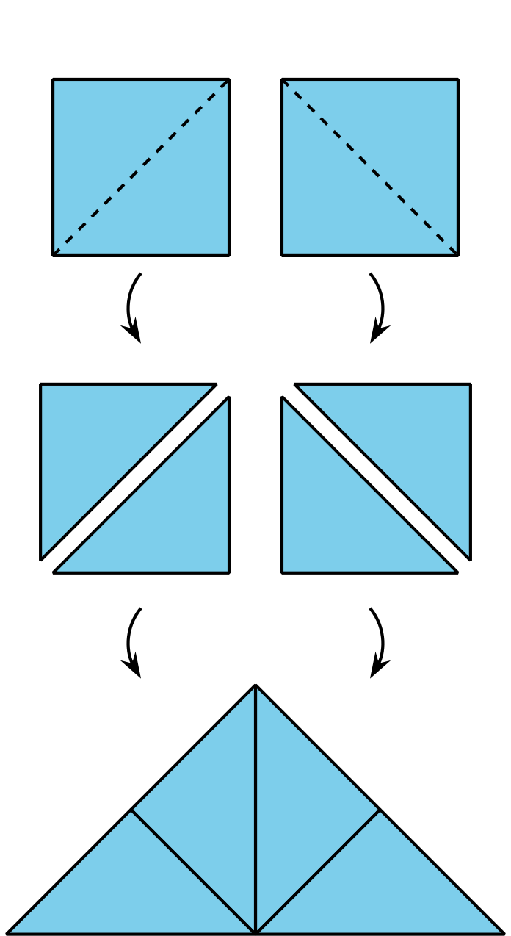
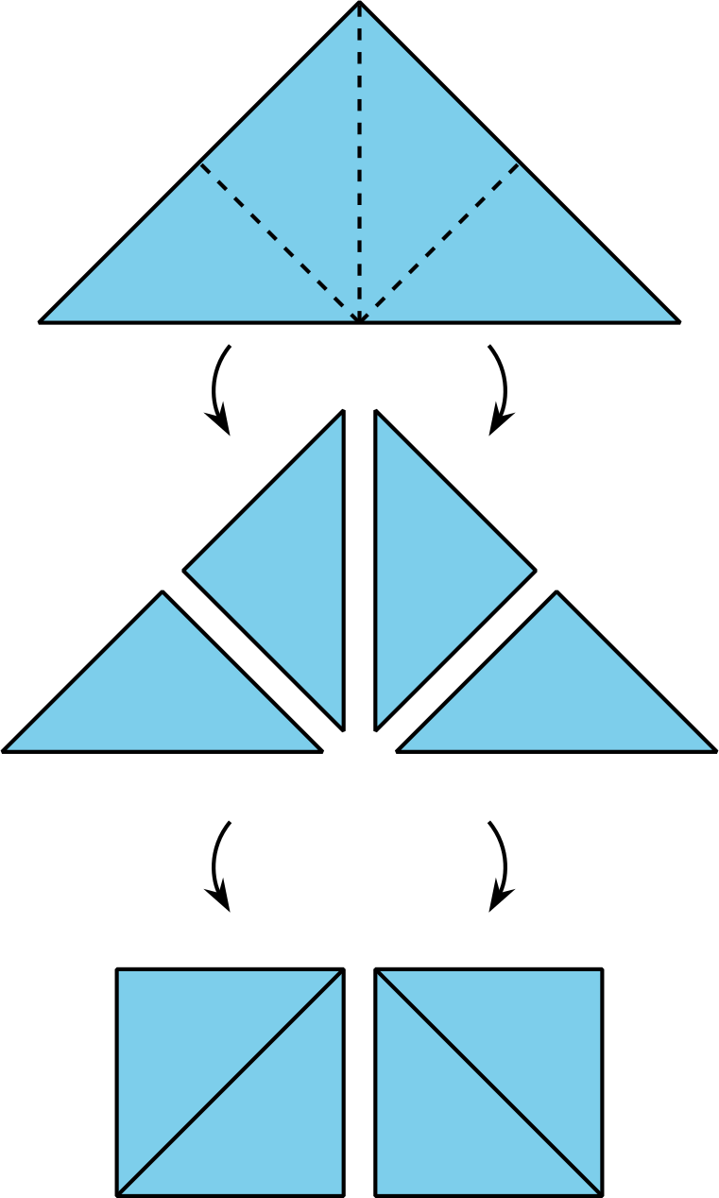
- Each square on the left can be decomposed into 2 triangles. These triangles can be rearranged into a large triangle. So, the large triangle has the same area as the 2 squares.
- Similarly, the large triangle on the right can be decomposed into 4 equal triangles. The triangles can be rearranged to form 2 squares. If each square has an area of 1 square unit, then the area of the large triangle is 2 square units. We also can say that each small triangle has an area of $\frac{1}{2}$ square unit.

