Grade 2
Unit 2Lesson 11CC BY NC 2024 Illustrative Mathematics®
Unit 2, Lesson 11

How Do You Solve Story Problems?
- Let’s solve story problems.
Grade 2
Unit 2Lesson 11CC BY NC 2024 Illustrative Mathematics®

Warm-upWhat Do You Know about Story Problems?
What do you know about story problems?
Grade 2
Unit 2Lesson 11CC BY NC 2024 Illustrative Mathematics®

Activity 1How Many Seeds?
- Diego gathers 42 orange seeds. Jada gathers 16 apple seeds. How many more seeds does Diego gather than Jada? Show your thinking using drawings, numbers, or words.
- 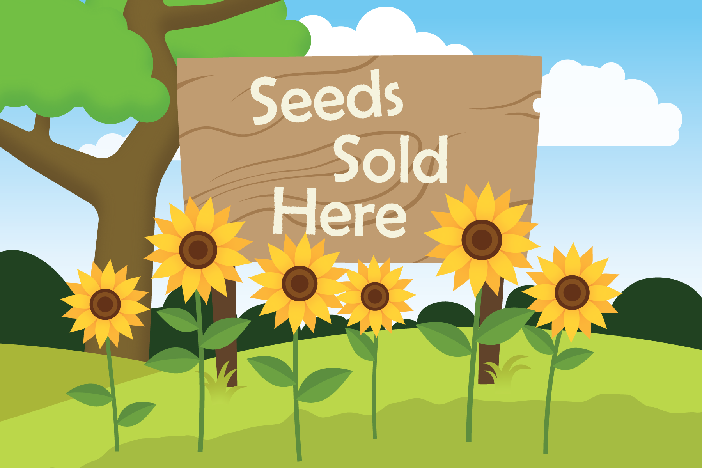
Grade 2
Unit 2Lesson 11CC BY NC 2024 Illustrative Mathematics®

Activity 2The Seeds of Greatness
Solve each story problem. Show your thinking using drawings, numbers, or words.
- Lin has 31 sunflower seeds. She gives 15 to Priya. How many seeds does Lin have now?
- Noah makes a design with yellow and blue corn seeds. He uses 37 seeds in all. He uses 28 yellow seeds. How many blue seeds does he use?
- Elena gathers 50 pumpkin seeds. Andre collects 23 fewer pumpkin seeds than her. How many seeds does Andre collect?

