Grade 2
Unit 1Lesson 17CC BY NC 2024 Illustrative Mathematics®
Unit 1, Lesson 17

Center Day 3
- Let’s count objects, play addition games, and create graphs.
Grade 2
Unit 1Lesson 17CC BY NC 2024 Illustrative Mathematics®

Warm-upNumber Talk: Add 10 More
Find the value of each sum mentally.
- $27+10$
- $27+10+10$
- $27+30$
- $37+30$
Grade 2
Unit 1Lesson 17CC BY NC 2024 Illustrative Mathematics®

Activity 2Centers: Choice Time
Choose a center.
What’s Behind My Back?
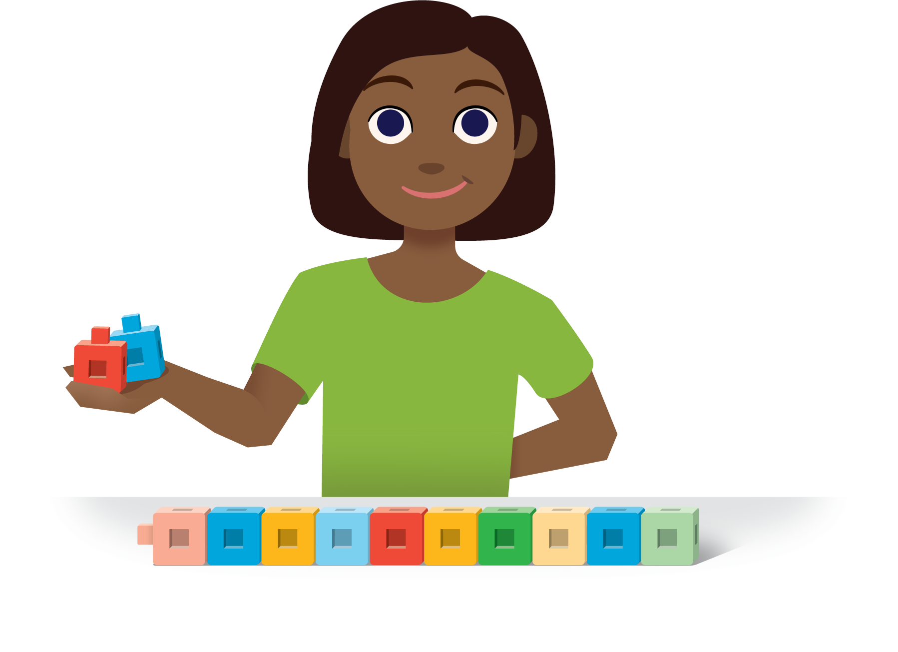
How Close?
Unable to process <img class="h-max-height--3-lines" src="/tikz_files/237760.svg">Failed: rsvg-convert --format png --dpi-x 300 --dpi-y 300 /app/tmp/svgtopng-1786380674.4204698.svg --output /app/tmp/svgtopng-1786380674.4204698.png Backtrace: /app/app/services/script/runner.rb:34:in `block in run_cmd' <internal:kernel>:90:in `tap' /app/app/services/script/runner.rb:32:in `run_cmd' /app/app/services/script/svg_to_png.rb:27:in `convert_svg_to_png' /app/app/services/script/svg_to_png.rb:17:in `to_png' /app/vendor/bundle/ruby/3.3.0/gems/embeddable_content-1.1.0/app/services/embeddable_content/images/image_downloader.rb:37:in `png_rendered_from_svg' /app/vendor/bundle/ruby/3.3.0/gems/embeddable_content-1.1.0/app/services/embeddable_content/images/image_downloader.rb:33:in `raw_image_data' /app/vendor/bundle/ruby/3.3.0/gems/embeddable_content-1.1.0/app/services/embeddable_content/images/image_downloader.rb:13:in `block in save' <internal:kernel>:90:in `tap' /app/vendor/bundle/ruby/3.3.0/gems/embeddable_content-1.1.0/app/services/embeddable_content/images/image_downloader.rb:13:in `save'
Number Puzzles
Unable to process <img class="h-max-height--2-lines" src="/tikz_files/237761.svg">Failed: rsvg-convert --format png --dpi-x 300 --dpi-y 300 /app/tmp/svgtopng-1786380674.4617622.svg --output /app/tmp/svgtopng-1786380674.4617622.png Backtrace: /app/app/services/script/runner.rb:34:in `block in run_cmd' <internal:kernel>:90:in `tap' /app/app/services/script/runner.rb:32:in `run_cmd' /app/app/services/script/svg_to_png.rb:27:in `convert_svg_to_png' /app/app/services/script/svg_to_png.rb:17:in `to_png' /app/vendor/bundle/ruby/3.3.0/gems/embeddable_content-1.1.0/app/services/embeddable_content/images/image_downloader.rb:37:in `png_rendered_from_svg' /app/vendor/bundle/ruby/3.3.0/gems/embeddable_content-1.1.0/app/services/embeddable_content/images/image_downloader.rb:33:in `raw_image_data' /app/vendor/bundle/ruby/3.3.0/gems/embeddable_content-1.1.0/app/services/embeddable_content/images/image_downloader.rb:13:in `block in save' <internal:kernel>:90:in `tap' /app/vendor/bundle/ruby/3.3.0/gems/embeddable_content-1.1.0/app/services/embeddable_content/images/image_downloader.rb:13:in `save'
Sort and Display


