Grade 6
Unit 9Lesson 9CC BY NC Illustrative Mathematics, based on IM 6–8 Math, CC BY Open Up Resources.
Unit 9, Lesson 9

Designing Districts
Let's design districts.
Grade 6
Unit 9Lesson 9CC BY NC Illustrative Mathematics, based on IM 6–8 Math, CC BY Open Up Resources.

9.1School Mascot (Part 2)
After the school mascot voting, the whole town gets interested in choosing a mascot. The mayor of the town decides to choose representatives to vote.
There are 50 blocks in the town, and the people on each block tend to have the same opinion about which mascot is best. Green blocks like sea lions, and gold blocks like banana slugs. The mayor decides to have 5 representatives, each representing a district of 10 blocks.
Here is a map of the town, with preferences shown.

- Suppose there were an election with each of the 50 blocks getting one vote. How many votes would be for banana slugs? For sea lions? Which mascot would win this election and what percentage of the votes would they get?
- Suppose the blocks are in districts 1–5, as shown here. What did the people in each district prefer? What did their representative vote? Which mascot would win the election?
- 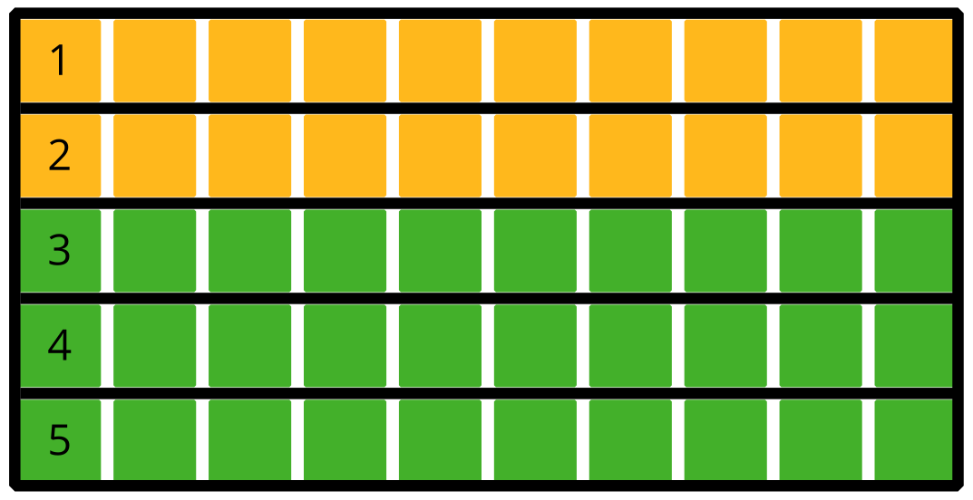
- Complete the table with this election’s results.
- district | - number of blocks for banana slugs | - number of blocks for sea lions | - percentage of blocks for banana slugs | - representative’s vote
- 1 | - 10 | - 0 |  | - banana slugs
- 2
- 3
- 4
- 5
- Suppose, instead, that the 5 districts are as shown in this new map. What did the people in each district prefer? What did their representative vote? Which mascot would win the election?
- 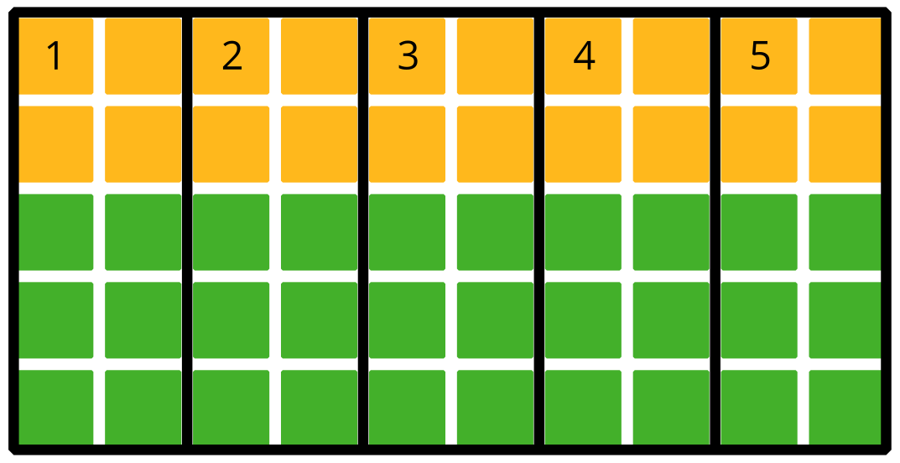
- Complete the table with this election’s results.
- district | - number of blocks for banana slugs | - number of blocks for sea lions | - percentage of blocks for banana slugs | - representative’s vote
- 1
- 2
- 3
- 4
- 5
- Suppose the 5 districts are designed in yet another way, as shown in this map. What did the people in each district prefer? What did their representative vote? Which mascot would win the election?
- 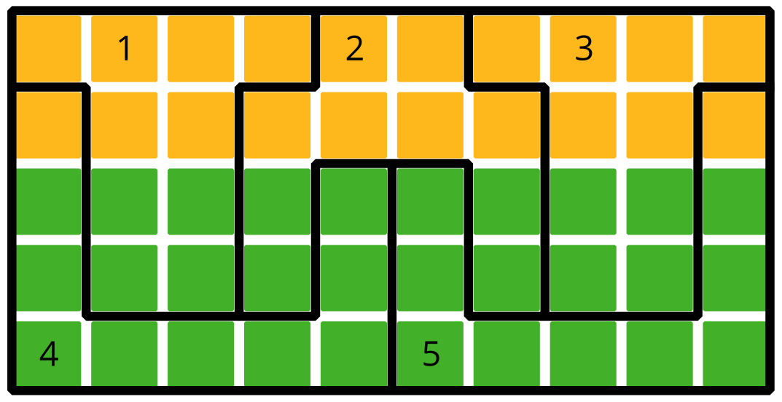
- Complete the table with this election’s results.
- district | - number of blocks for banana slugs | - number of blocks for sea lions | - percentage of blocks for banana slugs | - representative’s vote
- 1
- 2
- 3
- 4
- 5
- Write a headline for the local newspaper for each of the ways of splitting the town into districts.
- Which systems of the three maps of districts do you think are more fair? Are any totally unfair?
Grade 6
Unit 9Lesson 9CC BY NC Illustrative Mathematics, based on IM 6–8 Math, CC BY Open Up Resources.

9.2Fair and Unfair Districts
- Smallville’s map is shown, with opinions shown by block in green and gold. Decompose the map to create three connected, equal-area districts in two ways:
  - Design three districts in which green will win at least two of the three districts. Record results in Table 1.
  - 
  - Table 1:
- district | - number of blocks for green | - number of blocks for gold | - percentage of blocks for green | - representative’s vote
  - 1
  - 2
  - 3
  - Design three districts in which gold will win at least two of the three districts. Record results in Table 2.
  - Table 2:
- district | - number of blocks for green | - number of blocks for gold | - percentage of blocks for green | - representative’s vote
  - 1
  - 2
  - 3
- Squaretown’s map is shown, with opinions by block shown in green and gold. Decompose the map to create five connected, equal-area districts in two ways:
  - Design five districts in which green will win at least three of the five districts. Record the results in Table 3.
  - 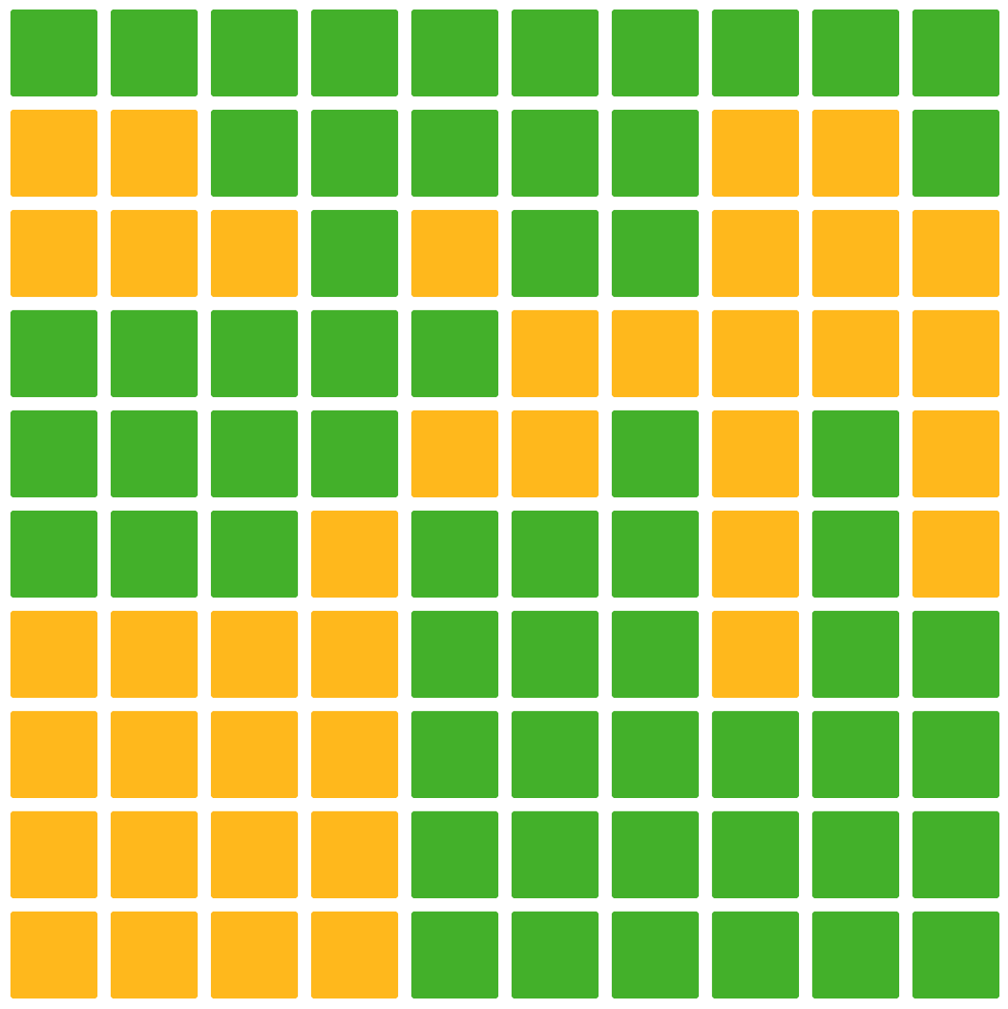
  - Table 3:
- district | - number of blocks for green | - number of blocks for gold | - percentage of blocks for green | - representative’s vote
  - 1
  - 2
  - 3
  - 4
  - 5
  - Design five districts in which gold will win at least three of the five districts. Record the results in Table 4.
  - Table 4:
- district | - number of blocks for green | - number of blocks for gold | - percentage of blocks for green | - representative’s vote
  - 1
  - 2
  - 3
  - 4
  - 5
- Mountain Valley’s map is shown, with opinions by block shown in green and gold. (This is a town in a narrow valley in the mountains.) Decompose the map to create 3 connected, equal-area districts in 2 ways.
  - Design three districts in which green will win at least 2 of the 3 districts. Record the results in Table 5.
  - 
  - Table 5:
- district | - number of blocks for green | - number of blocks for gold | - percentage of blocks for green | - representative’s vote
  - 1
  - 2
  - 3
  - Design three districts in which gold will win at least 2 of the 3 districts. Record the results in Table 6.
  - Table 6:
- district | - number of blocks for green | - number of blocks for gold | - percentage of blocks for green | - representative’s vote
  - 1
  - 2
  - 3

