Unit 5 Lesson 19: Which One Changes Faster?

1 Graph of Which Function? (Warm up)

Student Task Statement
Here is a graph.
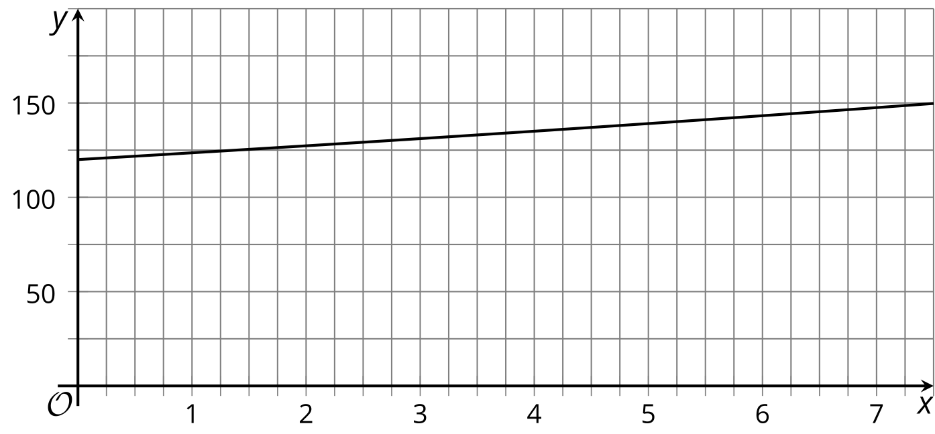
- Which equation do you think the graph represents? Use the graph to support your reasoning.
  - $y=120+\left(3.7\right)⋅x$
  - $y=120⋅{\left(1.03\right)}^{x}$
- What information might help you decide more easily whether the graph represents a linear or an exponential function?

Activity Synthesis
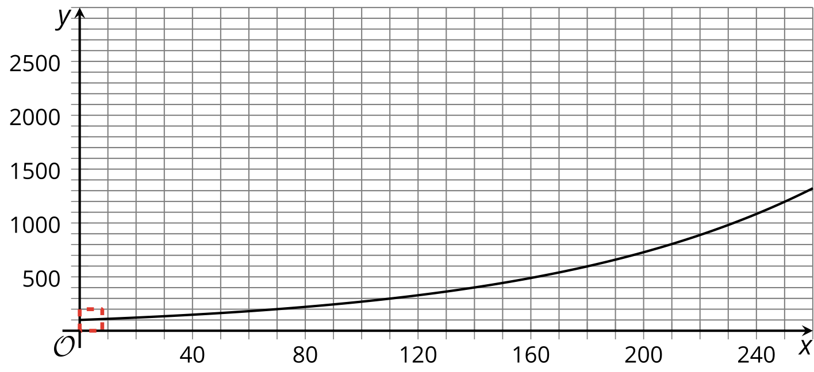

2 Simple and Compound Interests

Student Task Statement
A family has $1,000 to invest and is considering two options: investing in government bonds that offer 2% simple interest, or investing in a savings account at a bank, which charges a $20 fee to open an account and pays 2% compound interest. Both options pay interest annually.
Here are two tables showing what they would earn in the first couple of years if they do not invest additional amounts or withdraw any money.
Bonds
years of investment | amount in dollars
0 | $1,000
1 | $1,020
2 | $1,040
Savings Account
years of investment | amount in dollars
0 | $980
1 | $999.60
2 | $1,019.59
- Bonds: How does the investment grow with simple interest?
- Savings account: How are the amounts $999.60 and $1,019.59 calculated?
- For each option, write an equation to represent the relationship between the amount of money and the number of years of investment.
- Which investment option should the family choose? Use your equations or calculations to support your answer.
- Use graphing technology to graph the two investment options and show how the money grows in each.

3 Reaching 2,000

Student Task Statement
- Complete the table of values for the functions $f$ and $g$.
- $x$ | - $f\left(x\right)$ | - $g\left(x\right)$
- 1
- 10
- 50
- 100
- 500
- Based on the table of values, which function do you think grows faster? Explain your reasoning.
- Which function do you think will reach a value of 2,000 first? Show your reasoning. If you get stuck, consider increasing $x$ by 100 a few times and record the function values in the table.
© CC BY 2019 by Illustrative Mathematics®

