Grade 2
Unit 9Lesson 3CC BY NC 2024 Illustrative Mathematics®
Unit 9, Lesson 3

Measure on a Map
- Let’s add and subtract length measurements.
Grade 2
Unit 9Lesson 3CC BY NC 2024 Illustrative Mathematics®

Warm-up Notice and Wonder: From Sea to Shining Sea
What do you notice? What do you wonder?
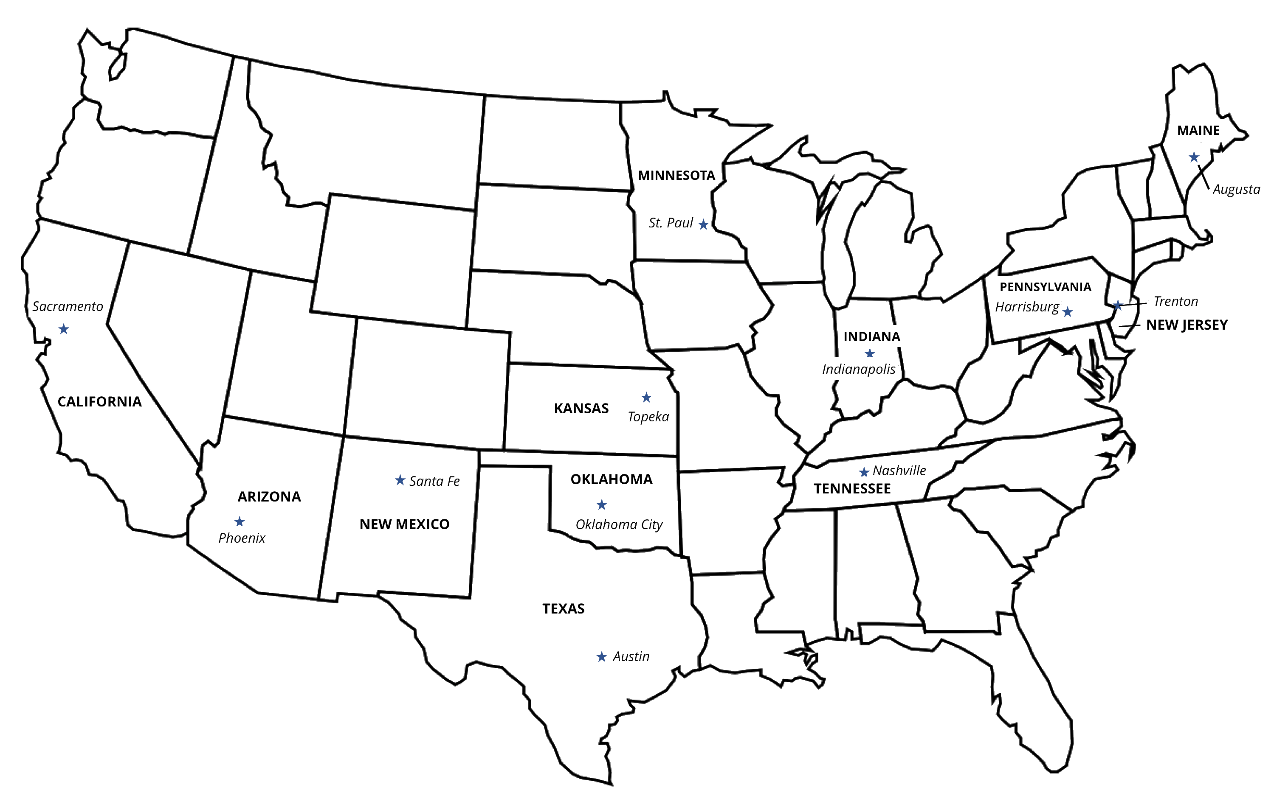
Grade 2
Unit 9Lesson 3CC BY NC 2024 Illustrative Mathematics®

Activity 1 Measure on the Map
Draw 3 lines on the map to show each trip. Each line should connect 2 cities. Measure the length of each line in centimeters.
- Noah’s Trip
  - Trenton, New Jersey, to Harrisburg, Pennsylvania: _____ cm
  - Harrisburg to Indianapolis, Indiana: _____ cm
  - Indianapolis to St. Paul, Minnesota: _____ cm
- Diego’s Trip
  - Sacramento, California, to Phoenix, Arizona: _____ cm
  - Phoenix to Santa Fe, New Mexico: _____ cm
  - Santa Fe to Topeka, Kansas: _____ cm
- Lin’s Trip
  - Austin, Texas, to Oklahoma City, Oklahoma: _____ cm
  - Oklahoma City to Nashville, Tennessee: _____ cm
  - Nashville to Augusta, Maine: _____ cm
- Find the total length of the 3 lines for each trip. Represent the total with an equation.
  - Lin’s total
  - Diego’s total
  - Noah’s total
Grade 2
Unit 9Lesson 3CC BY NC 2024 Illustrative Mathematics®

Activity 2 How Much Longer?
Use your total line lengths from the first activity. Represent each question with an equation. Use a ? for the unknown length. Then find the unknown length.
- How much shorter is Diego’s total than Lin’s?
- How much longer is Diego’s total than Noah’s?
- How much shorter is Noah’s total than Lin’s?

