Grade 6
Unit 2Lesson 10CC BY NC Illustrative Mathematics, based on IM 6–8 Math, CC BY Open Up Resources.
Unit 2, Lesson 10

Comparing Situations by Examining Ratios
Let’s use ratios to compare situations.
Grade 6
Unit 2Lesson 10CC BY NC Illustrative Mathematics, based on IM 6–8 Math, CC BY Open Up Resources.

10.1Notice and Wonder: Treadmill Displays
What do you notice? What do you wonder?
Mai's Treadmill Display
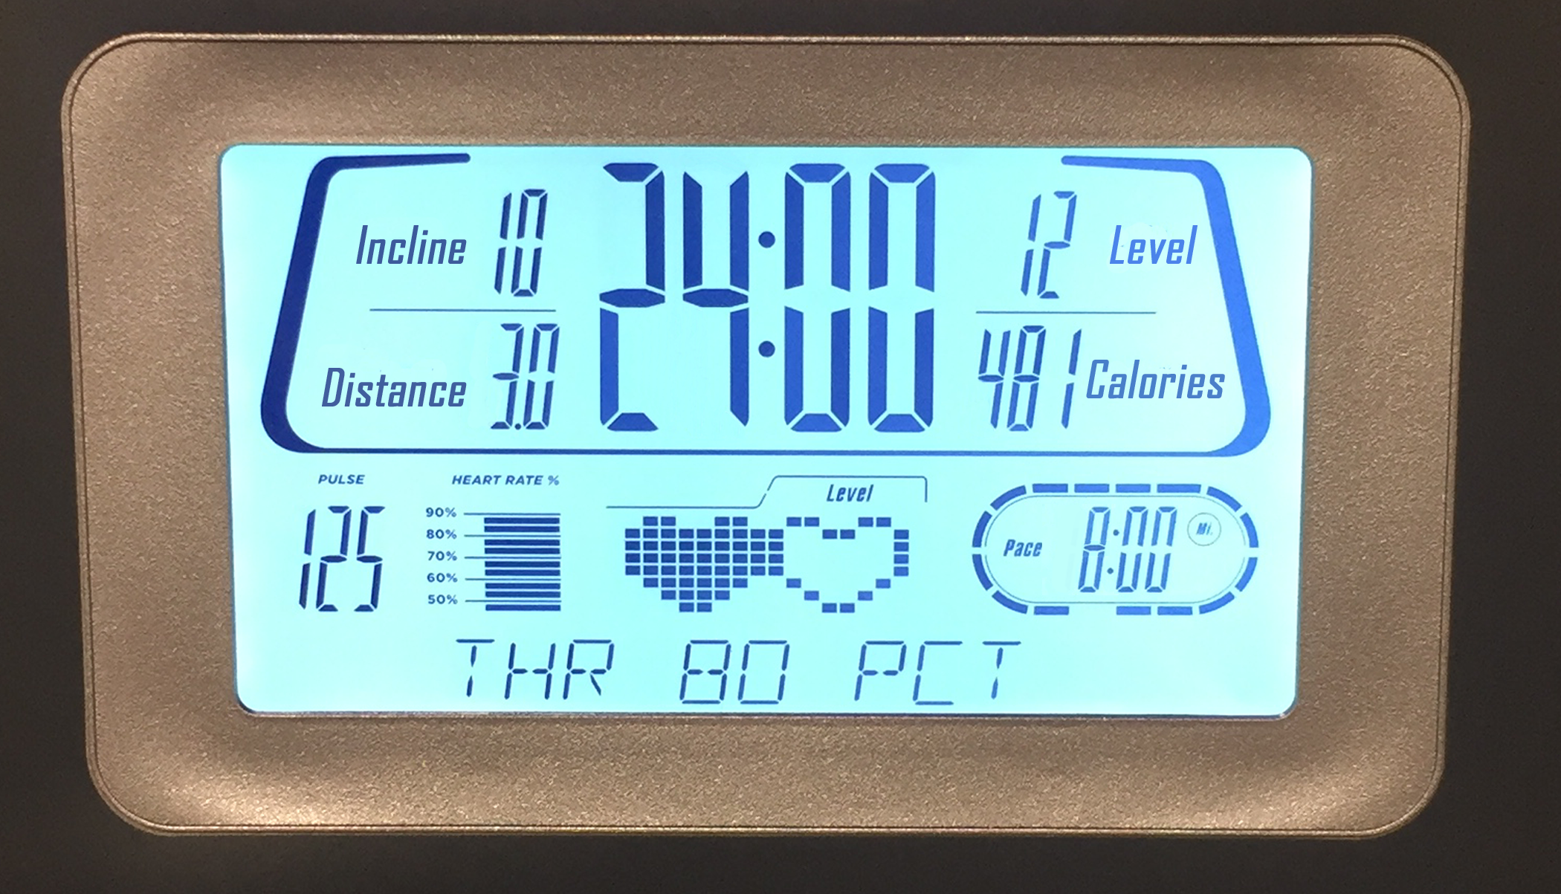
Jada’s Treadmill Display
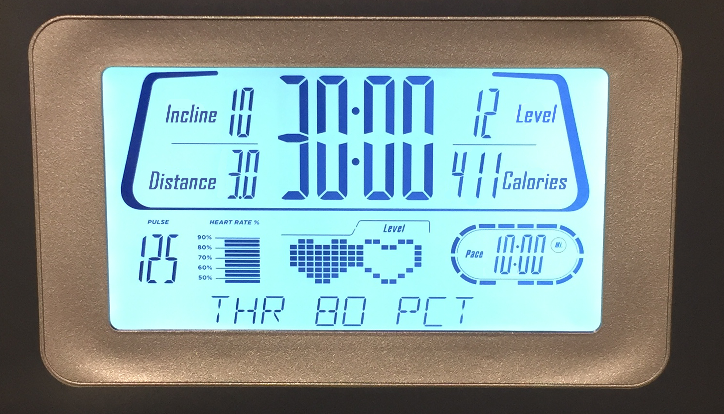
Grade 6
Unit 2Lesson 10CC BY NC Illustrative Mathematics, based on IM 6–8 Math, CC BY Open Up Resources.

10.2How Do They Compare?
- Mai and Jada ran on treadmills. Each person ran at a constant rate. Mai ran 3 miles in 24 minutes. Jada ran 3 miles in 30 minutes.
- Who was running faster? Explain or show your reasoning.
- Han and Tyler also ran on treadmills. Han ran 3.5 kilometers in 15 minutes. Tyler ran 7 kilometers in 30 minutes. Each person ran at a constant rate.
- Were Han and Tyler running at the same rate? Explain or show your reasoning.
Grade 6
Unit 2Lesson 10CC BY NC Illustrative Mathematics, based on IM 6–8 Math, CC BY Open Up Resources.

10.3Concert Tickets
Diego paid $47 for 3 tickets to a concert. Andre paid $141 for 9 tickets to a concert. Did they pay at the same rate? Explain or show your reasoning.
Grade 6
Unit 2Lesson 10CC BY NC Illustrative Mathematics, based on IM 6–8 Math, CC BY Open Up Resources.

10.4Sparkling Orange Juice
Lin and Noah each have their own recipe for making sparkling orange juice.
- Lin mixes 3 liters of orange juice with 4 liters of soda water.
- Noah mixes 4 liters of orange juice with 5 liters of soda water.
How do the two mixtures compare in taste? Explain your reasoning.

Are you ready for more?
- How can Lin make her sparkling orange juice taste the same as Noah’s just by adding more of one ingredient? How much will she need?
- How can Noah make his sparkling orange juice taste the same as Lin’s just by adding more of one ingredient? How much will he need?

Lesson 10 Summary
When we talk about two things happening at the same rate, we mean that the ratios of the quantities in the two situations are equivalent. There is also something specific about the situation that is the same.
- If two ladybugs are moving at the same rate, then they are traveling at the same constant speed.
- If two bags of apples are selling for the same rate, then they have the same unit price.
- If we mix two kinds of juice at the same rate, then the mixtures have the same taste.
- If we mix two colors of paint at the same rate, then the mixtures have the same shade.
For example, do these two paint mixtures make the same shade of orange?
- Kiran mixes 9 teaspoons of red paint with 15 teaspoons of yellow paint.
- Tyler mixes 7 teaspoons of red paint with 10 teaspoons of yellow paint.
To know if the two ratios describe the same rate, we can write an equivalent ratio for one or both ratios so that one quantity has the same value. Then we can compare the values for the other quantity.
Here is a double number line that represents Kiran's paint mixture. The ratio $9:15$ is equivalent to the ratios $3:5$ and $6:10$.
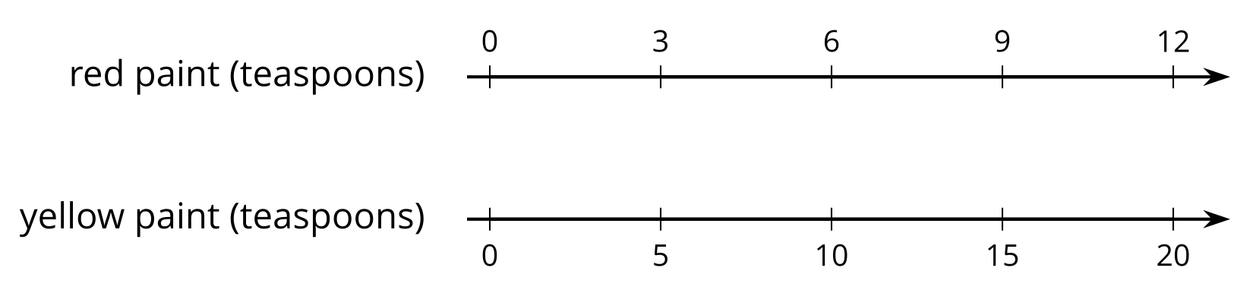
For 10 teaspoons of yellow paint, Kiran would mix in 6 teaspoons of red paint. This is less red paint than Tyler mixes with 10 teaspoons of yellow paint. The ratios $6:10$ and $7:10$ are not equivalent, so these two paint mixtures would not be the same shade of orange.

