Lesson 1 Practice Problems

  - A whale is at the surface of the ocean to breathe. What is the whale’s elevation?
  - The whale swims down 300 feet to feed. What is the whale’s elevation now?
  - The whale swims down 150 more feet more. What is the whale’s elevation now?
  - Plot each of the three elevations as a point on a vertical number line. Label each point with its numeric value.

  - A fish is 12 meters below the surface of the ocean. What is its elevation?
  - A sea bird is 28 meters above the surface of the ocean. What is its elevation?
  - If the bird is directly above the fish, how far apart are they?

  - Represent each of these temperatures in degrees Fahrenheit with a positive or negative number.
    - 5 degrees above zero
    - 3 degrees below zero
    - 6 degrees above zero
    - $2\frac{3}{4}$ degrees below zero
  - Order the temperatures above from the coldest to the warmest.
- It was $\text{-}5^{∘}\text{C}$ in Copenhagen and $\text{-}{12}^{∘}\text{C}$ in Oslo. Which city was colder?
- Han wants to buy a $30 ticket to a game, but the pre-order tickets are sold out. He knows there will be more tickets sold the day of the game, with a markup of 200%. How much should Han expect to pay for the ticket if he buys it the day of the game?
- (From Unit 6, Lesson 4.)
- Two students are both working on the same problem: A box of laundry soap has 25% more soap in its new box. The new box holds 2 kg. How much soap did the old box hold?
  - Here is how Jada set up her double number line.
  - 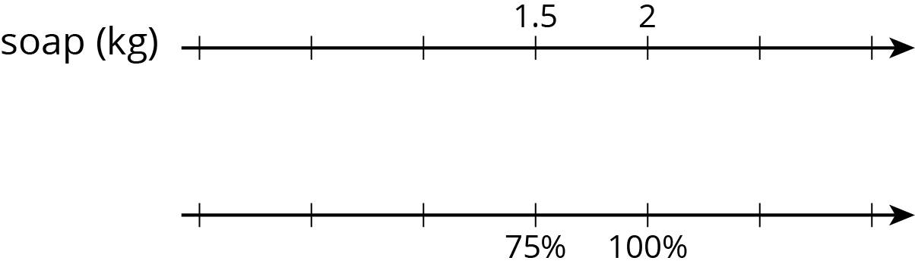
  - Here is how Lin set up her double number line.
  - 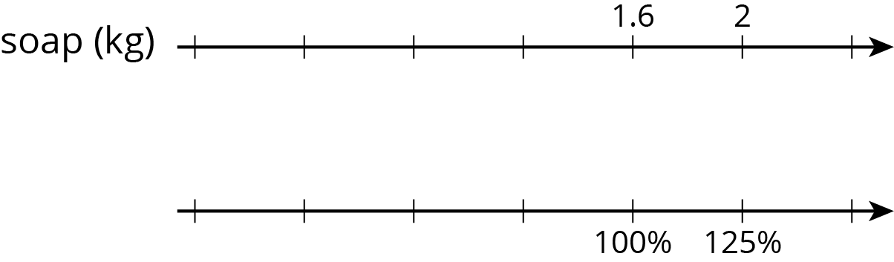
- Do you agree with either of them? Explain or show your reasoning.
- (From Unit 6, Lesson 4.)
© CC BY Open Up Resources. Adaptations CC BY IM.

