Grade 6
Unit 6Lesson 16CC BY NC Illustrative Mathematics, based on IM 6–8 Math, CC BY Open Up Resources.
Unit 6, Lesson 16

Two Related Quantities, Part 1
Let’s use tables, equations, and graphs to describe relationships.
Grade 6
Unit 6Lesson 16CC BY NC Illustrative Mathematics, based on IM 6–8 Math, CC BY Open Up Resources.

16.1What's the Relationship?
The table shows the relationship between Han’s age and the age of a neighbor, a high school student.
Han's age (years) | neighbor's age (years)
6
12 | 17
18
 | 25
$h$
 | $n$
- Complete the table to show their ages.
- Describe the relationship between the ages of the two students in two ways.
Grade 6
Unit 6Lesson 16CC BY NC Illustrative Mathematics, based on IM 6–8 Math, CC BY Open Up Resources.

16.2Painting the Set
Lin needs to mix a specific shade of orange paint for the set of the school play. The color is a mixture of red and yellow paint.
- Complete the table to show different combinations of red and yellow paint that will make the shade of orange Lin needs.
- cups of red paint | - cups of yellow paint
- 2 | - 3
- 6
 | - 12
- 12
 | - 21
- 1
 | - 1
- Use the values in the table to create two graphs that can represent the relationship between cups of red paint and cups of yellow paint.
- A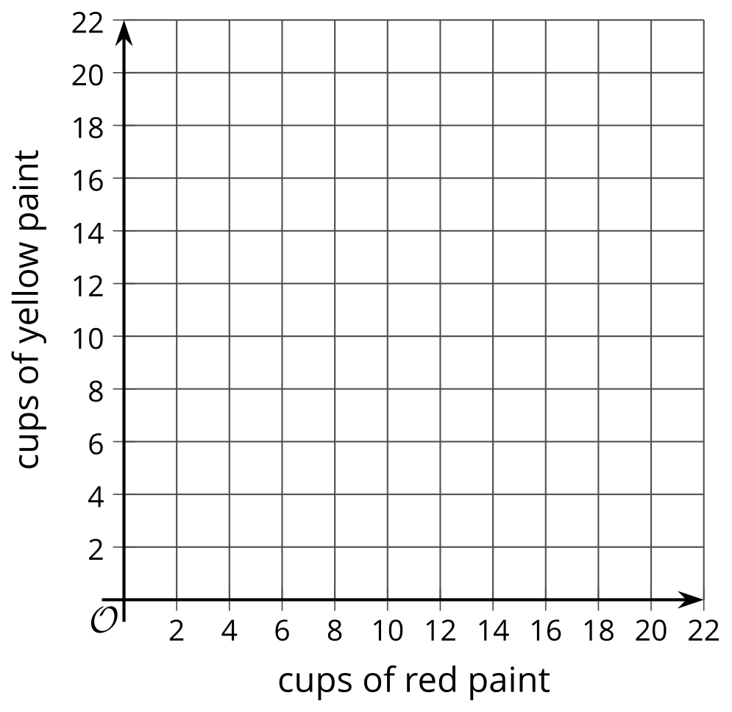
- B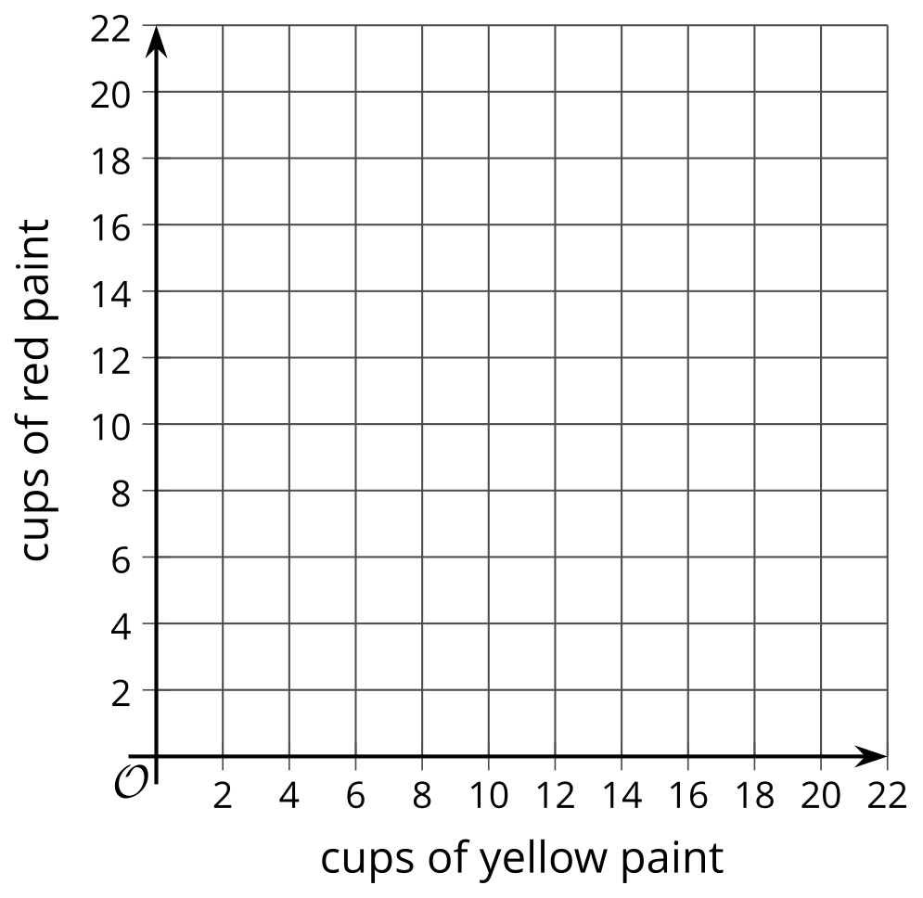
- Describe the relationship between cups of red paint and cups of yellow paint in as many ways as you can.
- Pause here for a discussion.
- Lin writes this equation to figure out the amount of yellow paint she will need if she knows the amount of red paint being used. In this equation, $y$ represents cups of yellow paint and $r$ represents cups of red paint.
- $y=\frac{3}{2}r$
- Do you agree that the equation represents the quantities in the situation? Explain your reasoning.
- What equation can we write to figure out the amount of red paint needed if we know the amount of yellow paint? Be prepared to explain how you know.

Are you ready for more?
The owners of a fruit stand sell apples, peaches, and tomatoes. Today, they sold 4 apples for every 5 peaches. They sold 2 peaches for every 3 tomatoes. They sold 132 pieces of those three fruits in total. How many of each fruit did they sell?

Lesson 16 Summary
Equations are very useful for representing the relationship in a set of equivalent ratios. Here is an example.
A cider recipe calls for 3 green apples for every 5 red apples. We can create a table to show some equivalent ratios.
We can see from the table that $r$ is always $\frac{5}{3}$ as large as $g$ and that $g$ is always $\frac{3}{5}$ as large as $r$.
green apples ($g$) | red apples ($r$)
3 | 5
6 | 10
9 | 15
12 | 20
We can write equations to describe the relationship between $g$ and $r$.
- When we know the number of green apples and want to find the number of red apples, we can write:
- $r=\frac{5}{3}g$
- In this equation, if $g$ changes, $r$ is affected by the change, so we refer to $g$ as the independent variable and $r$ as the dependent variable.
- We can use this equation with any value of $g$ to find $r$. If 270 green apples are used, then $\frac{5}{3}⋅\left(270\right)$ or 450 red apples are used.
- When we know the number of red apples and want to find the number of green apples, we can write:
- $g=\frac{3}{5}r$
- In this equation, if $r$ changes, $g$ is affected by the change, so we refer to $r$ as the independent variable and $g$ as the dependent variable.
- We can use this equation with any value of $r$ to find $g$. If 275 red apples are used, then $\frac{3}{5}⋅\left(275\right)$ or 165 green apples are used.
To help us see the relationship between the two quantities, we can also create two graphs, one graph that corresponds to each equation.
