Grade 2
Unit 1Lesson 6CC BY NC 2024 Illustrative Mathematics®
Unit 1, Lesson 6

Center Day 1
- Let’s add and subtract.
Grade 2
Unit 1Lesson 6CC BY NC 2024 Illustrative Mathematics®

Warm-upNumber Talk: Teen Numbers, 2-Digit Numbers
Find the value of each expression mentally.
- $14+22$
- $19+22$
- $15+25$
- $17+25$
Grade 2
Unit 1Lesson 6CC BY NC 2024 Illustrative Mathematics®

Activity 2Centers: Choice Time
Choose a center.
What's Behind My Back?
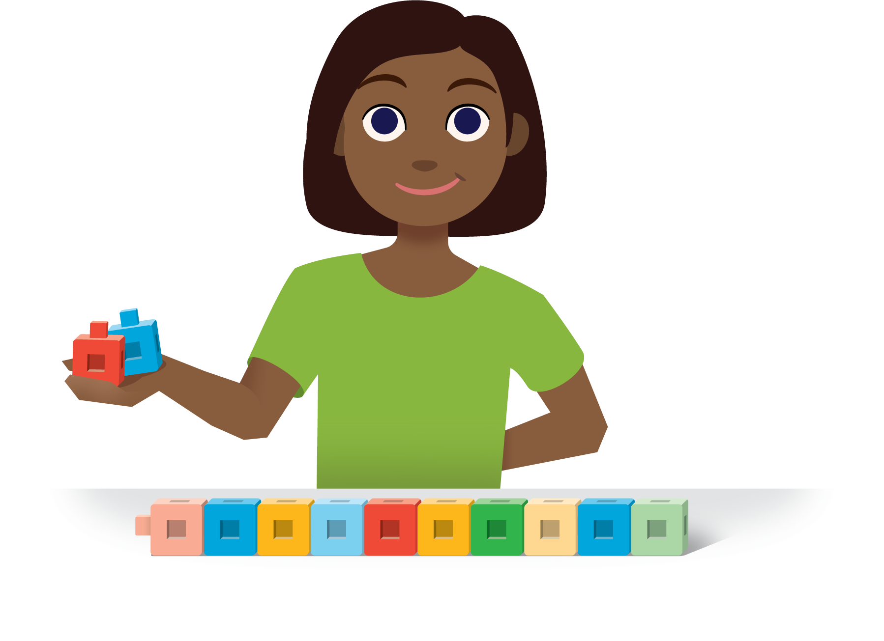
How Close?
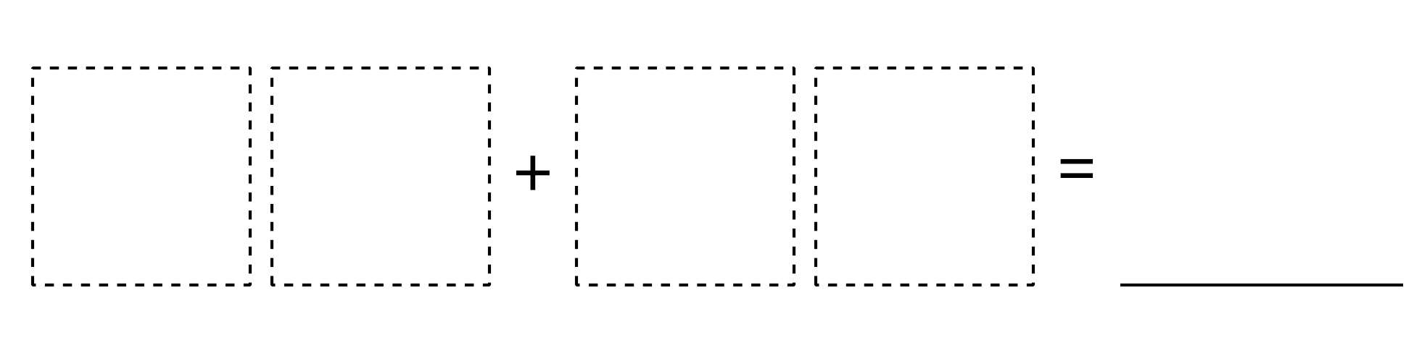
Number Puzzles
