Lesson 1: Representations of Fractions (Part 1)

Standards Alignments
Building On | 3.NF.A.1
Building Towards | 4.NF.A.1

Teacher-facing Learning Goals
- Make sense of the numerator and denominator of unit fractions that have denominators 2, 3, 4, 5, 6, 8, 10, and 12.
- Use physical and visual representations to reason about fractions.

Student-facing Learning Goals
- Let’s name some fractions and represent them visually.

Lesson Purpose
The purpose of this lesson is for students to make sense of unit fractions with denominators 2, 3, 4, 5, 6, 8, 10, and 12, using physical and visual representations.
In grade 3, students were introduced to fractions as numbers. They learned to name and represent fractions, to recognize simple equivalent fractions, and to compare fractions with like numerators and denominators (limited to 2, 3, 4, 6, and 8). They used fraction strips, area diagrams, tape diagrams, and number lines to support their reasoning with fractions.
This lesson activates students’ prior knowledge of unit fractions and includes fractions with new denominators 5, 6, 10, and 12. Students revisit the meaning of numerator and denominator, name unit fractions, create representations for them, and recall some strategies and tools for reasoning about fractions.
The idea of equivalence may naturally come up (and will help to prepare students for upcoming work), but it is not the focus of this lesson.

Access for:

Students with Disabilities
- Engagement (Activity 1)

Instructional Routines
MLR1 Stronger and Clearer Each Time (Activity 2), What Do You Know About _____? (Warm-up)

Materials to Gather
- Straightedges: Activity 1, Activity 2

Materials to Copy
- Fraction Strips (groups of 2): Activity 1

Lesson Timeline
Warm-up | 10 min
Activity 1 | 20 min
Activity 2 | 15 min
Lesson Synthesis | 10 min
Cool-down | 5 min

Teacher Reflection Question
What did you learn about each student and their foundational understanding of fractions based on their work today?

Cool-down
(to be completed at the end of the lesson) 5min
What Do the Diagrams Show?

Standards Alignments
Building Towards | 4.NF.A.1

Student-facing Task Statement
Each full diagram represents 1.
- What fraction does each shaded part represent?
- 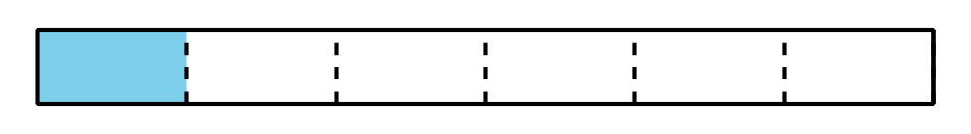
- 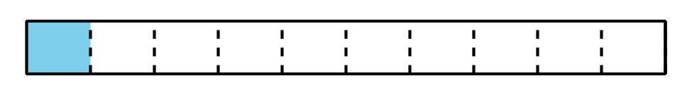
- 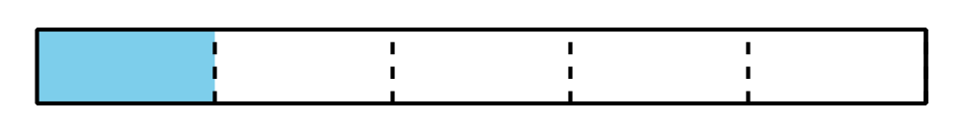
- Explain or show how you could use this diagram to represent sixths.
- 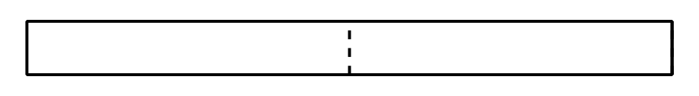

Student Responses
- $\frac{1}{6}$, $\frac{1}{10}$, and $\frac{1}{5}$.
- Sample response: Split each half into 3 equal parts so there will be a total of 6 parts. Each part is a sixth.

