Unit 3 Lesson 2: Measure in Centimeters

WU Notice and Wonder: Centimeters (Warm up)

Student Task Statement
What do you notice? What do you wonder?
A
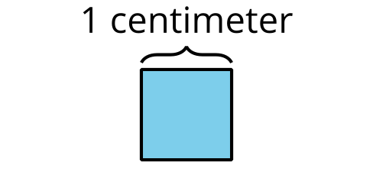
B


1 Length in Centimeters

Student Task Statement
- Measure the length of the bearded dragon using the single centimeter cubes.
- The bearded dragon is ____________ centimeter cubes long.
- Measure the bearded dragon using the 10-centimeter tool.
- The bearded dragon is ____________ 10-centimeter tools long.
- How many centimeters long is the bearded dragon?
- The bearded dragon is ____________ centimeters long.

2 Measure with 10-centimeter Tools

Student Task Statement
- Measure the length of each reptile in centimeters.
  - ____________ cm
  - ____________ cm
  - ____________ cm
  - ____________ cm
- Compare your measurements with your partner’s measurements.
- How much longer is the day gecko than the threadsnake?
© CC BY 2021 Illustrative Mathematics®

