Lesson 12: How Many Are Missing?
- Let’s fill 10-frames in different ways.

Warm-up: Which One Doesn’t Belong: 10-frames
Which one doesn’t belong?
A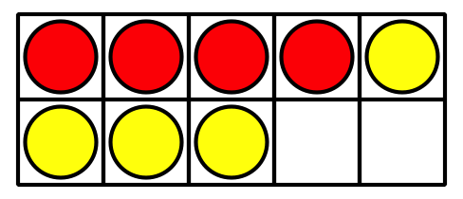
B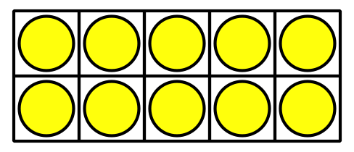
C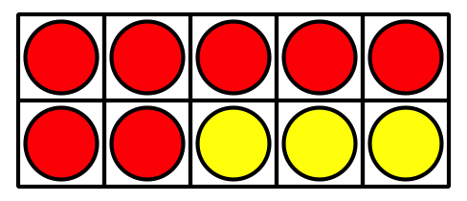
D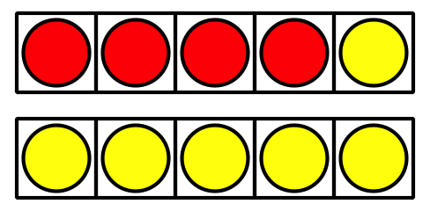

12.1: Shake, Spill, and Arrange with 10
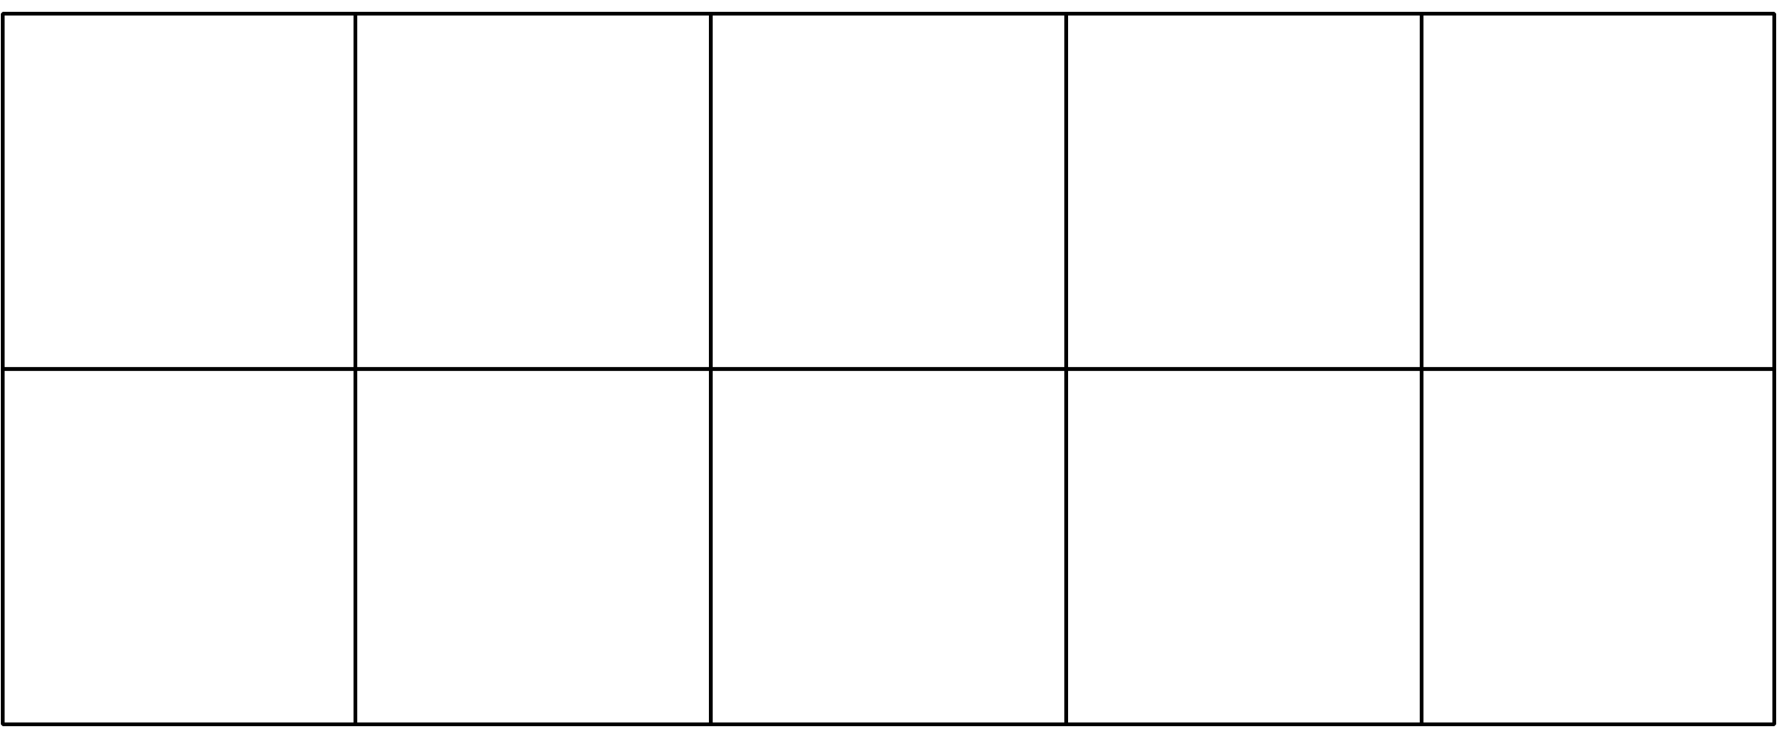
$10=5+5$
$10=9+1$
$10=4+6$
$10=2+8$
$10=6+4$
$10=3+7$
$10=1+9$
$10=8+2$
$10=5+5$

12.2: How Many to Fill the 10-frame?

- 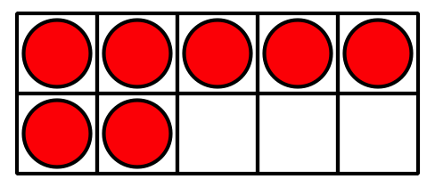
- _______________
- $10=7+3$
- $10=8+2$
- $10=5+5$

- 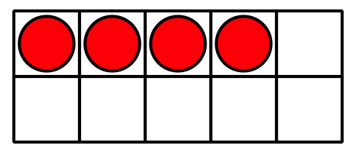
- _______________
- $10=8+2$
- $10=1+9$
- $10=4+6$

- 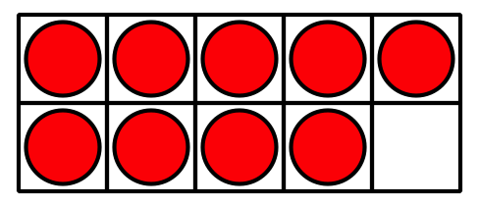
- _______________
- $10=9+1$
- $10=5+5$
- $10=7+3$

- 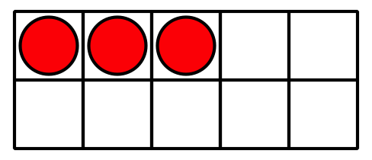
- _______________
- $10=5+5$
- $10=3+7$
- $10=2+8$

- 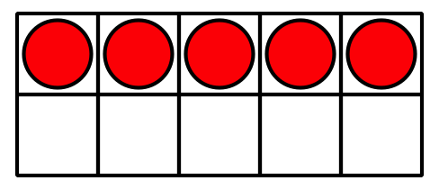
- _______________
- $10=9+1$
- $10=6+4$
- $10=5+5$

- 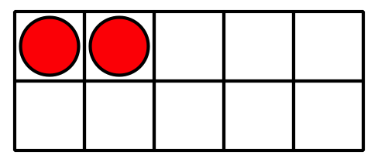
- _______________
- $10=1+9$
- $10=2+8$
- $10=4+6$

12.3: Centers: Choice Time
Choose a center.
Shake and Spill

Counting Collections
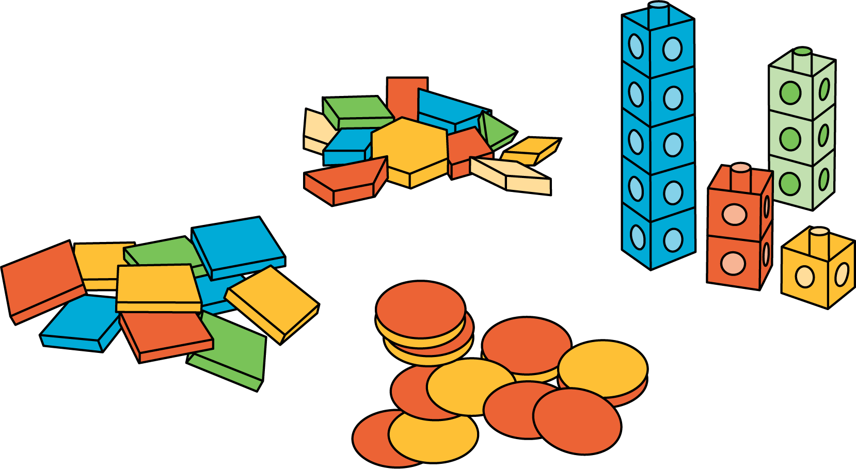
Roll and Add
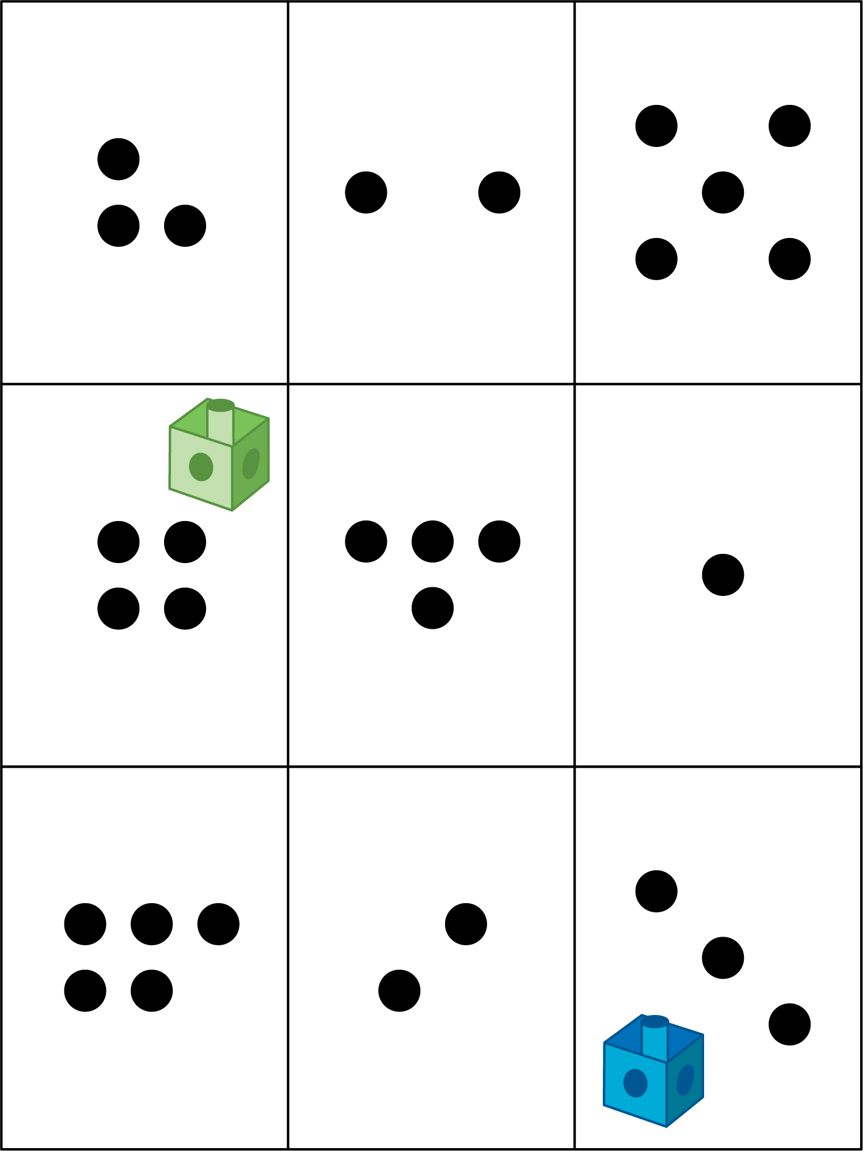
© CC BY 2021 Illustrative Mathematics®

