Unit 4 Lesson 4: Compare Numbers on a Number Line

WU Number Talk: Subtract Fives (Warm up)

Student Task Statement
Find the value of each expression mentally.
- $35−5$
- $35−10$
- $35−15$
- $35−25$

1 Compare the Numbers

Student Task Statement
- Partner A:
  - Roll 3 number cubes and find the sum.
  - Put a counter on the location of the sum.
- Partner B:
  - Roll 3 number cubes and find the sum.
  - Put a counter on the location of the sum on the same number line.
- Decide which number is greater and explain.
- Use $<$, $>$, or $=$ to compare the 2 numbers represented on your number line.
Partner A | $<$, $>$, or $=$ | Partner B

2 Compare Larger Numbers

Student Task Statement
- Each partner rolls 2 number cubes and makes a two-digit number.
- Locate and label your numbers on the number line.
- Use >, <, or = to compare the numbers.
- Explain why your comparison is true.
Partner A | $<,>,\text{or}=$ | Partner B

Images for Activity Synthesis
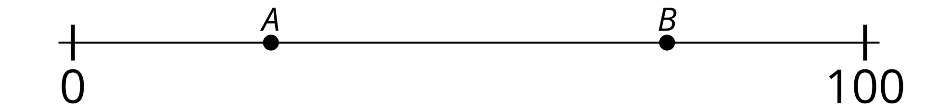
© CC BY 2021 Illustrative Mathematics®

