Algebra 1
Unit 2Lesson 19CC BY NC 2024 Illustrative Mathematics®
Unit 2, Lesson 19

Linear Patterns
Let’s graph and explore systems that make a pattern.
Algebra 1
Unit 2Lesson 19CC BY NC 2024 Illustrative Mathematics®

19.1Writing Out the Pattern
Here is a pattern made from 8 linear equations.
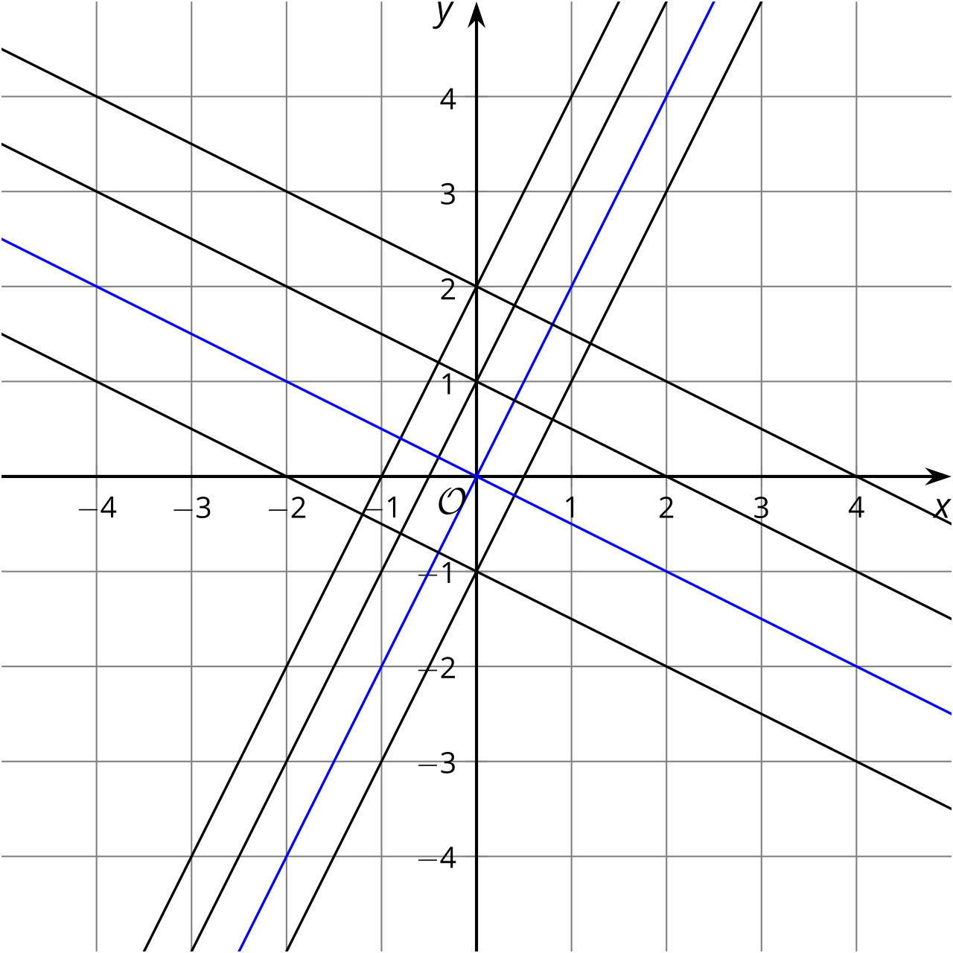
Two of the equations are $y=2x$ and $y=\frac{−1}{2}x$. If every line is parallel to one of those two, write an equation for each of the other 6 lines.
Algebra 1
Unit 2Lesson 19CC BY NC 2024 Illustrative Mathematics®

19.2Outlining a Pattern
Think of or draw an interesting pattern made of at least 4 lines.
Write at least 4 linear equations to create your pattern with these conditions:
- At least one equation written in standard form: $Ax+By=C$ with constants for $A,B,$ and $C$.
- At least one equation written in slope-intercept form: $y=mx+b$ with constants for $m$ and $b$.
- At least 2 lines that intersect.
- At least 2 lines that do not intersect.
Algebra 1
Unit 2Lesson 19CC BY NC 2024 Illustrative Mathematics®

19.3Solving Your Pattern
Trade equations with your new partner. Only the equations should be traded. Do not trade the patterns yet.
- Create a system of equations by selecting two of the equations that your partner gave you. Without graphing, solve that system of equations or show why there are no solutions. Be prepared to show your reasoning.
- Select another pair of equations, and do this again.
- Using one of the equations you have, write a new linear equation to create a system that has infinitely many solutions.
- Next, you and your partner should show each other your original patterns and check your answers using those graphs.

