Grade 6
Unit 3Lesson 12CC BY NC Illustrative Mathematics, based on IM 6–8 Math, CC BY Open Up Resources.
Unit 3, Lesson 12

Representing Percentages in Different Ways
Let's use tape diagrams to understand percentages.
Grade 6
Unit 3Lesson 12CC BY NC Illustrative Mathematics, based on IM 6–8 Math, CC BY Open Up Resources.

12.1Notice and Wonder: Tape Diagram
What do you notice? What do you wonder?
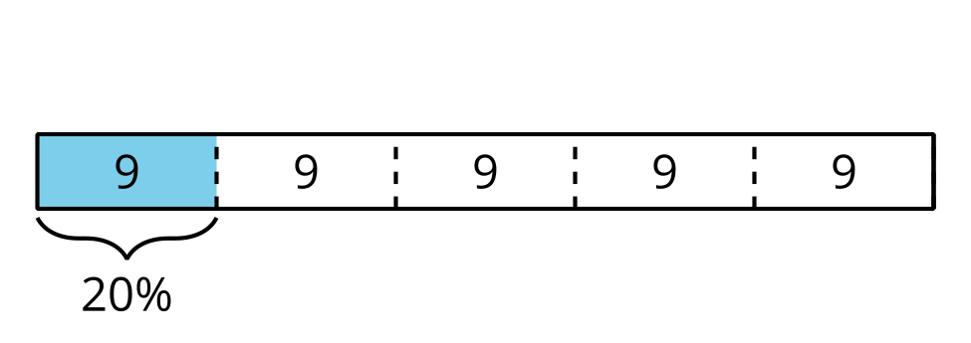
Grade 6
Unit 3Lesson 12CC BY NC Illustrative Mathematics, based on IM 6–8 Math, CC BY Open Up Resources.

12.2Revisiting Jada's Puppy
Jada has a new puppy that weighs 9 pounds.
- The weight of Jada’s puppy is 10% of the weight of another dog.
  - What does 100% represent in this situation?
  - What is the weight of the other dog? Explain or show your reasoning.
  - You can use the tape diagram or the table if you find either one helpful.
  - 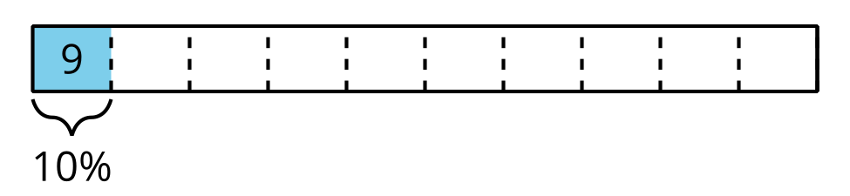
- weight (pounds) | - percentage
- 9 | - 10
- A bunny weighs 150% as much as Jada’s puppy.
  - What does 100% represent in this situation?
  - What is the weight of the bunny? Explain or show your reasoning.
  - You can use the double number line diagram, tape diagram, or table if you find one of them helpful.
  - 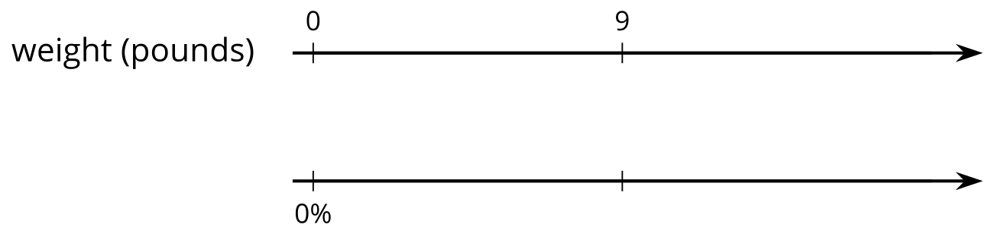
  - 
- weight (pounds) | - percentage
  - 9
Grade 6
Unit 3Lesson 12CC BY NC Illustrative Mathematics, based on IM 6–8 Math, CC BY Open Up Resources.

12.3Staying Hydrated
For each situation, answer the questions and show your reasoning.
- Noah drank 5 cups of water while at school. Diego drank 120% as much as Noah did. How much water did Diego drink?
- During the first part of a hike, Kiran drank 1.5 liters of the water he brought.
  - If this is 50% of the water he brought, how much water did he bring?
  - If he drank 80% of his water on his entire hike, how much water did he drink?

Are you ready for more?
Decide if each of Kiran’s plans is possible. Explain your reasoning.
- By the end of this hike, Kiran plans to drink 150% of the water he brought.
- Kiran plans to bring his dog on his next hike, along with 150% as much water as he brought on this hike.

Lesson 12 Summary
Tables and tape diagrams can also help us make sense of percentages.
Consider two problems that we solved earlier using a double number line diagram:
- What is 30% of 50 pounds? Here is a tape diagram that shows that 30% of 50 pounds is 15 pounds.
- 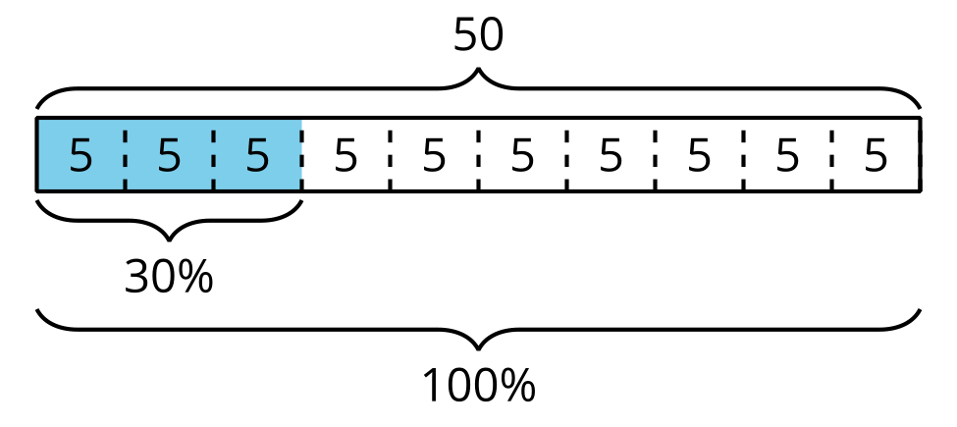
- Mai spent 90 minutes reading on Monday. This is 125% as much time she spent reading on Sunday. How long did she read on Sunday?
- In other words: If 90 is 125% of a number, what is 100% of that number? A table can help us reason about problems like this.
- Here is one that shows that 100% of that number must be 72.
- 