Grade 6
Unit 6Lesson 17CC BY NC Illustrative Mathematics, based on IM 6–8 Math, CC BY Open Up Resources.
Unit 6, Lesson 17

Two Related Quantities, Part 2
Let’s use equations and graphs to describe stories with constant speed.
Grade 6
Unit 6Lesson 17CC BY NC Illustrative Mathematics, based on IM 6–8 Math, CC BY Open Up Resources.

17.1Which One Travels Faster?
A wheelchair user is considering two electric wheelchairs. Wheelchair A can travel 25 meters in 10 seconds. Wheelchair B can travel 13 meters in 5 seconds.
- Which wheelchair can travel at a faster rate? Be prepared to explain how you know.
- How many seconds will it take each wheelchair, moving at a constant speed, to travel 195 meters? Show your reasoning.
Grade 6
Unit 6Lesson 17CC BY NC Illustrative Mathematics, based on IM 6–8 Math, CC BY Open Up Resources.

17.2The Robot Race
Diego, Elena, and Andre joined different teams for a robotics competition. Each team programmed a robot to travel at a constant rate.
- Complete each table to show how far each team’s robot traveled during the competition.
- Diego's Team
- time (minutes) | - distance traveled (meters)
 | - 1
- 1
- 2 | - 6
- 4
- 5
- Elena's Team
- time (minutes) | - distance traveled (meters)
 | - 1
- 1
- 2
- 4 | - 11
- 5
- Andre's Team
- time (minutes) | - distance traveled (meters)
 | - 1
- 1
- 2
- 4
- 5 | - 17.5
- Graph points to show the progress of each robot. Use a different color or symbol for each robot.
- 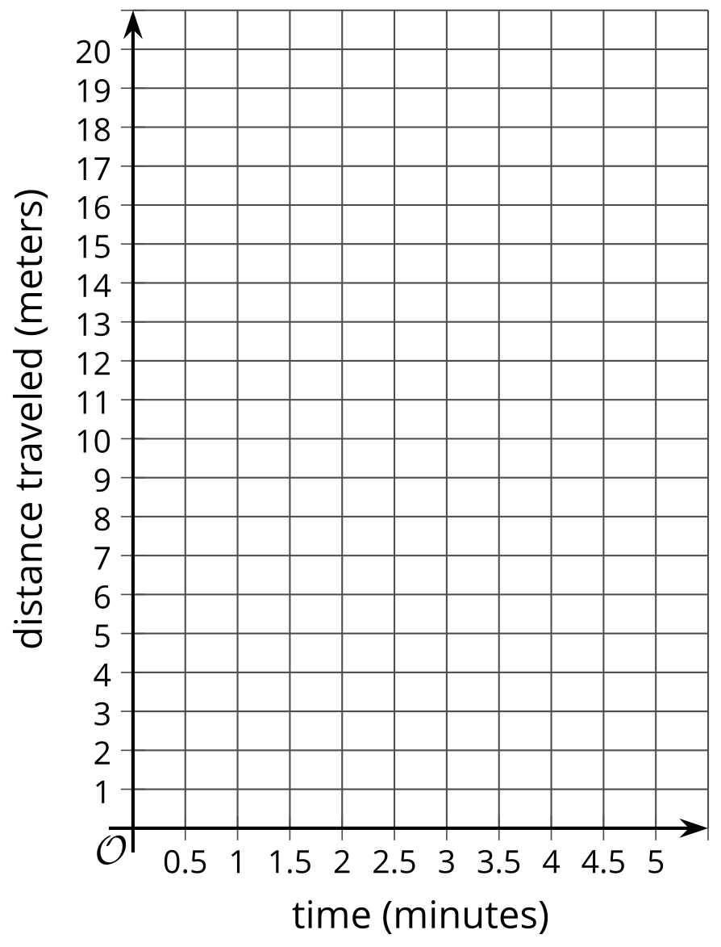
- Let’s say that $d$ represents the distance a robot traveled in meters and $t$ represents the time in minutes.
  - Explain why $d=3t$ relates the distance and time that Diego’s robot traveled.
  - In this equation, which variable is independent and which one is dependent? Record your answer in the table. Be prepared to explain how you know.
- Complete the table with equations that can relate distance and time for the other two robots. Make sure that in each equation, the independent and dependent variables are as shown. Be prepared to explain your reasoning.
 | - equation | - independent variable | - dependent variable
- Diego's team | - $d=3t$
- Elena's team |  | - time | - distance
- Andre's team |  | - distance | - time

Are you ready for more?
- Two trains are traveling toward each other, on parallel tracks. Train A is moving at a constant speed of 70 miles per hour. Train B is moving at a constant speed of 50 miles per hour. The trains are initially 320 miles apart. How long will it take them to meet?
- If you get stuck, consider using the table and adding as many rows as needed.
- elapsed time (hours) | - distance apart (miles)
- 0
- 1
- 2
- How long will it take a train traveling at 120 miles per hour to go 320 miles?
- How are the two problems related?

Lesson 17 Summary
Equations are very useful for solving problems that involve constant speed. Here is an example.
A boat travels at a constant speed of 25 miles per hour.
- How far can the boat travel in 3.25 hours?
- How long does it take for the boat to travel 60 miles?
We can write equations to help us answer questions like these.
Let's use $t$ to represent the time in hours and $d$ to represent the distance in miles that the boat travels.
When we know the time and want to find the distance, we can write: $d=25t$
In this equation, if $t$ changes, $d$ is affected by the change, so $t$ is the independent variable and $d$ is the dependent variable.
This equation can help us find $d$ when we have any value of $t$. In $3.25$ hours, the boat can travel $25\left(3.25\right)$ or 81.25 miles.
When we know the distance and want to find the time, we can write: $t=\frac{d}{25}$ In this equation, if $d$ changes, $t$ is affected by the change, so $d$ is the independent variable and $t$ is the dependent variable.
This equation can help us find $t$ for any value of $d$. To travel 60 miles, it will take $\frac{60}{25}$ or $2\frac{2}{5}$ hours.
We can also graph the two equations we wrote to get a picture of the relationship between the two quantities. By convention, the independent variable is represented on the horizontal axis.
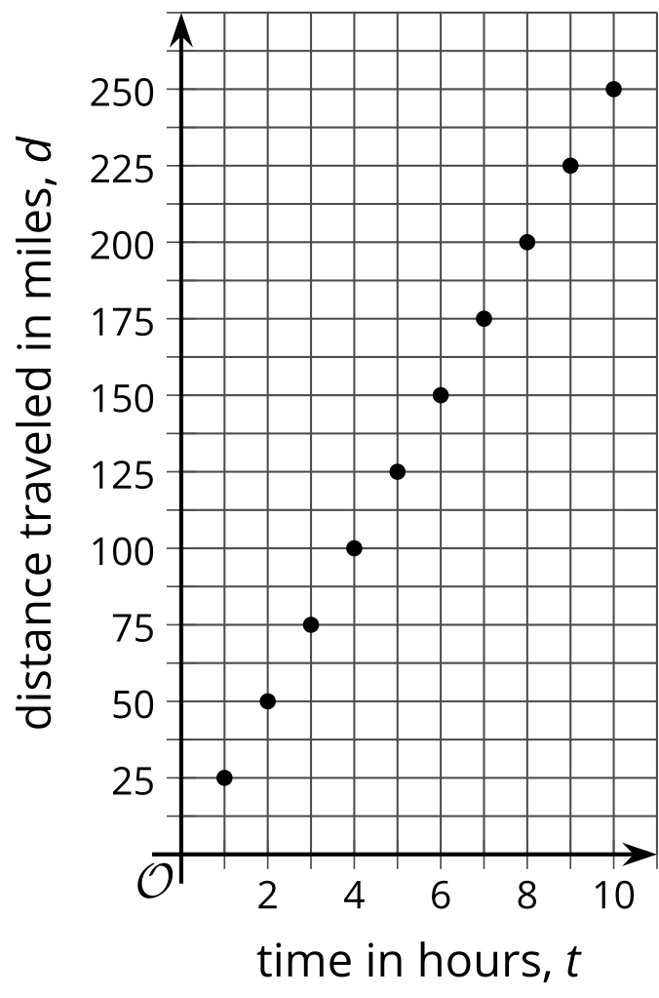
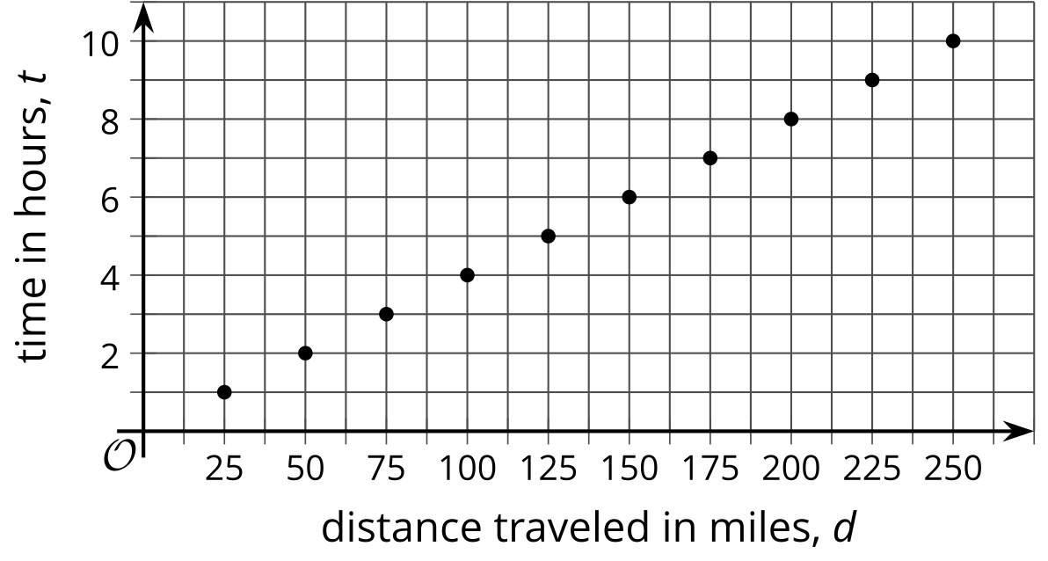
Problems about constant speed can also be solved using other strategies, such as by making a table of equivalent ratios.

