Grade 2
Unit 2Lesson 3CC BY NC 2024 Illustrative Mathematics®
Unit 2, Lesson 3

Add or Subtract to Solve Story Problems
- Let’s solve story problems.
Grade 2
Unit 2Lesson 3CC BY NC 2024 Illustrative Mathematics®

Warm-upHow Many Do You See: Base-Ten Diagram
How many do you see? How do you see them?
Unable to process <img src="/tikz_files/237763.svg">Failed: rsvg-convert --format png --dpi-x 300 --dpi-y 300 /app/tmp/svgtopng-1786380753.2199967.svg --output /app/tmp/svgtopng-1786380753.2199967.png Backtrace: /app/app/services/script/runner.rb:34:in `block in run_cmd' <internal:kernel>:90:in `tap' /app/app/services/script/runner.rb:32:in `run_cmd' /app/app/services/script/svg_to_png.rb:27:in `convert_svg_to_png' /app/app/services/script/svg_to_png.rb:17:in `to_png' /app/vendor/bundle/ruby/3.3.0/gems/embeddable_content-1.1.0/app/services/embeddable_content/images/image_downloader.rb:37:in `png_rendered_from_svg' /app/vendor/bundle/ruby/3.3.0/gems/embeddable_content-1.1.0/app/services/embeddable_content/images/image_downloader.rb:33:in `raw_image_data' /app/vendor/bundle/ruby/3.3.0/gems/embeddable_content-1.1.0/app/services/embeddable_content/images/image_downloader.rb:13:in `block in save' <internal:kernel>:90:in `tap' /app/vendor/bundle/ruby/3.3.0/gems/embeddable_content-1.1.0/app/services/embeddable_content/images/image_downloader.rb:13:in `save'
Unable to process <img src="/tikz_files/237764.svg">Failed: rsvg-convert --format png --dpi-x 300 --dpi-y 300 /app/tmp/svgtopng-1786380753.3079836.svg --output /app/tmp/svgtopng-1786380753.3079836.png Backtrace: /app/app/services/script/runner.rb:34:in `block in run_cmd' <internal:kernel>:90:in `tap' /app/app/services/script/runner.rb:32:in `run_cmd' /app/app/services/script/svg_to_png.rb:27:in `convert_svg_to_png' /app/app/services/script/svg_to_png.rb:17:in `to_png' /app/vendor/bundle/ruby/3.3.0/gems/embeddable_content-1.1.0/app/services/embeddable_content/images/image_downloader.rb:37:in `png_rendered_from_svg' /app/vendor/bundle/ruby/3.3.0/gems/embeddable_content-1.1.0/app/services/embeddable_content/images/image_downloader.rb:33:in `raw_image_data' /app/vendor/bundle/ruby/3.3.0/gems/embeddable_content-1.1.0/app/services/embeddable_content/images/image_downloader.rb:13:in `block in save' <internal:kernel>:90:in `tap' /app/vendor/bundle/ruby/3.3.0/gems/embeddable_content-1.1.0/app/services/embeddable_content/images/image_downloader.rb:13:in `save'
Unable to process <img src="/tikz_files/237765.svg">Failed: rsvg-convert --format png --dpi-x 300 --dpi-y 300 /app/tmp/svgtopng-1786380753.402197.svg --output /app/tmp/svgtopng-1786380753.402197.png Backtrace: /app/app/services/script/runner.rb:34:in `block in run_cmd' <internal:kernel>:90:in `tap' /app/app/services/script/runner.rb:32:in `run_cmd' /app/app/services/script/svg_to_png.rb:27:in `convert_svg_to_png' /app/app/services/script/svg_to_png.rb:17:in `to_png' /app/vendor/bundle/ruby/3.3.0/gems/embeddable_content-1.1.0/app/services/embeddable_content/images/image_downloader.rb:37:in `png_rendered_from_svg' /app/vendor/bundle/ruby/3.3.0/gems/embeddable_content-1.1.0/app/services/embeddable_content/images/image_downloader.rb:33:in `raw_image_data' /app/vendor/bundle/ruby/3.3.0/gems/embeddable_content-1.1.0/app/services/embeddable_content/images/image_downloader.rb:13:in `block in save' <internal:kernel>:90:in `tap' /app/vendor/bundle/ruby/3.3.0/gems/embeddable_content-1.1.0/app/services/embeddable_content/images/image_downloader.rb:13:in `save'
Grade 2
Unit 2Lesson 3CC BY NC 2024 Illustrative Mathematics®

Activity 1Fun at the Zoo
Some students sit on a bus. 34 more students get on the bus. Now there are 55 students. How many students were on the bus at first?
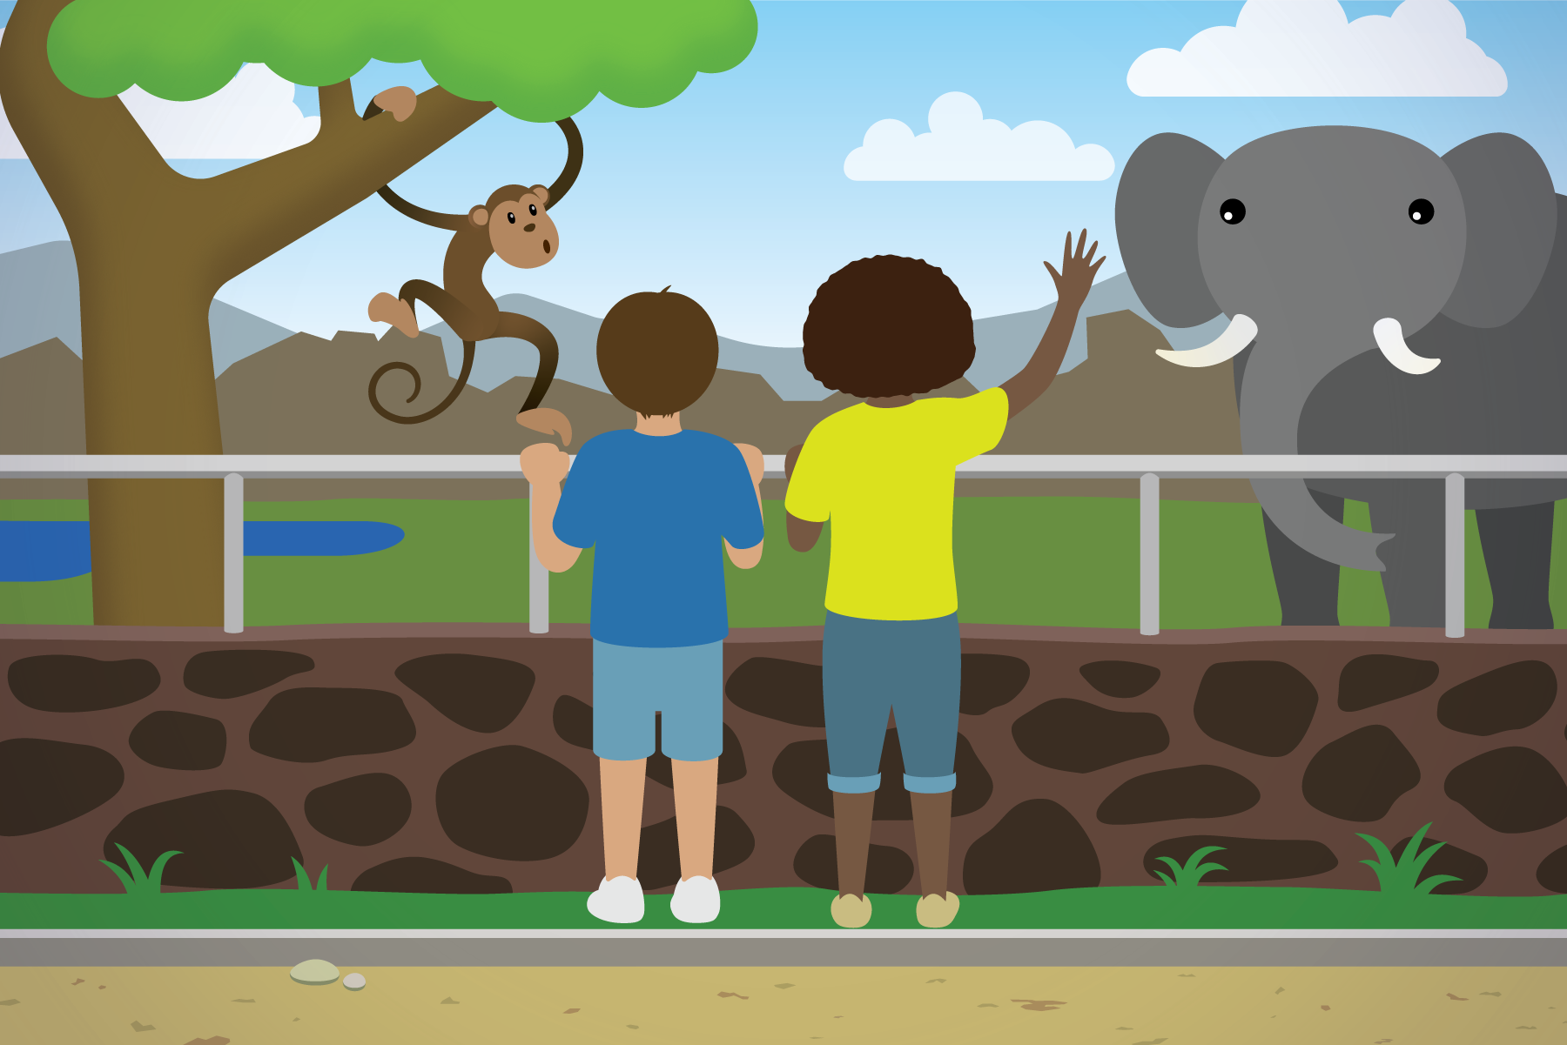
Grade 2
Unit 2Lesson 3CC BY NC 2024 Illustrative Mathematics®

Activity 2More Fun at the Zoo
Solve each story problem. Show your thinking.
- There are 65 students in the monkey house. 23 left to see the hippos. How many are still in the monkey house?
- 58 students want to see the bears. 27 students want to see the lions. How many more students want to see the bears than the lions?
- Some birds are in cages outside of the bird house. 34 birds are inside the bird house. There are 88 birds. How many birds are outside?

Section A Summary
We used addition and subtraction to find unknown values. We used different tools to show how to add and subtract 2-digit numbers.
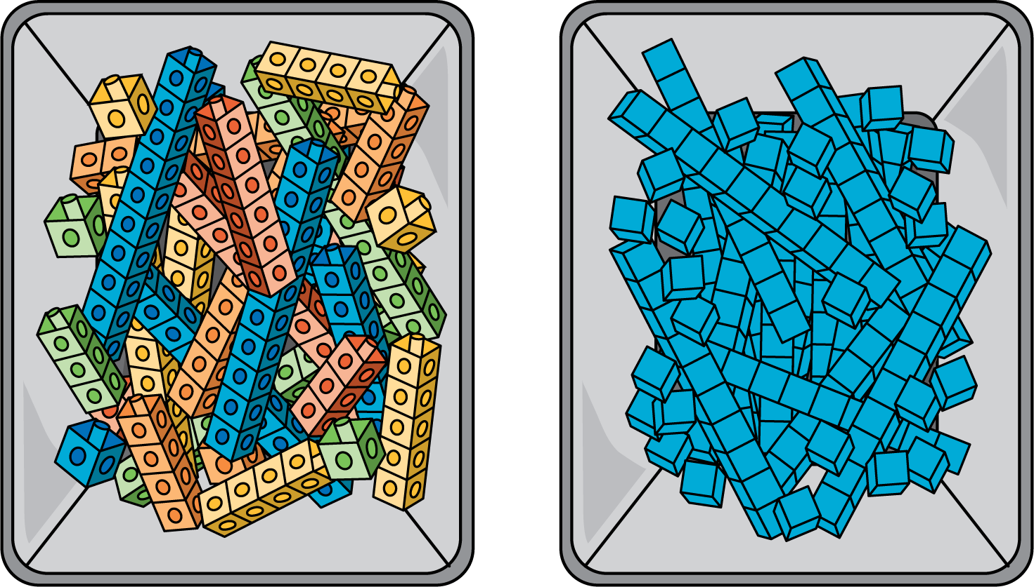
We subtracted two 2-digit numbers by subtracting tens from tens and ones from ones.
$55−34=?$
Unable to process <img src="/tikz_files/237086.svg">Failed: rsvg-convert --format png --dpi-x 300 --dpi-y 300 /app/tmp/svgtopng-1786380753.5986087.svg --output /app/tmp/svgtopng-1786380753.5986087.png Backtrace: /app/app/services/script/runner.rb:34:in `block in run_cmd' <internal:kernel>:90:in `tap' /app/app/services/script/runner.rb:32:in `run_cmd' /app/app/services/script/svg_to_png.rb:27:in `convert_svg_to_png' /app/app/services/script/svg_to_png.rb:17:in `to_png' /app/vendor/bundle/ruby/3.3.0/gems/embeddable_content-1.1.0/app/services/embeddable_content/images/image_downloader.rb:37:in `png_rendered_from_svg' /app/vendor/bundle/ruby/3.3.0/gems/embeddable_content-1.1.0/app/services/embeddable_content/images/image_downloader.rb:33:in `raw_image_data' /app/vendor/bundle/ruby/3.3.0/gems/embeddable_content-1.1.0/app/services/embeddable_content/images/image_downloader.rb:13:in `block in save' <internal:kernel>:90:in `tap' /app/vendor/bundle/ruby/3.3.0/gems/embeddable_content-1.1.0/app/services/embeddable_content/images/image_downloader.rb:13:in `save'
$50−30=20$
$5−4=1$
$\begin{matrix}20+1=21 \\ 55−34=21\end{matrix}$

