Lesson 9 Practice Problems
- Technology required. The data represent the average customer ratings for several items sold online.
- 0.5 | - 1 | - 1.2 | - 1.3 | - 2.1 | - 2.1 | - 2.1 | - 2.3
- 2.5 | - 2.6 | - 3.5 | - 3.6 | - 3.7 | - 4 | - 4.1 | - 4.1
- 4.2 | - 4.2 | - 4.5 | - 4.7 | - 4.8

  - Use technology to create a histogram for the data with intervals 0–1, 1–2, and so on.
  - Describe the shape of the distribution.
  - Which interval has the highest frequency?
- Technology required. The data represent the amount of corn, in bushels per acre, harvested from different locations.
- 133, 133, 134, 134, 134, 135, 135, 135, 135, 135, 135, 136, 136, 136, 137, 137, 138, 138, 139, 140
  - Use technology to create a dot plot and a box plot.
  - What is the shape of the distribution?
  - Compare the information displayed by the dot plot and box plot.

  - Describe the shape of the distribution.
  - How many values are represented by the histogram?
  - Write a statistical question that could have produced the data set summarized in the histogram.
- 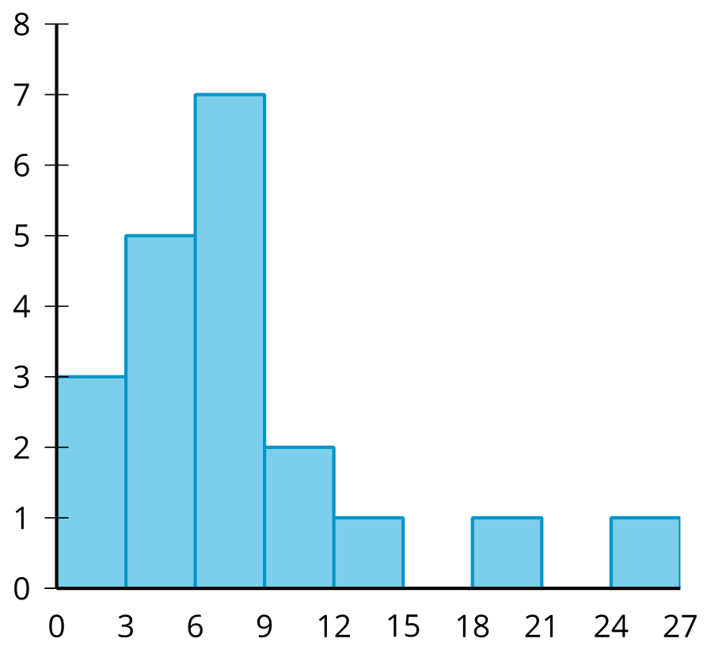
- (From Unit 1, Lesson 4.)
- The dot plot represents the distribution of satisfaction ratings for a landscaping company on a scale of 1 to 10. Twenty-five customers were surveyed.
- 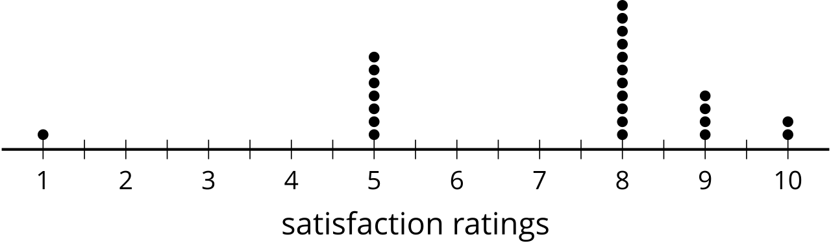
- On average, what was the satisfaction rating of the landscaping company?
- (From Unit 1, Lesson 3.)
© CC BY 2019 by Illustrative Mathematics®

