Lesson 17: Add 0 and 1
- Let’s see what happens when we add 0 or 1.

Warm-up: Notice and Wonder: Add 1 More
What do you notice?
What do you wonder?
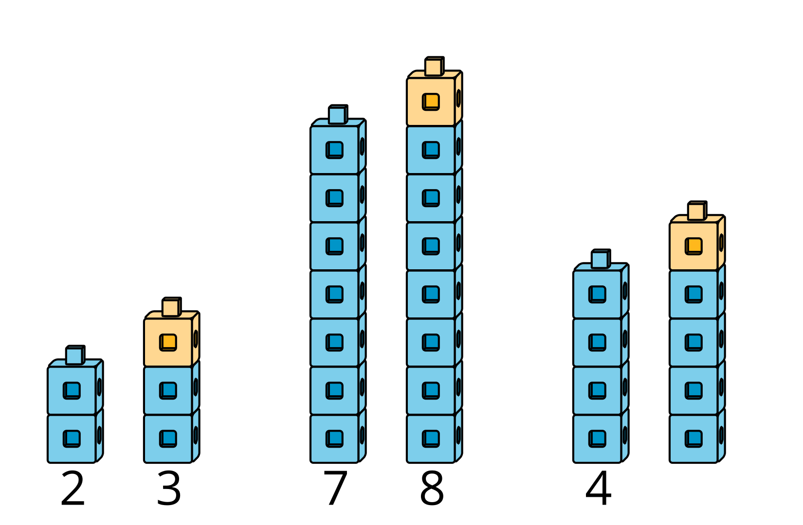

17.1: Add 0 and 1
$4+\underset{_}{}$
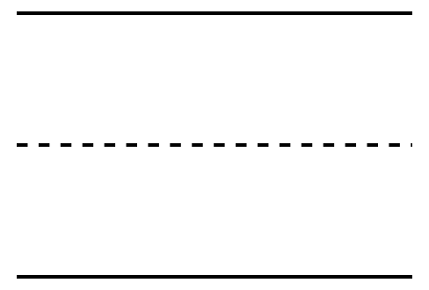
$2+\underset{_}{}$
$8+\underset{_}{}$
$3+\underset{_}{}$
$9+\underset{_}{}$
$1+\underset{_}{}$

17.2: Notice $+0$ and $+1$ Patterns
$4+0$
4

$2+0$
2

$8+0$
8

$3+1$
4

$9+1$
10

$1+1$
2


17.3: Introduce Find the Value of Expressions, Color the Total or Difference
Choose a center.
Find the Value of
Expressions
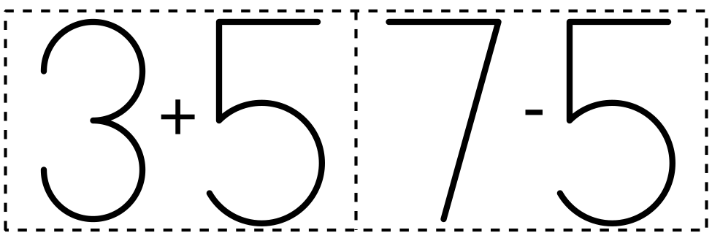
​​​​​​
Roll and Add
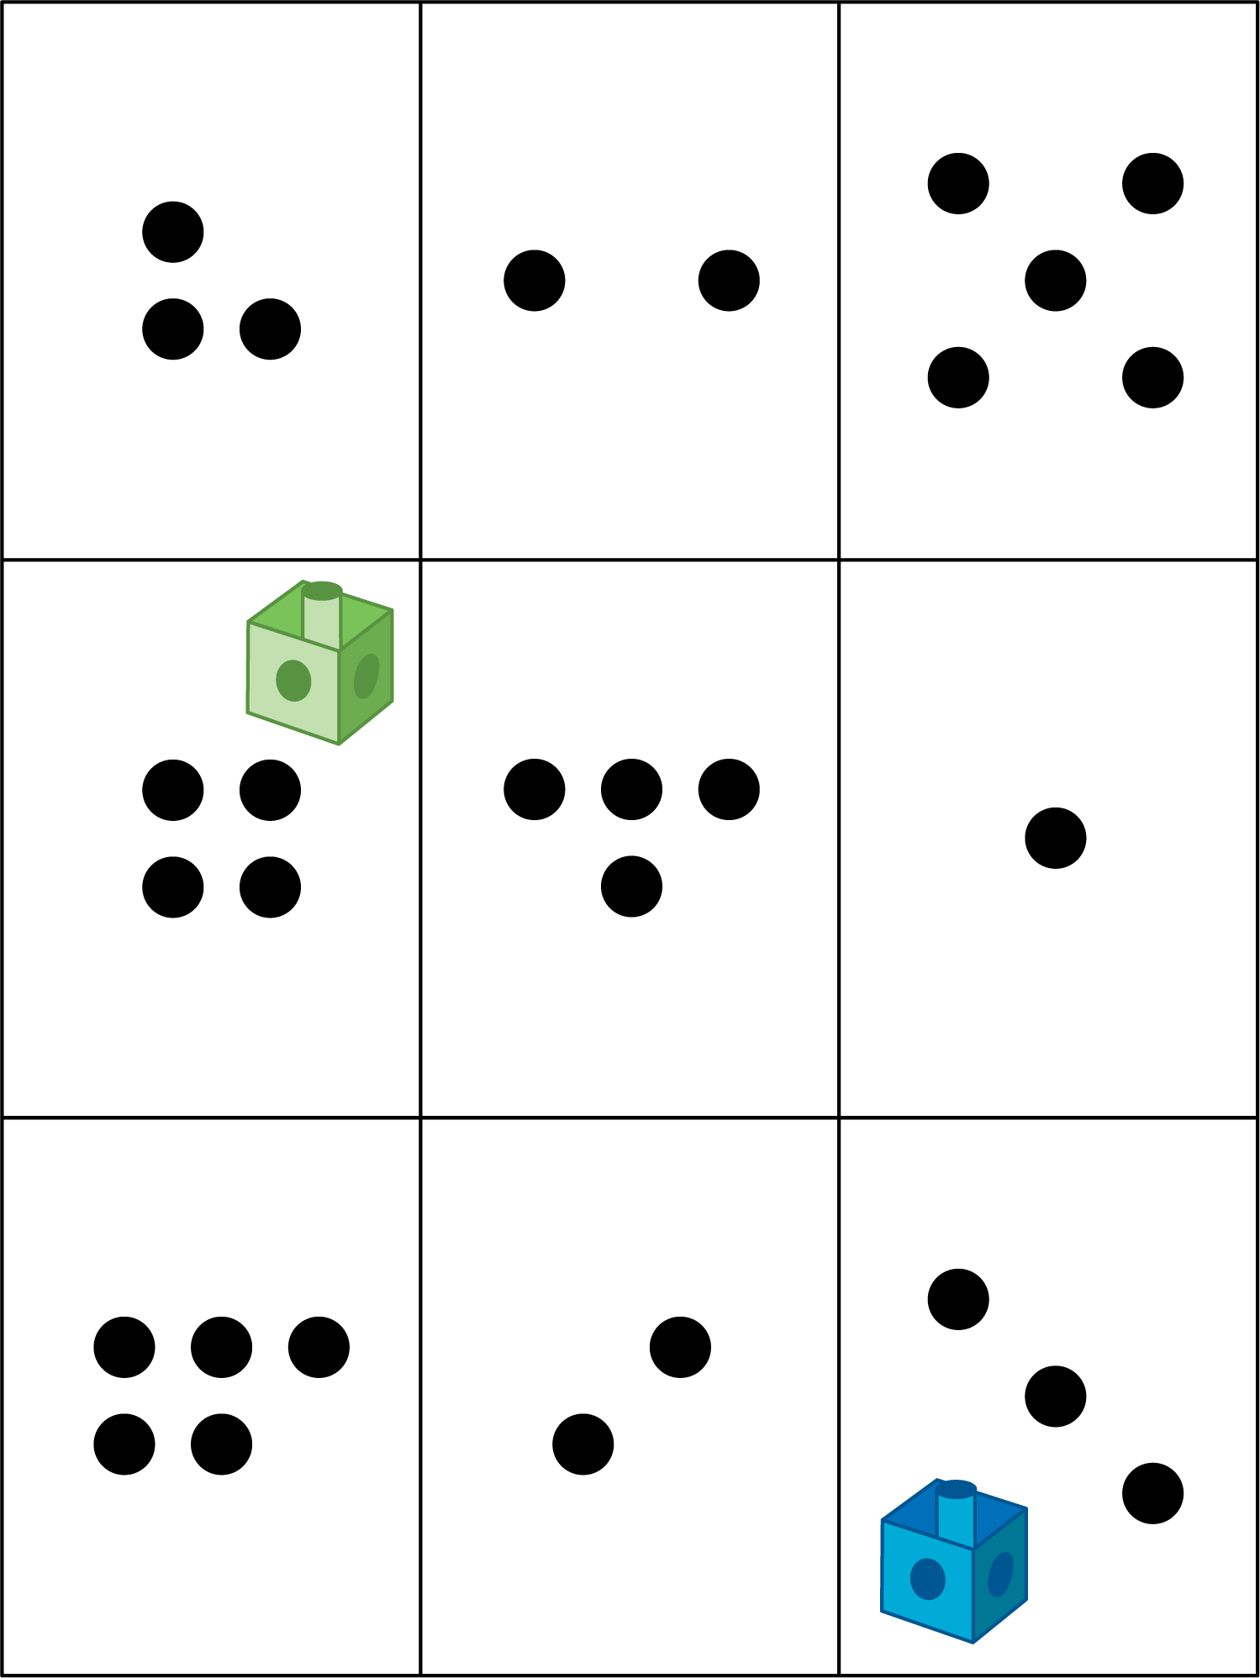
Shake and Spill

Math Stories
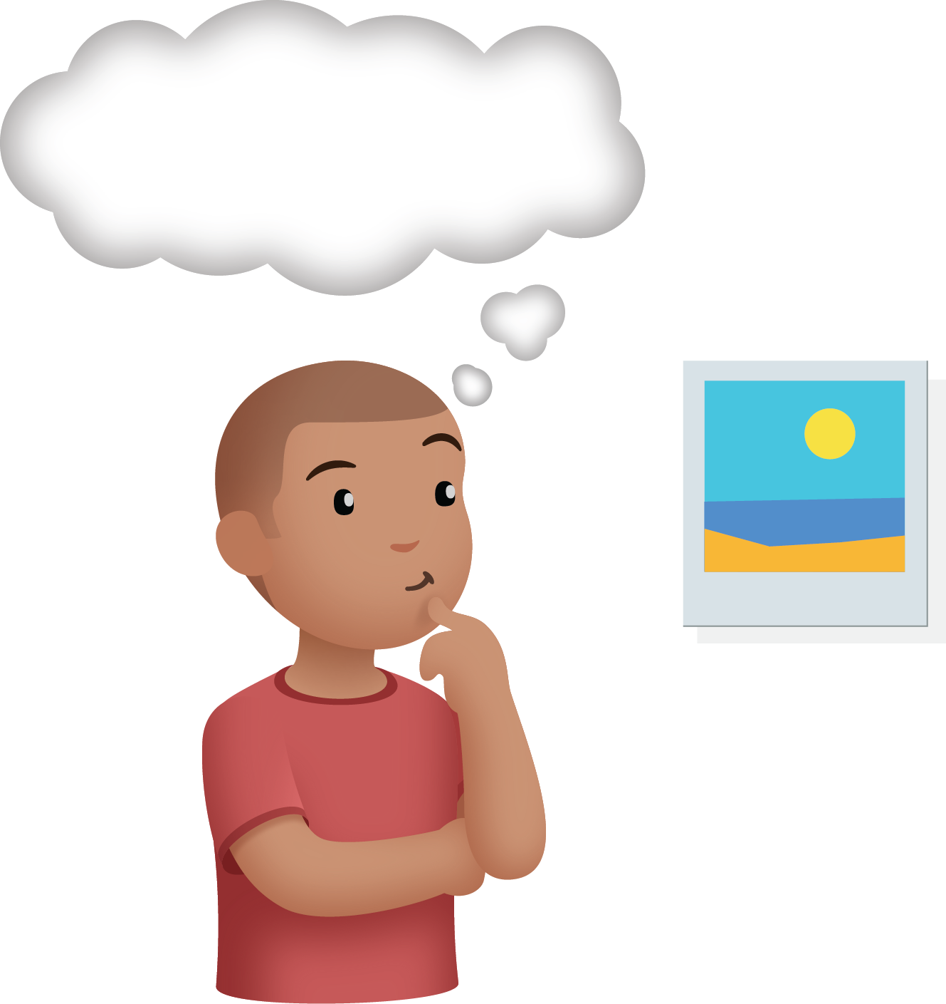
Number Race
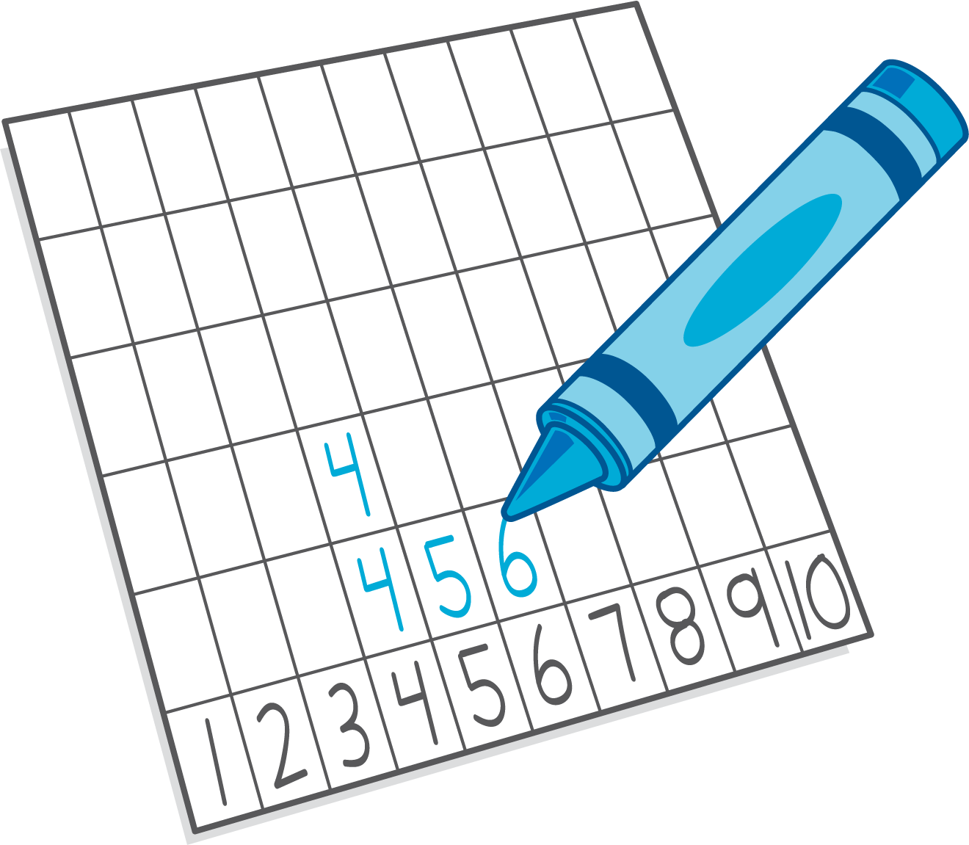

Section Summary
Section Summary
In this section, we used numbers and symbols to show when things are added and when things are subtracted, or taken away.
We matched expressions to story problems and drawings.
$8−6$
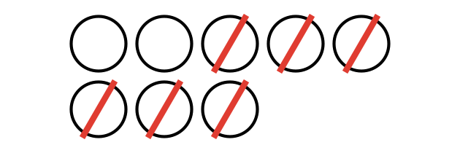
$2+1$

We used our fingers, objects, and drawings to find the value of expressions.
$4+2$


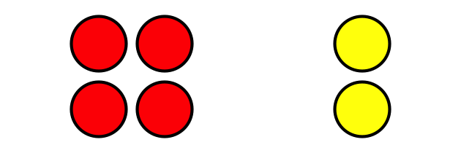

© CC BY 2021 Illustrative Mathematics®

