Grade 2
Unit 8Lesson 13CC BY NC 2024 Illustrative Mathematics®
Unit 8, Lesson 13

Center Day 2
- Let’s skip-count and practice addition and subtraction.
Grade 2
Unit 8Lesson 13CC BY NC 2024 Illustrative Mathematics®

Warm-up True or False: 2 or False
Decide if each statement is true or false. Be prepared to explain your reasoning.
- $2+2+2+2=4+4$
- $2+2+2=3+3$
- $2+2+2+2+2+2=5+5$
Grade 2
Unit 8Lesson 13CC BY NC 2024 Illustrative Mathematics®

Activity 1Centers: Choice Time
Choose a center.
Write Numbers

Target Numbers

Five in a Row
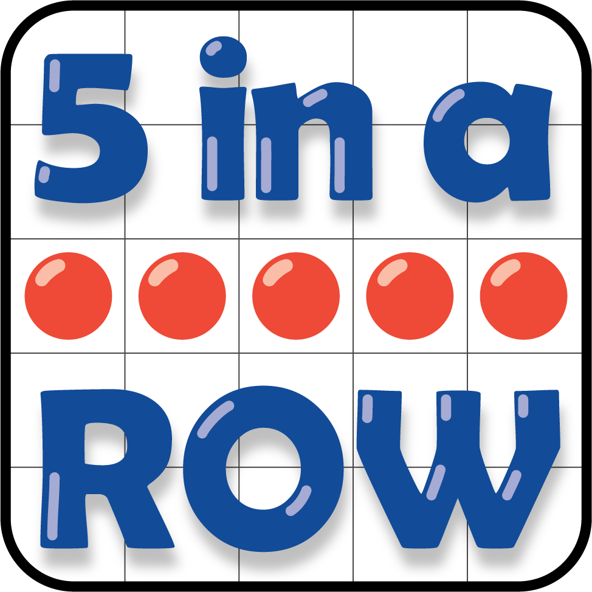
How Close
