Grade 6
Unit 1Practice ProblemsCC BY NC Illustrative Mathematics, based on IM 6–8 Math, CC BY Open Up Resources.

Lesson 4 Practice Problems
- 1
- Select all of the parallelograms. For each figure that is not selected, explain how you know it is not a parallelogram.
- 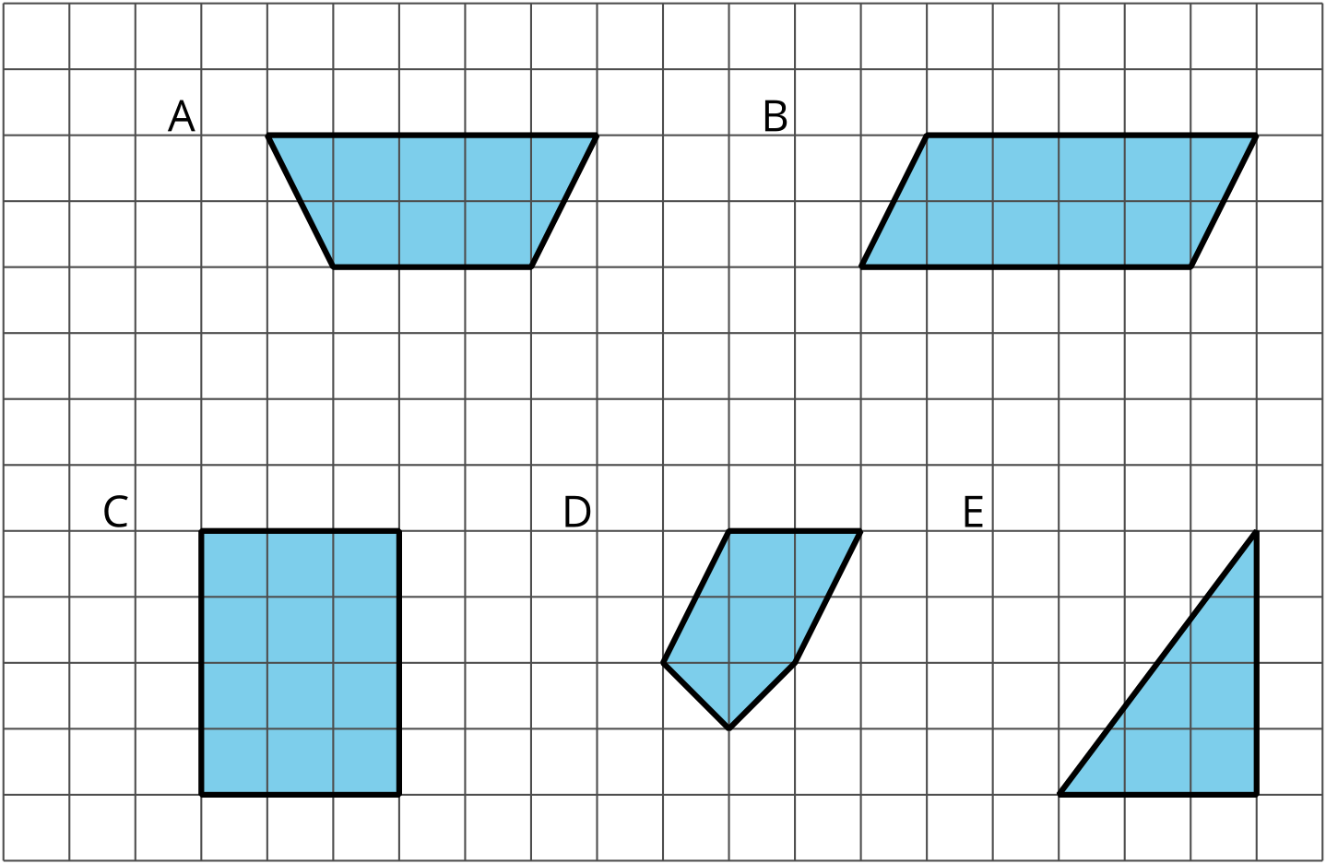
- 2
- 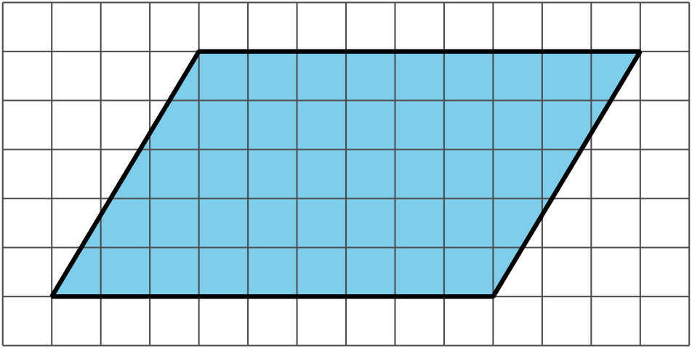
  - Decompose and rearrange this parallelogram to make a rectangle.
  - What is the area of the parallelogram? Explain your reasoning.
- 3
- Find the area of the parallelogram.
- 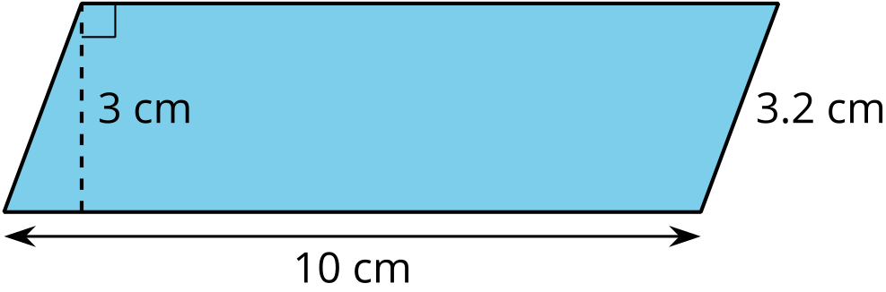
- 4
- Explain why this quadrilateral is not a parallelogram.
- 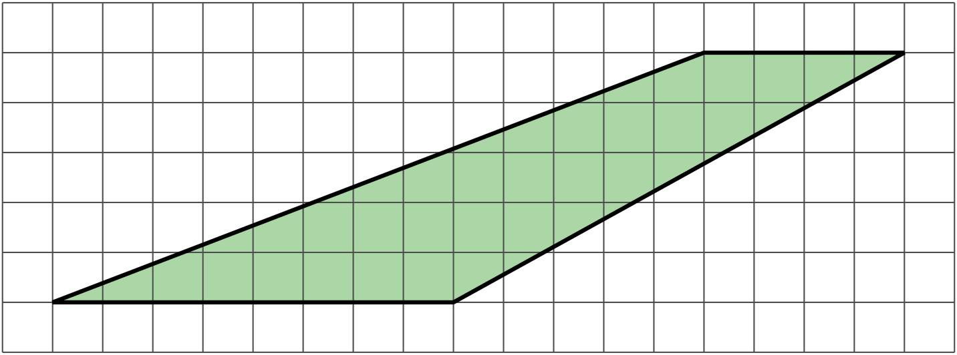
- 5from Unit 1, Lesson 3
- Find the area of each shape. Show your reasoning.
- A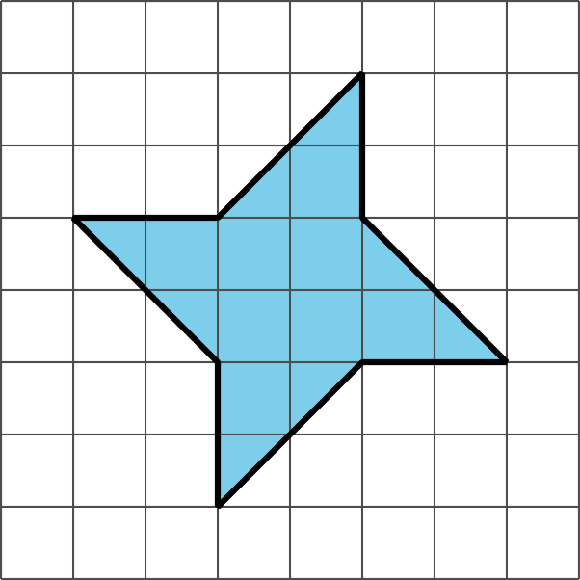
- B