## Unit 7 Lesson 5: What is an Angle?

### WU Notice and Wonder: A Wall of Clocks (Warm up)

#### Student Task Statement

What do you notice? What do you wonder?

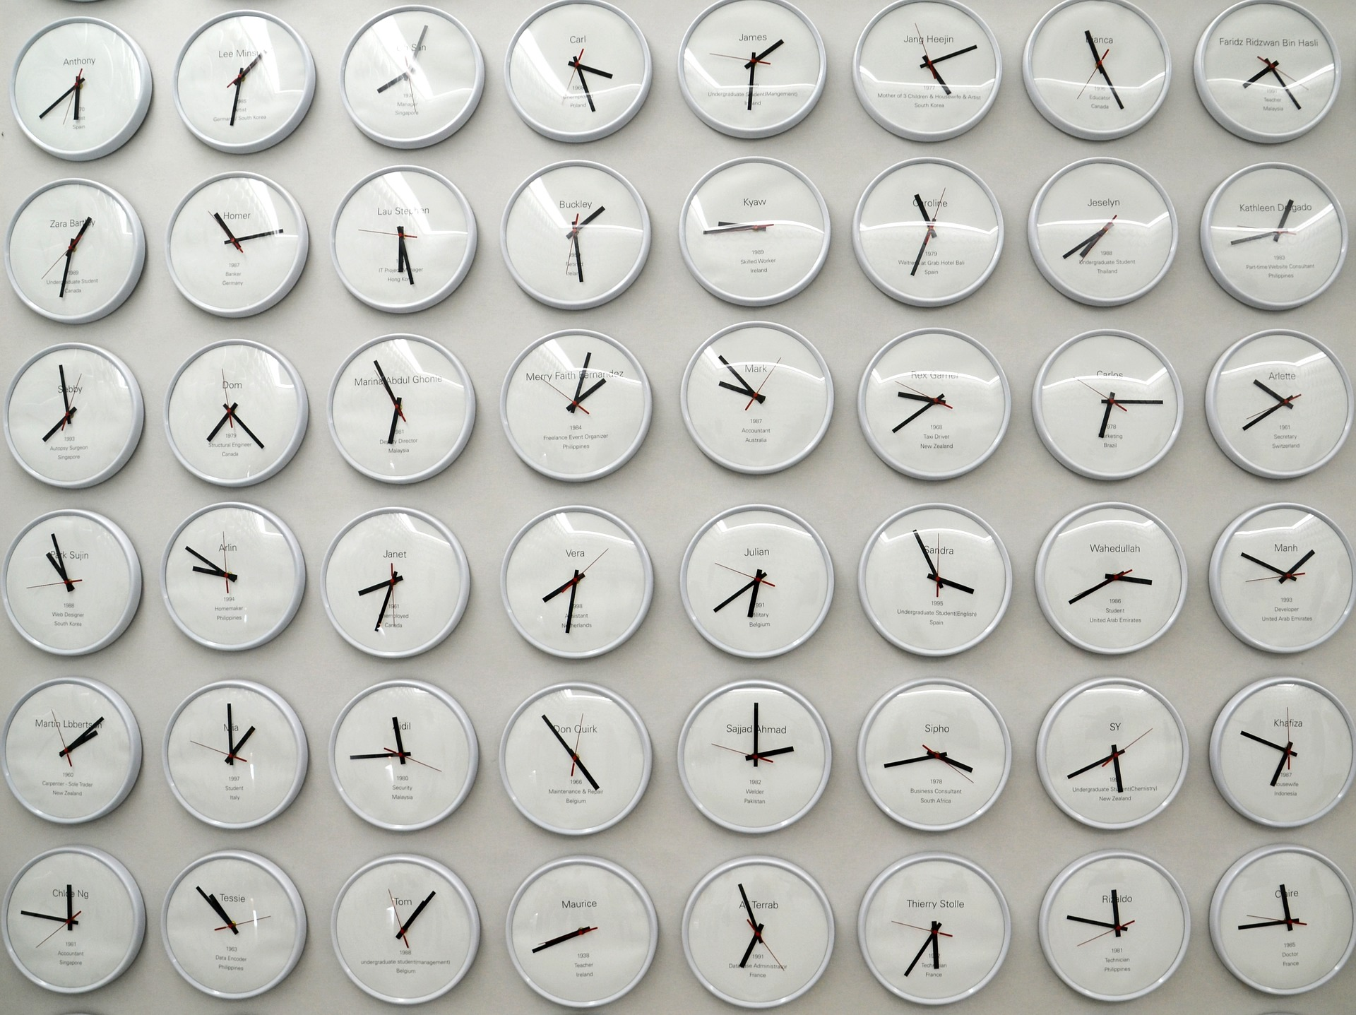

### 1 Tricky Figures

#### Student Task Statement

Work with a partner in this activity. Choose a role: A or B. Sit back to back, or use a divider to keep one person from seeing the other person’s work.

Partner A:

* Your teacher will give you a card. Don’t show it to your partner.
* Describe both images on the card—as clearly and precisely as possible—so that your partner can draw the same images.

Partner B:

* Your partner will describe two images. Listen carefully to the descriptions.
* Create the drawings as described. Follow the instructions as closely as possible.

1. When done, compare the drawings to the original images. Discuss:
   * Which parts were accurate? Which were off?
   * How could the descriptions be improved so the drawing could be more accurate?
2. Switch roles and repeat the exercise. Compare the drawings to the original images afterwards.

If you have time: Request two new cards from your teacher (one card at a time). Take turns describing and drawing the geometric figure on each card.

#### Activity Synthesis

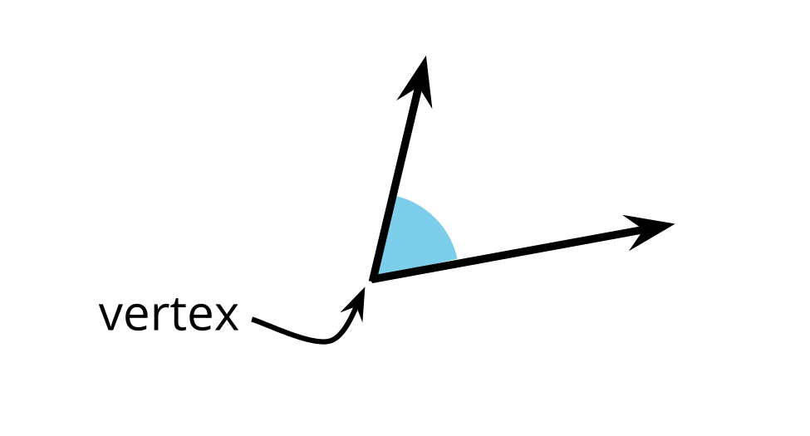

### 2 Angles or Not Angles?

#### Student Task Statement

1. Decide if each figure shows at least one angle. Explain or show your reasoning for each.

* 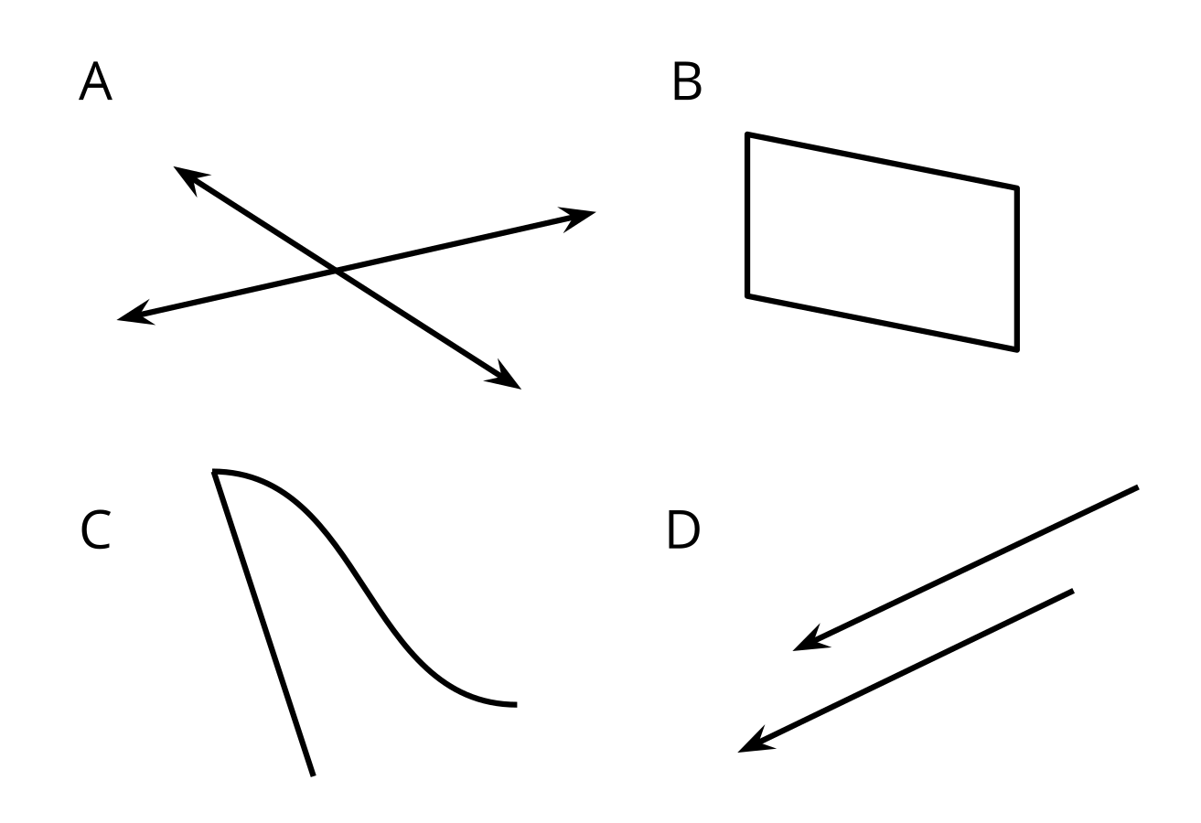

1. Clare and Kiran are looking at this diagram. Clare says there are no angles because the rays do not meet at a point. Kiran says he sees two angles.

* 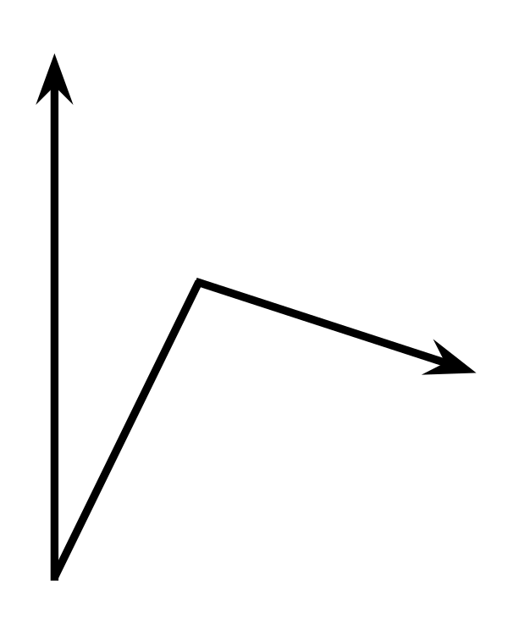
* Do you agree with either of them? How many angles do you see?

#### Activity Synthesis

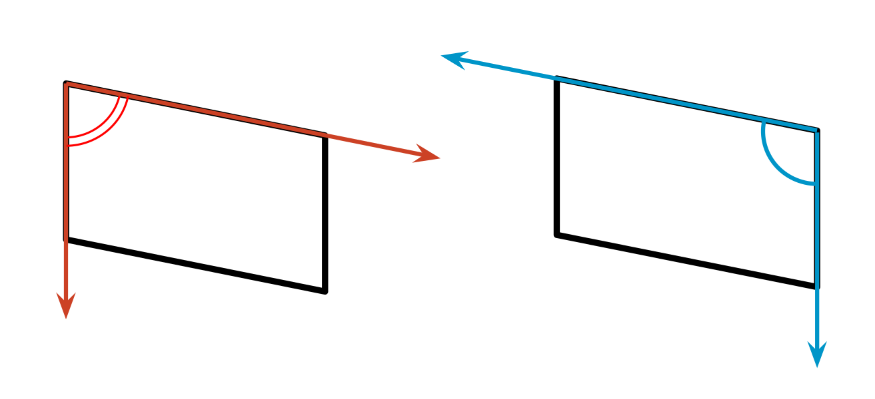

### 3 Discover Angles

#### Student Task Statement

Here are two figures.



1. Find 2–3 angles in each figure. Draw pairs of rays to show the angles.
2. Sketch a part of your classroom that has 2–3 angles. Draw pairs of rays to show the angles.



© CC BY 2021 Illustrative Mathematics®