Lesson 2 Practice Problems
- The height of water in a bathtub, $w$, is a function of time, $t$. Let $P$ represent this function. Height is measured in inches and time in minutes.
- Match each statement in function notation with a description.
  - $P\left(0\right)=0$
  - $P\left(4\right)=10$
  - $P\left(10\right)=4$
  - $P\left(20\right)=0$
  - After 20 minutes, the bathtub is empty.
  - The bathtub starts out with no water.
  - After 10 minutes, the height of the water is 4 inches.
  - The height of the water is 10 inches after 4 minutes.
- Function $C$ takes time for its input and gives a student’s Monday class for its output.
  - Use function notation to represent: A student has English at 10:00.
  - Write a statement to describe the meaning of $C\left(11​:​15\right)=\text{chemistry}$.
- Function $f$ gives the distance of a dog from a post, in feet, as a function of time, in seconds, since its owner left.
- Find the value of $f\left(20\right)$ and of $f\left(140\right)$.
- 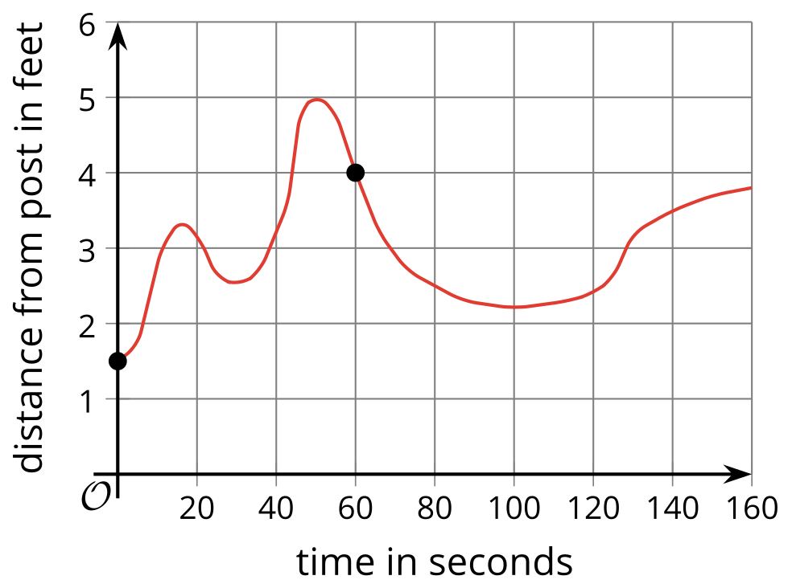
- Function $C$ gives the cost, in dollars, of buying $n$ apples. What does each expression or equation represent in this situation?
  - $C\left(5\right)=4.50$
  - $C\left(2\right)$
- A number of identical cups are stacked up. The number of cups in a stack and the height of the stack in centimeters are related.
  - Can we say that the height of the stack is a function of the number of cups in the stack? Explain your reasoning.
  - Can we say that the number of cups in a stack is a function of the height of the stack? Explain your reasoning.
- (From Unit 4, Lesson 1.)
- In a function, the number of cups in a stack is a function of the height of the stack in centimeters.
  - Sketch a possible graph of the function on the coordinate plane. Be sure to label the axes.
  - Identify one point on the graph and explain the meaning of the point in the situation.
- 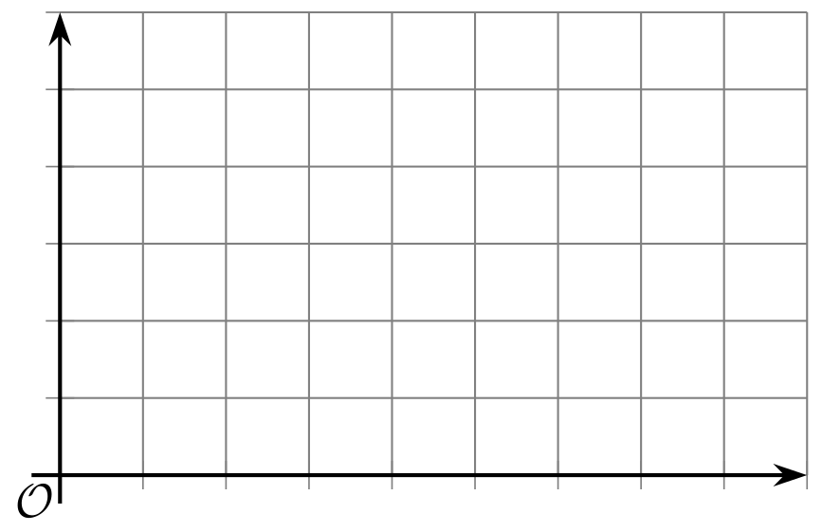
- (From Unit 4, Lesson 1.)
- Solve each system of equations without graphing. Show your reasoning.
  - $\left\{\begin{matrix}\text{-}5x+3y=\text{-}8 \\ 3x−7y=\text{-}3\end{matrix}\right.$
  - $\left\{\begin{matrix}\text{-}8x−2y=24 \\ 5x−3y= 2\end{matrix}\right.$
- (From Unit 2, Lesson 16.)
© CC BY 2019 by Illustrative Mathematics®

