Lesson 23 Practice Problems
- This year, students in the 9th grade are collecting dimes and quarters for a school fundraiser. They are trying to collect more money than the students who were in the 9th grade last year. The students in 9th grade last year collected $143.88.
- Using $d$ to represent the number of dimes collected and $q$ to represent the number of quarters, which statement best represents this situation?
  - $0.25d+0.1q≥143.88$
  - $0.25q+0.1d≥143.88$
  - $0.25d+0.1q>143.88$
  - $0.25q+0.1d>143.88$
- A farmer is creating a budget for planting soybeans and wheat. Planting soybeans costs $200 per acre and planting wheat costs $500 per acre. He wants to spend no more than $100,000 planting soybeans and wheat.
  - Write an inequality to describe the constraints. Specify what each variable represents.
  - Name one solution to the inequality and explain what it represents in that situation.
- Elena is ordering dried chili peppers and corn husks for her cooking class. Chili peppers cost $16.95 per pound and corn husks cost $6.49 per pound.
- Elena spends less than $50 on $d$ pounds of dried chili peppers and $h$ pounds of corn husks.
- Here is a graph that represents this situation.
- 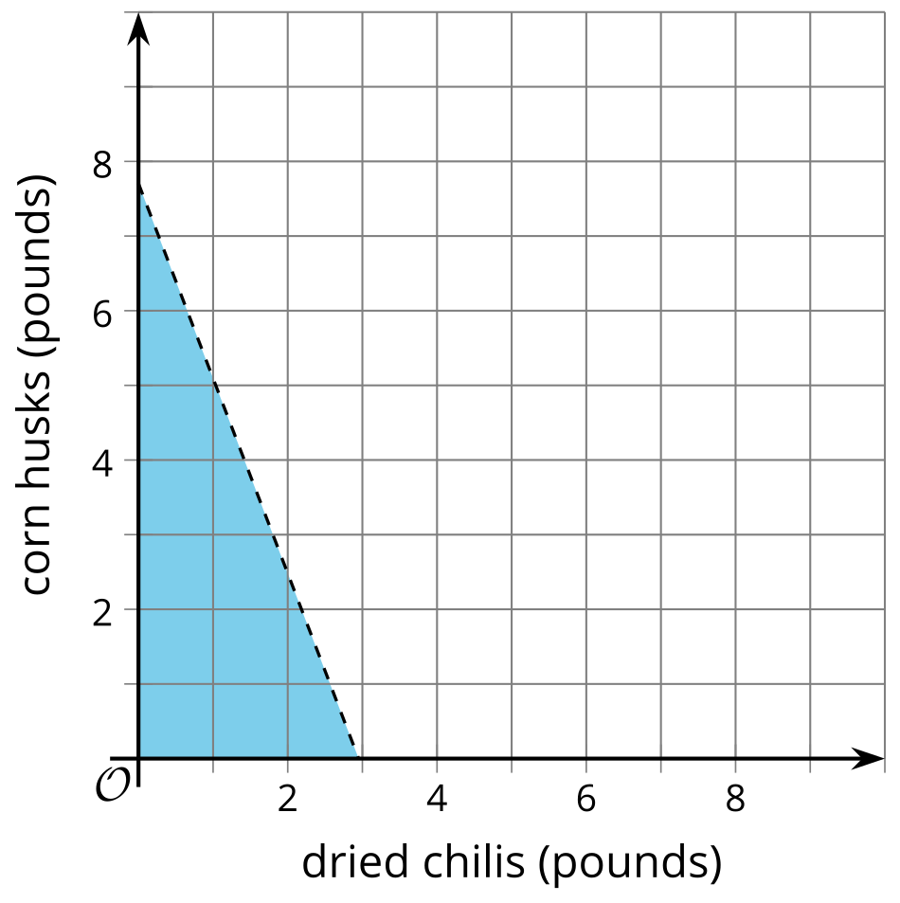
  - Write an inequality that represents this situation.
  - Can Elena purchase 2 pounds of dried chili peppers and 4 pounds of corn husks and spend less than $50? Explain your reasoning.
  - Can Elena purchase 1.5 pounds of dried chili peppers and 3 pounds of corn husks and spend less than $50? Explain your reasoning.
- Which inequality is represented by the graph?
- 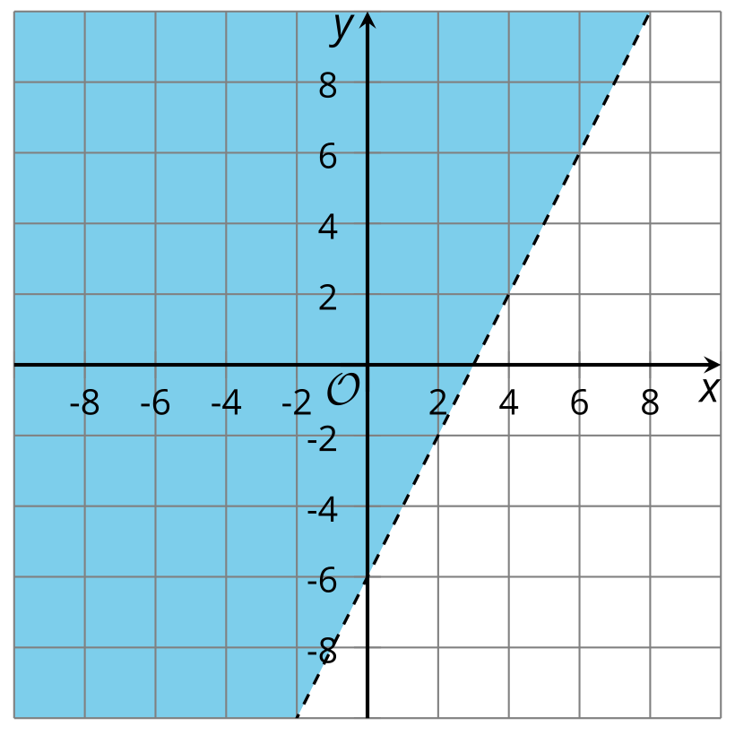

  - $4x−2y>12$
  - $4x−2y<12$
  - $4x+2y>12$
  - $4x+2y<12$
- Here are some statistics for the number of minutes it took each of 9 members of the track team to run 1 mile.
- When a tenth time is added to the list, the standard deviation increases to 1.5. Is the tenth time likely an outlier? Explain your reasoning.
  - mean: 7.3
  - median: 7.1
  - standard deviation: 1.1
  - Q1: 6.8
  - Q3: 7.4

- (From Unit 1, Lesson 14.)
- Elena is solving this system of equations: $\left\{\begin{matrix}10x−6y=16 \\ 5x−3y=8\end{matrix}\right.$
- She multiplies the second equation by 2, then subtracts the resulting equation from the first. To her surprise, she gets the equation $0=0$.
- What is special about this system of equations? Why does she get this result and what does it mean about the solutions? (If you are not sure, try graphing them.)
- (From Unit 2, Lesson 17.)
- Jada has a sleeping bag that is rated for ${30}^{∘}$ F. This means that if the temperature outside is at least ${30}^{∘}$ F, Jada will be able to stay warm in her sleeping bag.
  - Write an inequality that represents the outdoor temperature at which Jada will be able to stay warm in her sleeping bag.
  - Write an inequality that represents the outdoor temperature at which a thicker or warmer sleeping bag would be needed to keep Jada warm.
- (From Unit 2, Lesson 18.)
- What is the solution set to this inequality: $6x−20>3\left(2−x\right)+6x−2$ ?
- (From Unit 2, Lesson 19.)
- Here is a graph of the equation $2x−3y=15$.
- 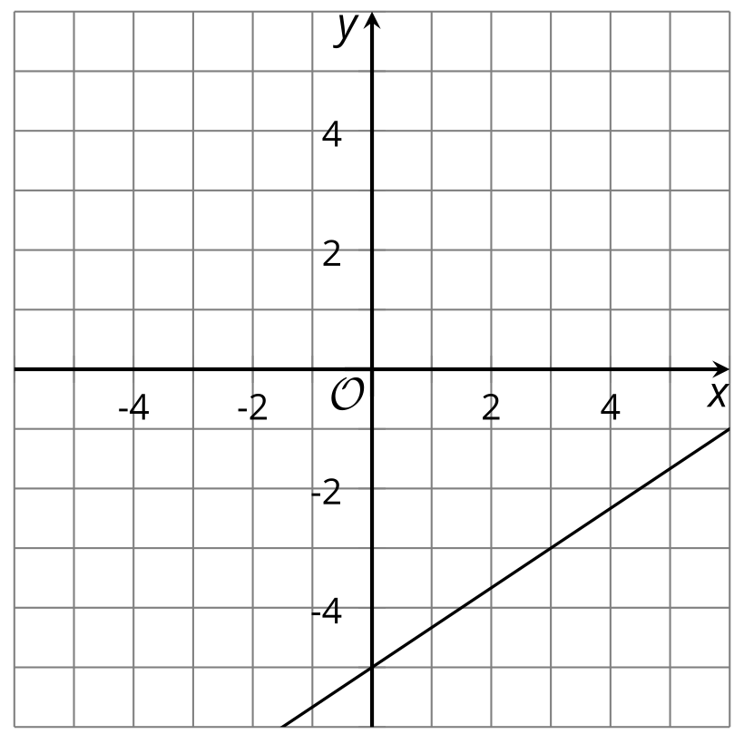
  - Are the points $\left(1.5,\text{-}4\right)$ and $\left(4,\text{-}4\right)$ solutions to the equation? Explain or show how you know.
  - Check if each of these points is a solution to the inequality $2x−3y<15$:
  - $\left(0,\text{-}5\right)$
  - $\left(4,\text{-}2\right)$
  - $\left(2,\text{-}4\right)$
  - $\left(5,\text{-}1\right)$
  - Shade the solutions to the inequality .
  - Are the points on the line included in the solution region? Explain how you know.
- (From Unit 2, Lesson 21.)
- A store sells notepads in packages of 24 and packages of 6. The organizers of a conference needs to prepare at least 200 notepads for the event.
  - Would they have enough notepads if they bought these quantities?
    - Seven packages of 24 and one package of 6
    - Five packages of 24 and fifteen packages of 6
  - Write an inequality to represent the relationship between the number of large and small packages of notepads and the number of notepads needed for the event.
  - Use graphing technology to graph the solution set to the inequality. Then, use the graph to name two other possible combinations of large and small packages of notepads that will meet the number of notepads needed for the event.
- (From Unit 2, Lesson 22.)
© CC BY 2019 by Illustrative Mathematics®

