Lesson 6: Center Day 1
- Let’s add and subtract in center activities.

Warm-up: Number Talk: Teen Numbers, Two-digit Numbers
Find the value of each expression mentally.
- $14+22$
- $19+22$
- $15+25$
- $17+25$

6.2: Centers: Choice Time
Choose a center.
What's Behind My Back?
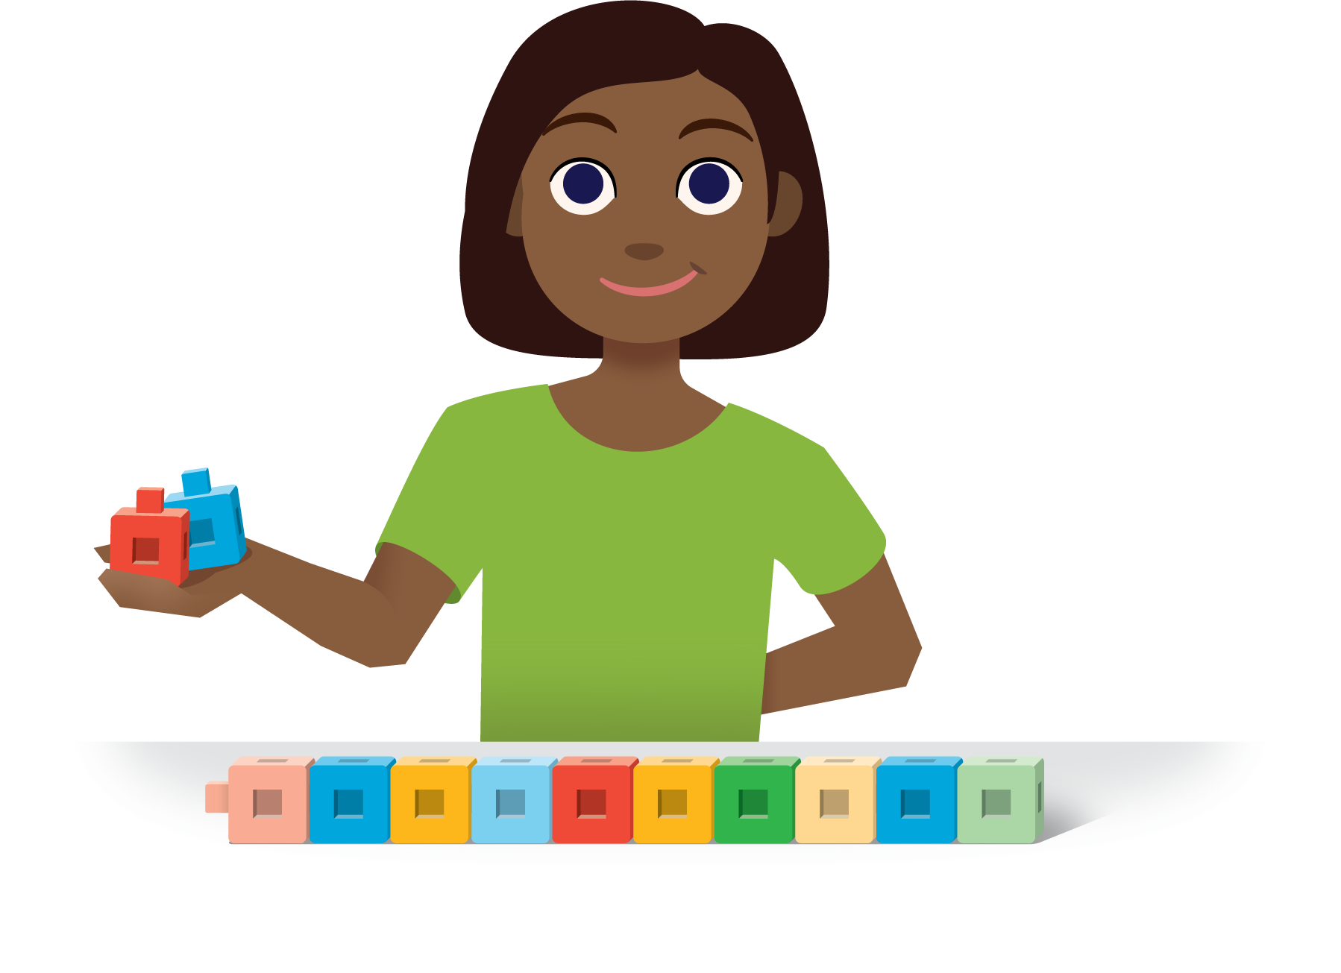
How Close?
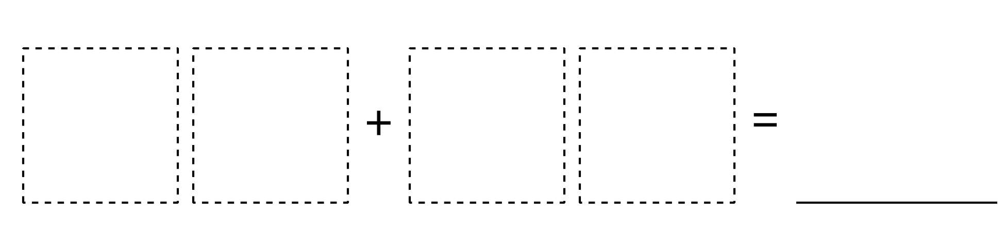
Number Puzzles
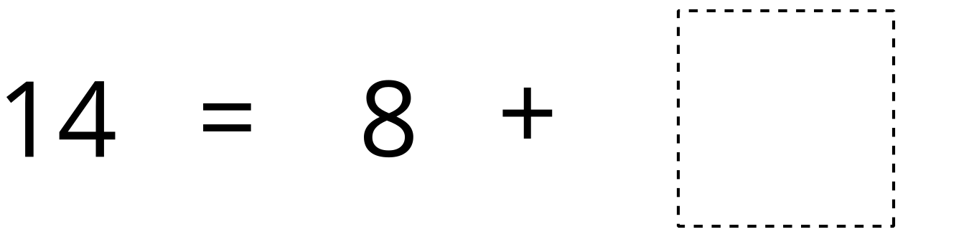
© CC BY 2021 Illustrative Mathematics®

