Lesson 4: Build Fractions from Unit Fractions

Standards Alignments
Addressing | 3.NF.A.1, 3.OA.C.7
Building Towards | 3.NF.A.2

Teacher-facing Learning Goals
- Build non-unit fractions and whole numbers from unit fractions.

Student-facing Learning Goals
- Let’s build other fractions from unit fractions.

Lesson Purpose
The purpose of this lesson is for students to build non-unit fractions and whole numbers from unit fractions.
In the previous lesson, students named non-unit fractions and made sense of the notation used to write them. In this lesson, students play a game in which they build non-unit fractions from unit fractions (for example, they try to collect enough cards showing $\frac{1}{6}$ to make $\frac{3}{6}$). They record these fractions on a fraction strip diagram. Then, students partition and shade diagrams to represent situations involving fractional lengths and consider the location of the endpoint of a fractional length. This will be helpful in subsequent lessons, when students represent fractions on a number line.
This lesson has a Student Section Summary.

Access for:

Students with Disabilities
- Engagement (Activity 1)

English Learners
- MLR8 (Activity 2)

Instructional Routines
Number Talk (Warm-up)

Materials to Gather
- Colored pencils: Activity 1
- Folders: Activity 1
- Materials for creating a visual display: Activity 2

Materials to Copy
- Secret Fractions Stage 1 Cards (groups of 2): Activity 1
- Secret Fractions Stage 1 Gameboard (groups of 2): Activity 1

Lesson Timeline
Warm-up | 10 min
Activity 1 | 20 min
Activity 2 | 15 min
Lesson Synthesis | 10 min
Cool-down | 5 min

Teacher Reflection Question
How did having visual representations help students think about building fractions from unit fractions in today’s lesson?

Cool-down
(to be completed at the end of the lesson) 5min
Represent a Fraction

Standards Alignments
Addressing | 3.NF.A.1

Student-facing Task Statement
This strip represents 1 whole. Partition the diagram and shade it to represent $\frac{6}{8}$.
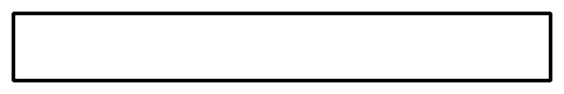

Student Responses
