Grade 2
Unit 3Lesson 11CC BY NC 2024 Illustrative Mathematics®
Unit 3, Lesson 11

Saree Silk Stories: Necklaces and Bracelets
- Let’s solve story problems about length.
Grade 2
Unit 3Lesson 11CC BY NC 2024 Illustrative Mathematics®

Warm-upNotice and Wonder: Take From
What do you notice? What do you wonder?
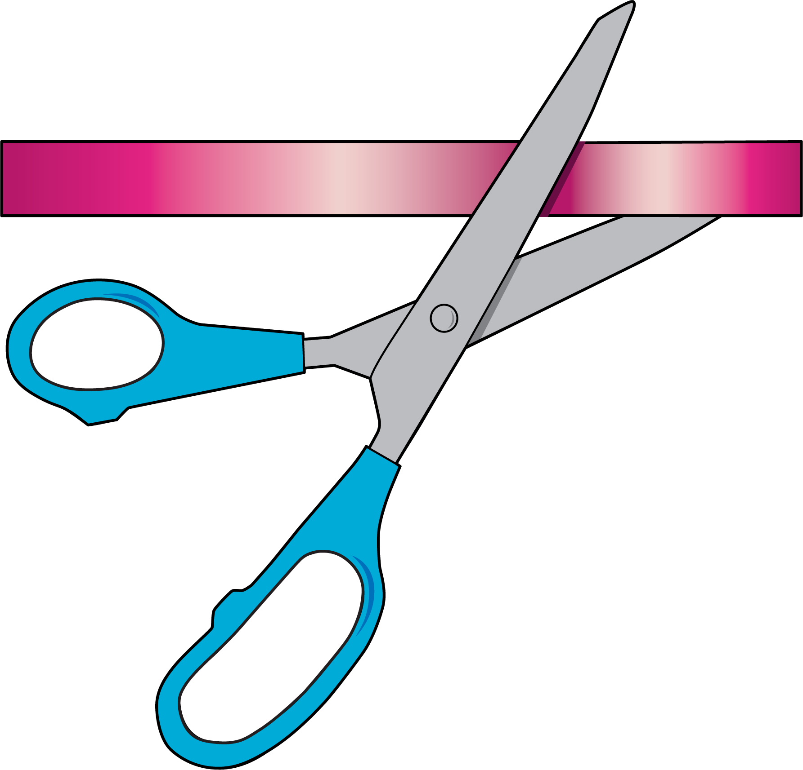
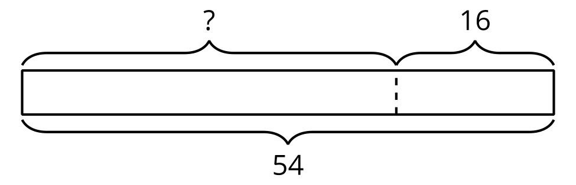
$54−16=?$
Grade 2
Unit 3Lesson 11CC BY NC 2024 Illustrative Mathematics®

Activity 1Saree Silk Ribbon Necklaces
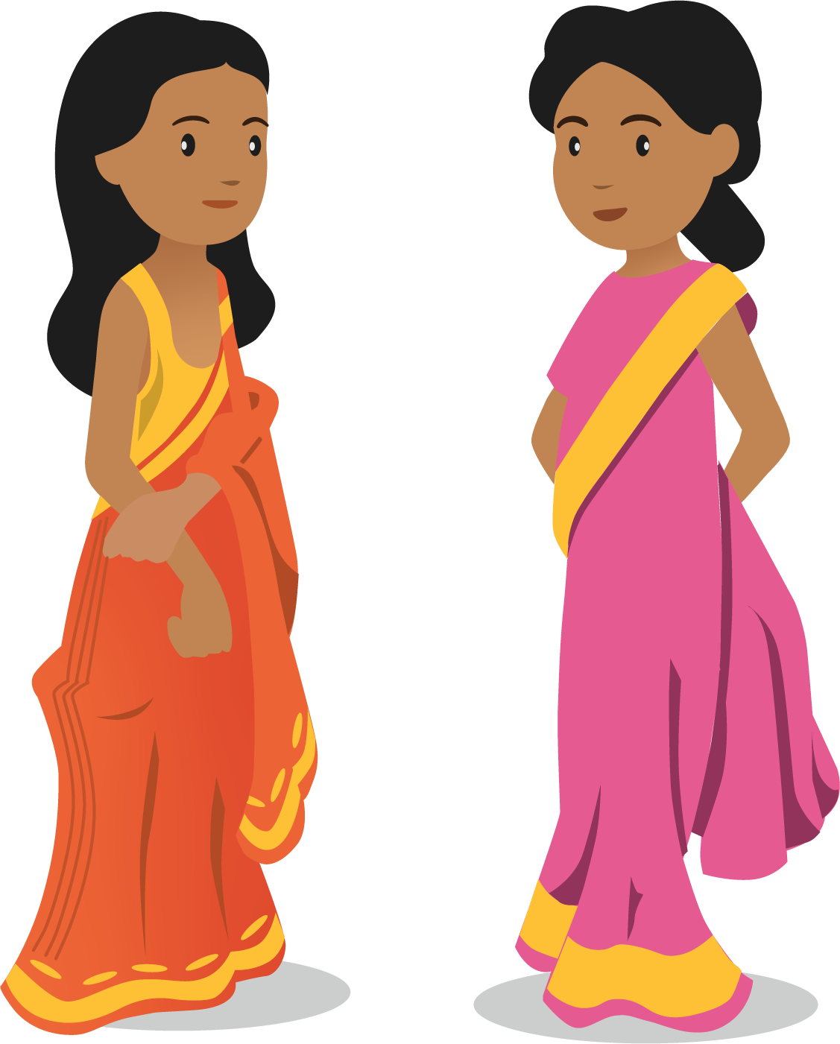
What do you notice? What do you wonder?
Priya has a ribbon that is 44 inches long. She cuts off 18 inches. How long is it now?
Andre draws this diagram to help him think about the problem.
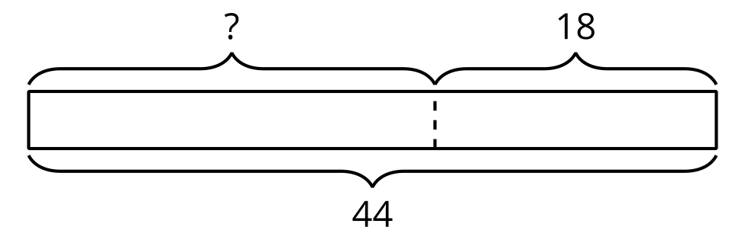
- What does the “?” represent in the story?
- Why do you think there is a dotted line between the parts?
- Find the unknown value. Show your thinking using drawings, numbers, or words.
- Priya’s ribbon is __________________ long.
Grade 2
Unit 3Lesson 11CC BY NC 2024 Illustrative Mathematics®

Activity 2Saree Silk Ribbon Projects
Label the diagram. Find the unknown value. Show your thinking using drawings, numbers, or words. Write the units.
- Elena starts with 58 inches of ribbon. She gives Clare 27 inches of ribbon. How much did Elena keep?
- 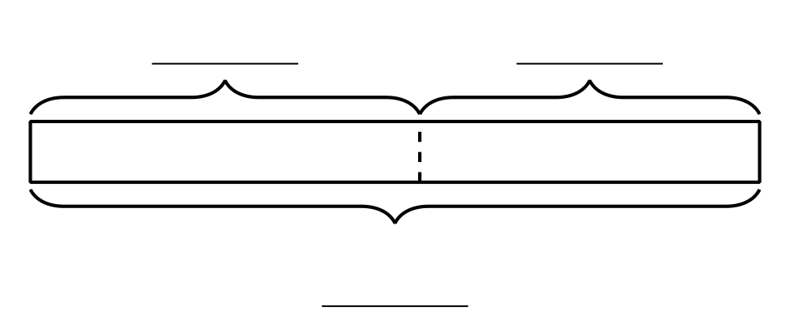
- Han has a piece of ribbon that is 64 inches long. He cuts off 28 inches to make a necklace for his sister. How much ribbon is left?
- 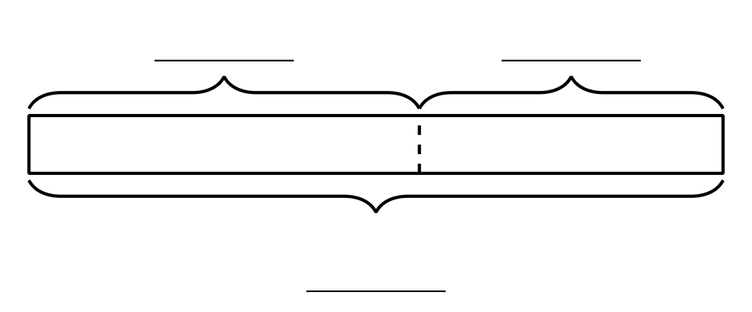
- Priya cuts off 25 inches of ribbon. She has 38 inches of ribbon left. How much ribbon did Priya start with?
- 