Lesson 1: ¿Qué es el área?

Standards Alignments
Addressing | 3.MD.C.5, 3.OA.A.1
Building Towards | 3.MD.C.5

Teacher-facing Learning Goals
- Describe the relative size of plane figures in their own language.

Student-facing Learning Goals
- Comparemos el tamaño de algunas figuras.

Lesson Purpose
The purpose of this lesson is for students to recognize that different shapes cover different amounts of space.
In grade 2, students estimated, measured, and compared lengths using standard units. They learned how the length of the unit affects measurements.
This lesson introduces the concept of area as students compare the size of different shapes. Students consider what it means for two-dimensional shapes to be larger or cover more space. They measure and describe relative area with increasing precision as they participate in the activities in this lesson.
Give students access to pattern blocks and scissors during the cool-down.

Access for:

Students with Disabilities
- Action and Expression (Activity 2)

English Learners
- MLR8 (Activity 2)

Instructional Routines
How Many Do You See? (Warm-up)

Materials to Gather
- Pattern blocks: Activity 2
- Scissors: Activity 1, Activity 2

Materials to Copy
- Pattern Blocks to Compare Shapes, Spanish (groups of 1): Activity 2

Lesson Timeline
Warm-up | 10 min
Activity 1 | 15 min
Activity 2 | 20 min
Lesson Synthesis | 10 min
Cool-down | 5 min

Teacher Reflection Question
What part of the lesson went really well today in terms of students learning? What did you do that made that part go well?

Cool-down
(to be completed at the end of the lesson) 5min
Compara el área

Standards Alignments
Addressing | 3.MD.C.5

Student-facing Task Statement
¿Cuál rectángulo tiene mayor área? ¿Cómo lo sabes?
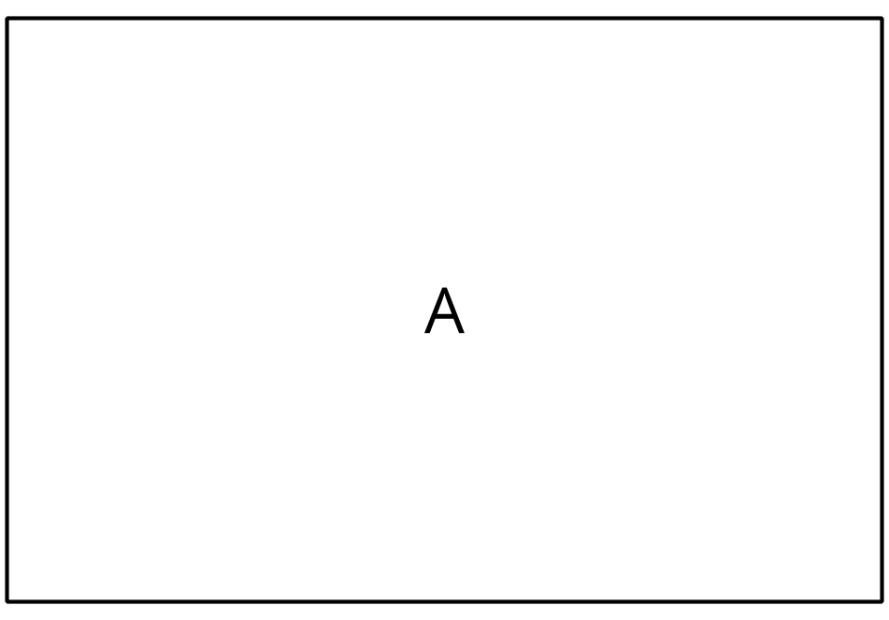
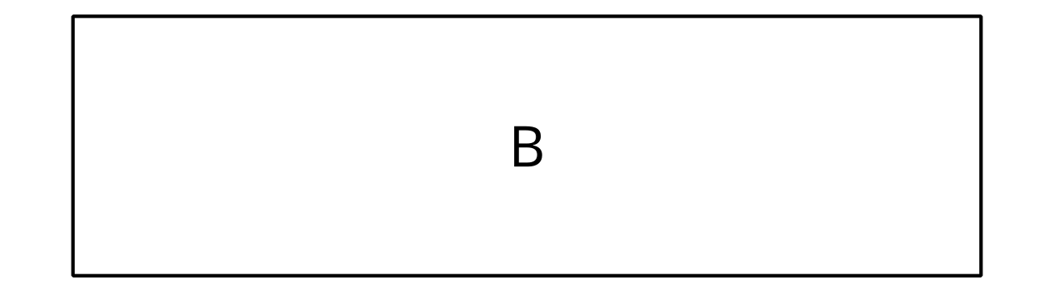

Student Responses
Sample response: Figure A covers more space. Even if you cut Figure B in half it would fit in Figure A with leftover space.

