Lesson 6 Practice Problems
- Here is a scale drawing of a swimming pool where 1 cm represents 1 m.
- 
  - How long and how wide is the actual swimming pool?
  - Will a scale drawing where 1 cm represents 2 m be larger or smaller than this drawing?
  - Make a scale drawing of the swimming pool where 1 cm represents 2 m.
- A map of a park has a scale of 1 inch to 1,000 feet. Another map of the same park has a scale of 1 inch to 500 feet. Which map is larger? Explain or show your reasoning.
- On a map with a scale of 1 inch to 12 feet, the area of a restaurant is 60 in². Han says that the actual area of the restaurant is 720 ft². Do you agree or disagree? Explain your reasoning.
- If Quadrilateral Q is a scaled copy of Quadrilateral P created with a scale factor of 3, what is the perimeter of Q?
- 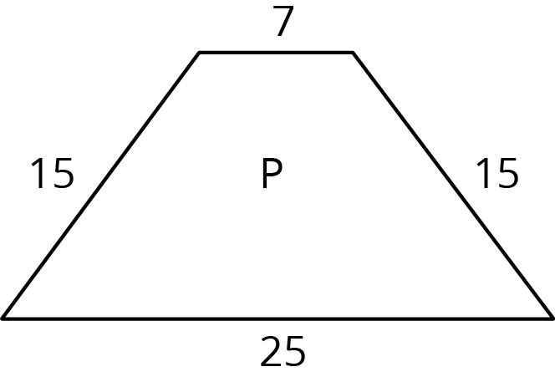
- (From Unit 2, Lesson 2.)
- Triangle $DEF$ is a scaled copy of triangle $ABC$. For each of the following parts of triangle $ABC$, identify the corresponding part of triangle $DEF$.
  - angle $ABC$
  - angle $BCA$
  - segment $AC$
  - segment $BA$
- 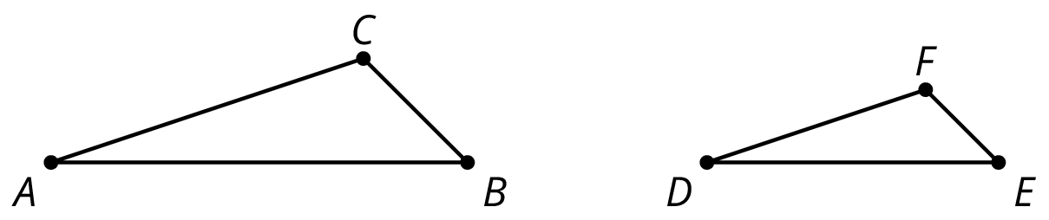
- (From Unit 2, Lesson 2.)
© CC BY Open Up Resources. Adaptations CC BY IM.

