Grade 6
Unit 4Lesson 10CC BY NC Illustrative Mathematics, based on IM 6–8 Math, CC BY Open Up Resources.
Unit 4, Lesson 10

Dividing by Unit and Non-Unit Fractions
Let’s look for patterns when we divide by a fraction.
Grade 6
Unit 4Lesson 10CC BY NC Illustrative Mathematics, based on IM 6–8 Math, CC BY Open Up Resources.

10.1Dividing by a Whole Number
Work with a partner. One person solves the problems labeled “Partner A” and the other person solves those labeled “Partner B.”
Write an equation for each question. If you get stuck, consider drawing a diagram.
- Partner A:
- How many 3s are in 12?
- Division equation:
- 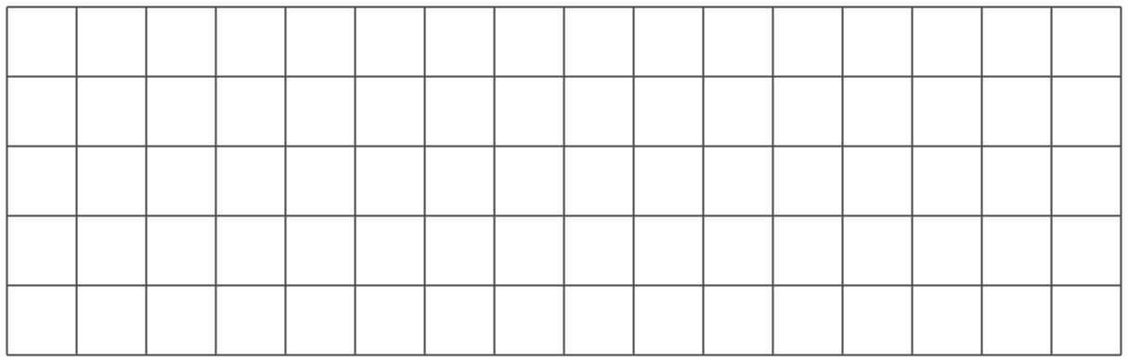
- How many 4s are in 12?
- Division equation:
- How many 6s are in 12?
- Division equation:
- Partner B:
- What is 12 groups of $\frac{1}{3}$?
- Multiplication equation:
- What is 12 groups of $\frac{1}{4}$?
- Multiplication equation:
- What is 12 groups of $\frac{1}{6}$?
- Multiplication equation:
- What do you notice about the diagrams and equations? Discuss with your partner.
- Complete this sentence based on what you noticed:
- Dividing by a whole number $a$ produces the same result as multiplying by $\underset{_}{​}$ .
Grade 6
Unit 4Lesson 10CC BY NC Illustrative Mathematics, based on IM 6–8 Math, CC BY Open Up Resources.

10.2Dividing by Unit Fractions
- To find the value of $6÷\frac{1}{2}$, Elena thought, “How many $\frac{1}{2}$s are in 6?” and then she drew this tape diagram. It shows 6 ones, with each one partitioned into 2 equal pieces.
- $6÷\frac{1}{2}$
- 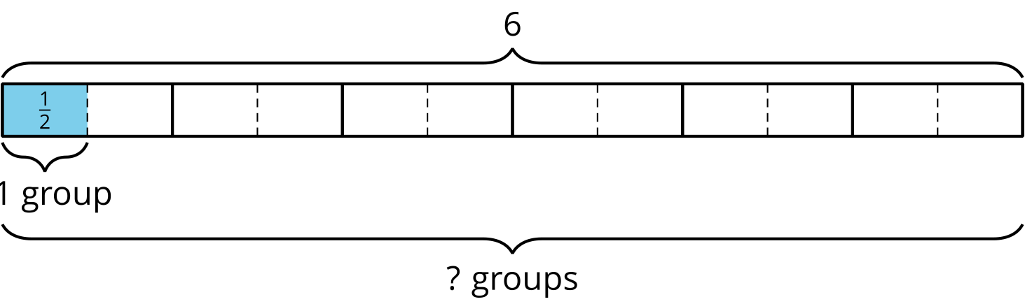
- For each division expression, complete the diagram using the same method as Elena. Then, find the value of the expression.
  - $6÷\frac{1}{3}$
  - 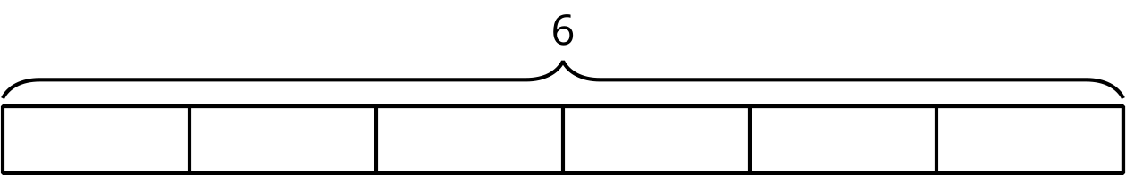
  - Value of the expression: $\underset{_}{​}$
  - $6÷\frac{1}{4}$
  - Value of the expression: $\underset{_}{​}$
  - $6÷\frac{1}{6}$
  - Value of the expression: $\underset{_}{​}$
- Look for a pattern in the expressions and their values. Talk to your partner about how to find how many halves, thirds, fourths, or sixths were in 6 wholes, without counting all the parts.
- Use the pattern you noticed to find the values of these expressions. If you get stuck, consider drawing a diagram.
  - $6÷\frac{1}{8}$
  - $6÷\frac{1}{10}$
  - $6÷\frac{1}{25}$
  - $6÷\frac{1}{b}$
- Find the value of each expression.
  - $8÷\frac{1}{4}$
  - $12÷\frac{1}{5}$
  - $a÷\frac{1}{2}$
  - $a÷\frac{1}{b}$
Grade 6
Unit 4Lesson 10CC BY NC Illustrative Mathematics, based on IM 6–8 Math, CC BY Open Up Resources.

10.3Dividing by Non-unit Fractions
- To find the value of $6÷\frac{2}{3}$, Elena started by drawing this diagram.
- 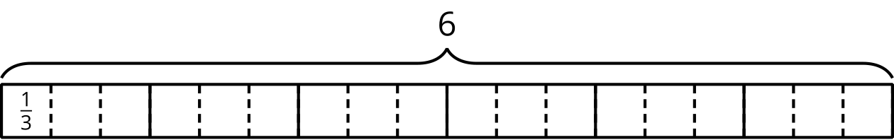
  - Complete the diagram to show how many $\frac{2}{3}$s are in 6.
  - Elena says, “To find $6÷\frac{2}{3}$, I can take the value of $6÷\frac{1}{3}$ and then either multiply it by $\frac{1}{2}$ or divide it by 2.”
  - Discuss with your partner why Elena’s method works.
- Use the diagram and Elena’s method to find the value of each expression. Think about how to find that value without counting all the pieces in the diagram.
  - $6÷\frac{3}{4}$
  - 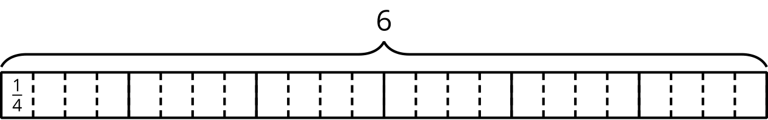
  - Value of the expression: $\underset{_}{​}$
  - ​​​​​​ $6÷\frac{4}{3}$
  - Value of the expression: $\underset{_}{​}$
  - $6÷\frac{4}{6}$
  - 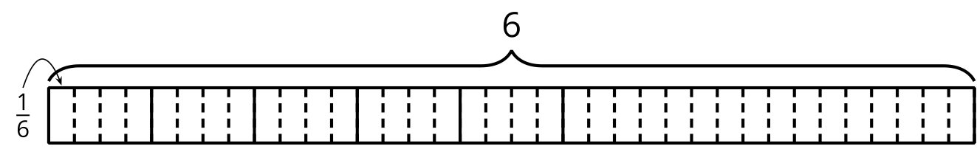
  - Value of the expression: $\underset{_}{​}$
- Elena noticed that she always took the same two steps to show division by a fraction on a tape diagram. She said:
- “First, I would partition each 1 whole into as many parts as the number in the denominator. For $6÷\frac{3}{4}$, that number is 4, so the diagram would have 4 times as many parts.
- Next, I would put a certain number of those parts into one group. For $6÷\frac{3}{4}$, I would put 3 of the $\frac{1}{4}$s into each group and see how many groups there are.”
- Which expression represents the result of taking these two steps to find $6÷\frac{3}{4}$?
- Be prepared to explain your reasoning.
  - $6÷4⋅3$
  - $6÷4÷3$
  - $6⋅4÷3$
  - $6⋅4⋅3$

Are you ready for more?
Find the unknown value.

Lesson 10 Summary
To answer the question “How many $\frac{1}{3}$s are in 4?” or “What is $4÷\frac{1}{3}$?”, we can reason that there are 3 thirds in 1, so there are $\left(4⋅3\right)$ thirds in 4.
In other words, dividing 4 by $\frac{1}{3}$ has the same result as multiplying 4 by 3.
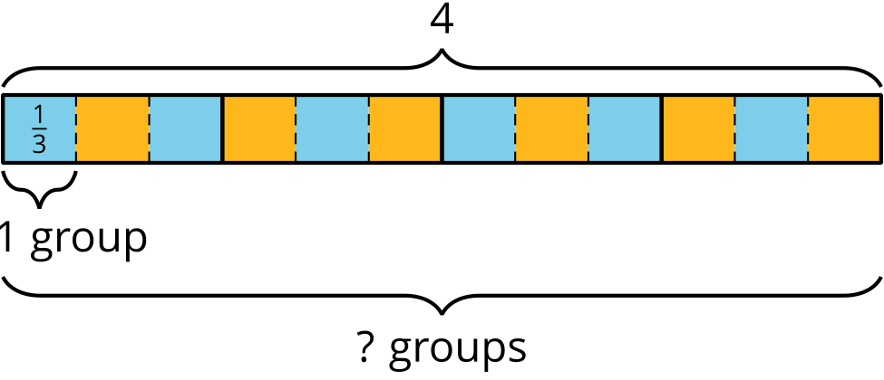
$4÷\frac{1}{3}=4⋅3$
In general, dividing a number by a unit fraction $\frac{1}{b}$ is the same as multiplying the number by $b$.
How can we reason about $4÷\frac{2}{3}$?
We already know that there are $\left(4⋅3\right)$ or 12 groups of $\frac{1}{3}$s in 4. To find how many $\frac{2}{3}$s are in 4, we need to put together every 2 of the $\frac{1}{3}$s into a group. Doing this results in half as many groups, which is 6 groups. In other words,
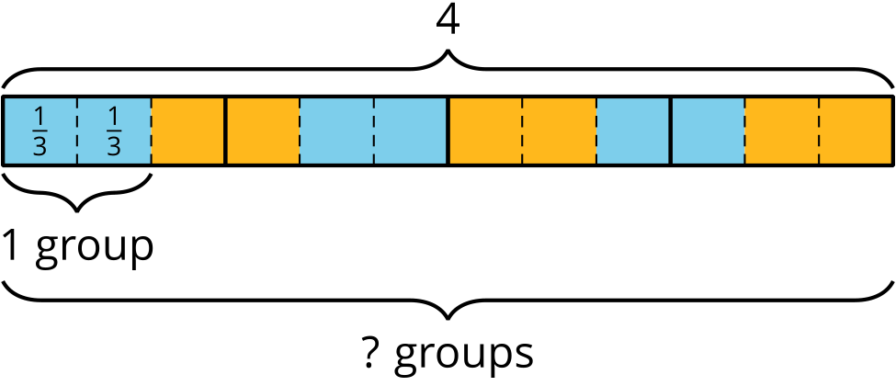
$4÷\frac{2}{3}=\left(4⋅3\right)÷2$
or
$4÷\frac{2}{3}=\left(4⋅3\right)⋅\frac{1}{2}$
In general, dividing a number by $\frac{a}{b}$, is the same as multiplying the number by $b$ and then dividing by $a$, or multiplying the number by $b$ and then by $\frac{1}{a}$.

